

CAPSTONE PROJECT REPORT
Report 3 – Software Requirement Specification

– Hanoi, Aug 2026 –
Table of Contents
Change Log 7
Definition and Acronyms 8
I. Overall Requirements 9
1. Context Diagram 9
2. Main Business Flow 9
2.1 Tutor Onboarding & Approval 9
2.2 Membership Purchase & Posting 10
2.3 Search & Trial Lesson Booking 11
2.4 Class Management 13
3. Conceptual Data Model 14
3.1 Entity Relationship Diagram 14
3.2 Entity Descriptions 14
3.3 Data Business Rules 20
4. User Requirements 22
4.1 Actors 22
4.2 Use Cases (UC) 22
4.3 Use Case Diagrams 30
4.4 Permission Matrix 37
5. System Functionalities 42
5.1 Screen Inventory 42
5.2 External API Inventory 46
5.3 Background Job Inventory 47
II. Use Case Specifications 47
1. Authentication & Authorization 47
1.1 Login 47
1.2 Register Account 48
1.3 Logout 48
1.4 Change Password 49
1.5 Reset Password 50
1.6 Create Staff Account 51
1.7 Update Roles and Permissions 52
1.8 Ban Staff Account 53
1.9 View Staffs List 54
1.10 View Staff Detail 54
1.11 Update Staff Information 55
1.12 Update Tutor and Learner Status 56
1.13 View System Log 57
1.14 Configure System Settings 58
1.15 View System Statistics 58
1.16 Export System Reports 59
2. Learner & Tutor Profile Management 60
2.1 View Profile 60
2.2 Update Profile 61
2.3 View Tutor and Learner List 61
2.4 View Tutor and Learner Profile Details 62
3. Tutor Verification 63
3.1 View Tutor Verification Form 63
3.2 Update Verification Information 64
3.3 Submit Tutor Verification Information 65
3.4 View Verification Applications 66
3.5 Request Additional Verification Information 67
3.6 Review Tutor Verification Application 68
3.7 Approve or Reject Tutor Application 69
3.9 View Verification Feedback 72
3.10 View verification History 73
4. Tutor Search & Connection 74
4.5 View Received Tutor Response 77
4.6 View Received Connection Request 78
5. Trial Lesson Booking & Learning Activation 85
5.1 Book Trial Lesson 85
5.2 Cancel Trial Booking 86
5.3 Reschedule Trial Lesson 87
5.4 View Lesson Calendar 88
5.5 Request Lesson Reschedule 89
5.6 View Trial Bookings 90
5.7 View Trial Booking Details 91
5.8 Process Trial Bookings 92
5.9 Create Teaching Schedule 93
5.10 View Teaching Schedule 94
5.11 Update Teaching Schedule 95
6. Classroom & Learning Materials Management 96
6.1 Access Classroom 96
6.2 Update Learning Materials 97
7. Homework, Assessment & Progress Tracking 98
7.1 Update Assignments 98
7.2 Resubmit Assignments 99
8. Learning Support 100
8.1 Practice Kanji Writing 100
8.2 Take Placement Test 101
8.3 View Course 102
8.4 View Learning Progress 103
8.5 Submit Tutor Review 104
8.6 View Learning Materials 105
8.7 Study Flashcards 106
8.8 View Assignment 107
8.9 Submit Assignment 108
8.10 Upload Learning Materials 109
8.11 Create and Assign Assignment 110
8.12 Grade Assignment 111
9. Membership & Payment Management 114
9.1 View Membership Expiry Date 114
9.2 Handle Payment Issues 115
9.3 Configure Membership Pricing 116
9.5 View Tutor Membership List 118
9.6 View Tutor Membership Details 119
9.7 Payment Membership 119
9.8 View Assignments 120
9.9 Submit Assignment 121
9.10 View Learning Materials 122
9.11 Upload Learning Materials 123
9.12 Upload Assignments 124
9.14 Grade Assignments 125
9.15 Create Progress Report 126
9.16 Submit Learner Feedback 127
10. Support Ticket & Escalation 128
10.1 View Support Ticket 128
10.2 Submit Support Ticket 129
10.3 View Referred Support Requests 130
10.4 View Referred Support Request Details 131
10.5 Process Referred Support Request 131
10.6 Send Support Resolution 132
10.7 View Support Ticker List 133
10.8 Send Support Ticket Response 133
10.9 Refer Support Request to Manager 134
10.10 Handel Support Ticket 135
10.11 View Booking Support Request 136
10.12 Assist with Connection Issues 136
11.1 Manage Booking Policy Configuration 137
11.2 Monitor System Health 138
11.3 Handle Technical Incidents 139
11.4 View System Terms and Policies 140
12. Notification Management 140
12.1 Configure Notifications Preferences 140
12.3 Mark Notification as Read 142
12.4 Delete Notification 143
12.5 Broadcast Notifications 144
12.6 View Notification History 145
12.7 Send Notification to All Users 146
III. Functional Requirements 148
1. Authentication & Authorization 148
1.1 User Register 148
2. Learner & Tutor Profile Management 150
3. Tutor Onboarding & Verification 150
3.1 Tutor Application Review 150
4. Tutor Search & Suggest 154
5. Lesson Scheduling & Attendance 159
6. Background Job Inventory 163
6.1 Auto-Cancel Unpaid Trial Bookings (JOB-01) 163
6.2 Auto-Check-Out Expired Sessions (JOB-02) 164
6.3 Clean Up Expired Verification OTPs (JOB-03) 164
7. External API Inventory 164
7.1 Payment Gateway Request (API-EXT-01) 164
7.2 VnPay Webhook / IPN (API-EXT-02) 165
7.3 Email Service API (API-EXT-03) 165
7.4 Google Maps API (API-EXT-04) 165
7.5 Cloud Storage API (API-EXT-05) 165
IV. Non-Functional Requirements 165
1. External Interfaces 165
2. Quality Attributes 166
2.1 Usability 166
2.2 Performance 166
2.3 Security 167
2.4 Scalability, Availability, Maintainability & Compliance 168
V. Requirement Appendix 168
1. Business Rules 168
2. System Messages 172
3. Other Requirements 175
3.1 Out of Scope (OOS) 175
3.2 Technical Assumptions (ASM) 176
3.3 Abbreviations & Acronyms 177

Change Log
Date | A*  M, D | In charge | Change Description
19/09/2026 | A | Hoangvm | Create the first draft of Software Requirement Specification
25/09/2026 | M | Hoangvm | Update requirement
27/09/2026 | M | Hoangvm | Update requirement
30/09/2026 | D,M,A | Hoangvm | Delete UCs, modified actor, context
1/10/2026 | A | Linhtk | Add use case specifications(1-5)
03/10/2026 | A | Hannd | Modified System Functionalities
03/10/2026 | A | Hoangvm | Add use case specifications(6-10)
04/10/2026 | M | Hannd | Modified Context Diagram
04/10/2026 | M | Linhtk | Modified Conceptual Data Model , Business rule
05/10/2026 | M | Huyendt | Modified use case diagram
06/10/2026 | M | Haipt | Modified Main Business Flow
07/10/2026 | M | Hoangvm | Modified use case specifications
7/10/2026 | M | Hoangvm | Modified Requirement Appendix
08/10/2026 | M | Huyendt | Modified Non-Functional Requirements
09/10/2026 | A | Haipt | Add Functional Requirements
14/10/2026 | M | Hannd | Modified Context Diagram
15/10/2026 | D | Linhtk | Payout Tutor
23/10/2026 | M | Haipt | Modified Main Business Flow
*A - Added M - Modified D - Deleted

Definition and Acronyms
Acronym | Definition
KZT | KizunaTutor – Japanese Learning Matching and Learning support system.
JLPT | Japanese - Language proficiency test. The standard certification to evaluate and certify Japanese language proficiency (ranging from N5 to N1).
Tutor | A system actor who registers to provide Japanese tutoring services and has a verified profile.
Learner | A system actor who searches for tutors, views profiles, and books tutoring sessions for their children or themselves.
Admin | Administrator. The system actor responsible for managing users, approving tutor profiles, resolving disputes, and handling system operations.
Matching | The core process of learner's specific learning requirements with a suitable tutor's profile
GAP | A discrepancy between what is available in existing solutions and what is actually needed to solve the user's problem.
IRT | Item response theory - Psychometric methodology used in JLPT to calculate standardized scaled scores (out of 180).
SRS | Spaced repetition system - Learning technique for Japanese flashcards/Kanji memorization.

I. Overall Requirements

1. Context Diagram
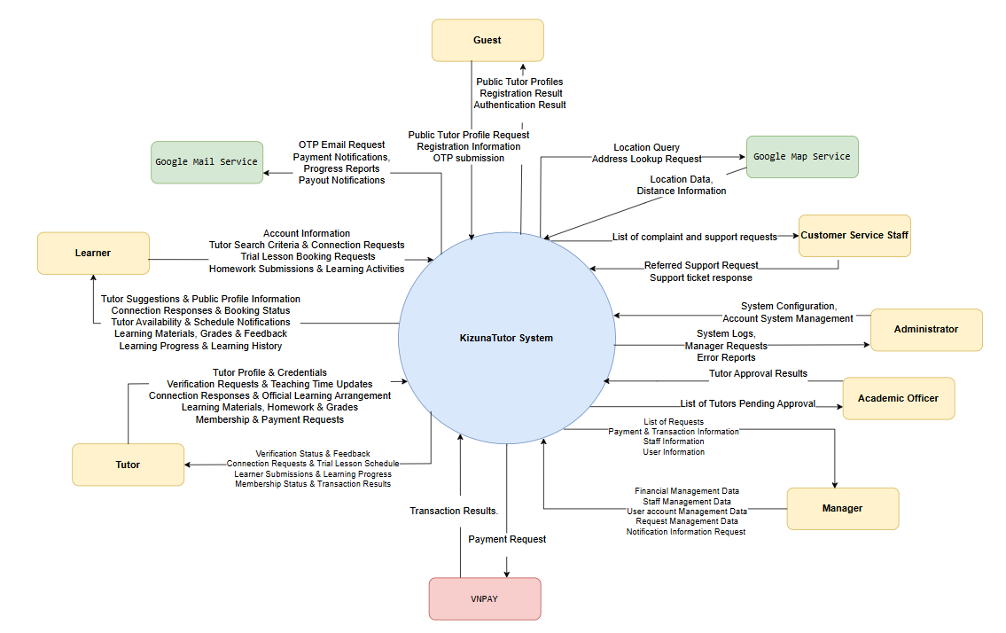
Figure 3-1.1: System Context Diagram

2. Main Business Flow

2.1 Tutor Onboarding & Approval
Trigger: A registered Tutor opens the tutor profile page, uploads the verification documents and submits the profile for review.
End condition: The Academic Officer approves the profile, the tutor status is updated to Approved, a notification email is sent and teaching access is granted. If the profile is rejected, a rejection email with the reason is sent and the Tutor returns to the upload step to resubmit.
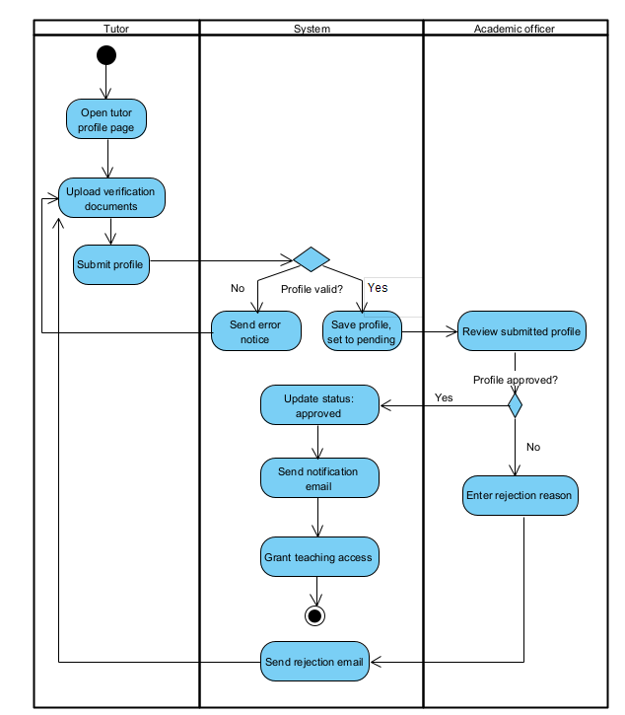
Figure 3-.2.1:Tutor Onboarding & Approval Workflow Diagram

2.2 Membership Purchase & Posting

Trigger: A registered Tutor with an approved account opens the membership page, selects a membership plan and proceeds to purchase it.
End condition: The payment is confirmed and the membership plan is activated, then the Tutor’s post is reviewed by the Academic Officer. If approved, the post is published. If the payment fails, the Tutor retries the payment. If the post is rejected, the Tutor is notified and resubmits.

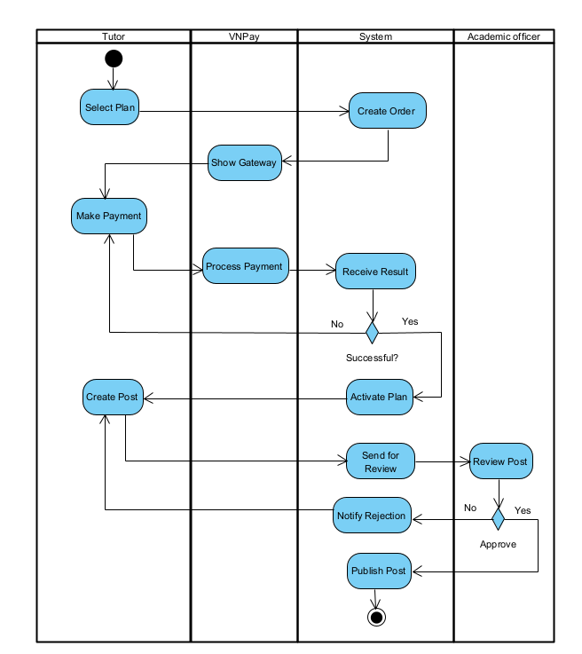
Figure 3-2.2: Membership Purchase & Posting Workflow Diagram

2.3 Search & Trial Lesson Booking
Trigger: A Learner opens the tutor search page and enters search criteria to find a tutor.
End condition: The Learner selects a suitable tutor and an open trial slot, and the Tutor confirms the request. The system then confirms the trial lesson. If the tutor is not suitable, the Learner selects another tutor from the list. If the slot is invalid, the Learner is notified of the rejection. If the Tutor declines the slot, the Learner selects another slot.\

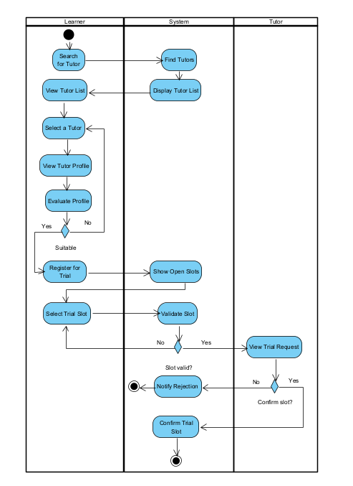
Figure 3-2.3: Search & Trial Lesson Booking Workflow Diagram

2.4 Class Management
Trigger: : A Tutor selects a connected Learner to open a class.
End condition: The class is created and the Learner joins it, then the Tutor and Learner exchange materials, homework and feedback while the membership is active. When it expires, the class becomes read-only and the Learner can only review past content.

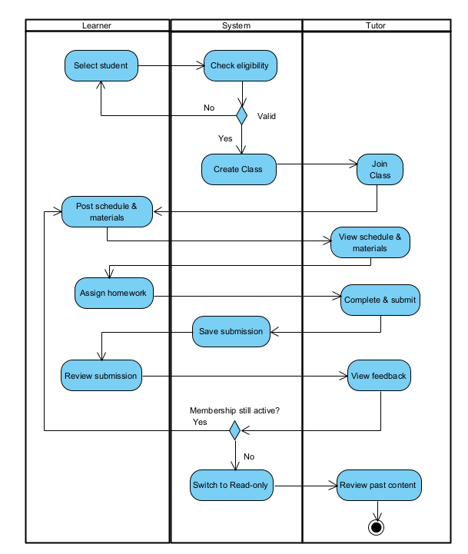
Figure 3-2.4: Class Management Workflow Diagram

3. Conceptual Data Model

3.1 Entity Relationship Diagram
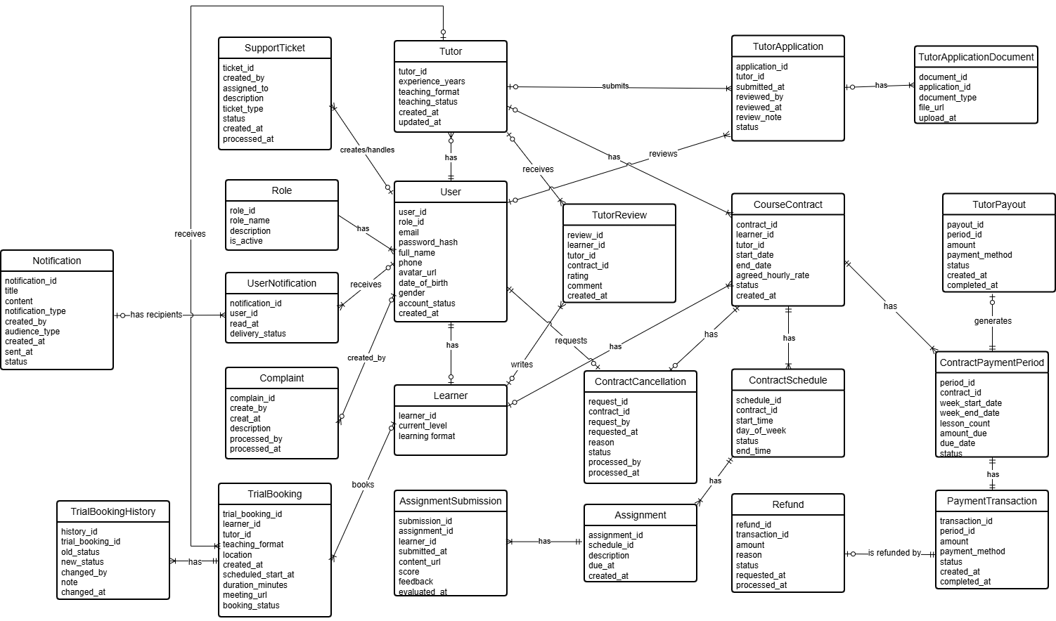
Figure 3-3.1: Entity Relationship Diagram

3.2 Entity Descriptions
Entity: User
Field | Value
Purpose | Stores core account and personal profile details for every individual with access to the system (Learners, Tutors, and Administrators).
Key business attributes | user_id, role_id, email, full_name, phone, avatar_url, date_of_birth, gender, account_status, created_at
Business identity | Email address (unique across the entire system) and Phone number.
Status / lifecycle | Active (normal) · Inactive (deactivated/unverified) · Suspended/Locked (policy violation or repeated failed logins)
Entity: Role
Field | Value
Purpose | Defines user roles and access privilege classifications across system modules and features.
Key business attributes | role_id, role_name, description, is_active
Business identity | Role name (unique across the entire system, e.g., Admin, Tutor, Learner).
Status / lifecycle | Active (currently in use) · Inactive (deprecated/disabled)
Entity: TutorProfile
Field | Value
Purpose | Maintains dedicated teaching profile, expertise credentials, and professional background for registered tutors.
Key business attributes | tutor_id, experience_years, teaching_format, teaching_status, created_at, updated_at
Business identity | Associated user_id (1-to-1 relationship with a valid User record).
Status / lifecycle | Draft · Available (open for bookings) · Busy / Unavailable (temporarily paused) · Suspended
Entities: TutorApplication
Field | Value
Purpose | Tracks onboarding applications and vetting/approval workflow for candidates applying to become tutors.
Key business attributes | application_id, tutor_id, submitted_at, reviewed_by, reviewed_at, review_note, status
Business identity | application_id / Combination of tutor_id and submitted_at date.
Status / lifecycle | Submitted · Under Review · Approved · Rejected
Entities: TutorPayout
Field | Value
Purpose | Records payout transactions made to tutors for their completed teaching services
Key business attributes | payout_id, period_id, amount, payment_method, status, created_at, completed_at
Business identity | payout_id / Each payout transaction is uniquely identified by payout_id and linked to a specific payout period through period_id.
Status / lifecycle | Pending · Processing · Completed · Failed
Entities: TutorApplicationDocument
Field | Value
Purpose | Stores supporting verification documents, certificates, degrees, and identification uploaded by tutor applicants.
Key business attributes | document_id, application_id, document_type, file_url, uploaded_at
Business identity | document_id / Combination of application_id and file_url / document_type.
Status / lifecycle | Uploaded · Verified · Rejected
Entities: LearnerProfile
Field | Value
Purpose | Holds learner-specific academic background, current skill levels, and learning preferences.
Key business attributes | learner_id, current_level, learning_format
Business identity | Associated user_id (1-to-1 relationship with a valid User record).
Status / lifecycle | Active · Inactive
Entities: TrialBooking
Field | Value
Purpose | Manages scheduling, format, and execution of introductory/trial lessons between learners and tutors.
Key business attributes | trial_booking_id, learner_id, tutor_id, teaching_format, location, scheduled_start_at, duration_minutes, meeting_url, booking_status, created_at
Business identity | trial_booking_id / Unique reservation slot between a learner and a tutor at scheduled_start_at.
Status / lifecycle | Pending · Confirmed · In Progress · Completed · Cancelled · No-Show
Entities: TrialBookingHistory
Field | Value
Purpose | Provides an immutable audit log tracking lifecycle state transitions and remarks for trial bookings.
Key business attributes | history_id, trial_booking_id, old_status, new_status, changed_by, note, changed_at
Business identity | history_id / Sequential audit log entry per trial_booking_id.
Status / lifecycle | Append-only (immutable audit log record; no status lifecycle)
Entities: CourseContract
Field | Value
Purpose | Represents formal tutoring contracts agreed between a learner and tutor, defining schedules, duration, and financial rates.
Key business attributes | contract_id, learner_id, tutor_id, start_date, end_date, agreed_hourly_rate, status, created_at
Business identity | contract_id / Contract agreement reference code.
Status / lifecycle | Draft · Active · Completed · Terminated / Cancelled
Entities: ContractSchedule
Field | Value
Purpose | Defines regular weekly recurring lesson schedules and meeting time slots under an active course contract.
Key business attributes | schedule_id, contract_id, day_of_week, start_time, end_time, status
Business identity | schedule_id / Combination of contract_id, day_of_week, and start_time.
Status / lifecycle | Scheduled · Ongoing · Paused · Cancelled
Entities: ContractCancellation
Field | Value
Purpose | Manages formal cancellation requests, justifications, and administrative review for early contract termination.
Key business attributes | request_id, contract_id, request_by, requested_at, reason, status, processed_by, processed_at
Business identity | request_id / Cancellation request record tied to a contract_id.
Status / lifecycle | Pending · Approved · Rejected
Entities: ContractPaymentPeriod
Field | Value
Purpose | Tracks recurring billing cycles (weekly/monthly) and required tuition fees due per contract.
Key business attributes | period_id, contract_id, week_start_date, week_end_date, lesson_count, amount_due, due_date, status
Business identity | period_id / Combination of contract_id and billing cycle interval (week_start_date to week_end_date).
Status / lifecycle | Unpaid / Pending · Paid · Overdue · Waived
Entities: PaymentTransaction
Field | Value
Purpose | Records financial transaction executions, payment gateways, and settlement receipts for tuition billing periods.
Key business attributes | transaction_id, period_id, amount, payment_method, status, created_at, completed_at
Business identity | transaction_id / External payment gateway reference number.
Status / lifecycle | Pending · Processing · Success · Failed
Entities: Refund
Field | Value
Purpose | Manages refund processing, reason verification, and payout disbursement for cancelled sessions or billing adjustments.
Key business attributes | refund_id, transaction_id, amount, reason, status, requested_at, processed_at
Business identity | refund_id / Refund transaction reference number.
Status / lifecycle | Requested · Approved · Processing · Refunded · Rejected
Entities: TutorReview
Field | Value
Purpose | Captures performance evaluation, star ratings, and subjective feedback submitted by learners for their tutors.
Key business attributes | review_id, learner_id, tutor_id, contract_id, rating, comment, created_at
Business identity | review_id / Unique evaluation per learner_id and contract_id pair.
Status / lifecycle | Published · Hidden / Flagged (moderated by Admin)
Entities: Assignment
Field | Value
Purpose | Stores homework, exercises, and learning tasks assigned by tutors to learners following scheduled sessions.
Key business attributes | assignment_id, schedule_id, description, due_at, created_at
Business identity | assignment_id / Task title and issue timestamp per schedule_id.
Status / lifecycle | Open (active) · Closed / Past Due
Entities: AssignmentSubmission
Field | Value
Purpose | Stores learner homework submissions, attachments, along with tutor grades and evaluation feedback.
Key business attributes | submission_id, assignment_id, learner_id, content_url, score, feedback, submitted_at, evaluated_at
Business identity | submission_id / Submission per learner_id and assignment_id.
Status / lifecycle | Submitted · Late Submitted · Graded
Entities: Notification
Field | Value
Purpose | Stores system-wide and targeted notifications, alert messaging, and transmission dispatch status.
Key business attributes | notification_id, title, content, notification_type, audience_type, created_by, created_at, sent_at, status
Business identity | notification_id.
Status / lifecycle | Draft · Queued · Sent · Read · Failed
Entities: UserNotification
Field | Value
Purpose | Stores notifications delivered to users and tracks their read status and delivery status.
Key business attributes | notification_id, user_id, read_at, delivery_status
Business identity | notification_id / Each notification is uniquely identified by notification_id and associated with a specific user through user_id
Status / lifecycle | Pending · Sent · Delivered · Failed / Read status is tracked through read_at; a NULL value indicates the notification has not been read.
Entities: Complaint
Field | Value
Purpose | Handles formal user complaints and disputes regarding service delivery, teaching conduct, or technical problems.
Key business attributes | complain_id, create_by, description, created_at, processed_by, processed_at
Business identity | complain_id / Formal incident dispute case number.
Status / lifecycle | Submitted · Under Investigation · Resolved · Dismissed
Entities: SupportTicket
Field | Value
Purpose | Tracks customer service and technical support inquiries, assignments, and resolution workflows.
Key business attributes | ticket_id, created_by, assigned_to, ticket_type, description, status, created_at, processed_at
Business identity | ticket_id / Support inquiry tracking code.
Status / lifecycle | Open · In Progress · Resolved · Closed

3.3 Data Business Rules
Rule | Description | Enforced On
Unique email address | No two users may share the same email address across the entire system, regardless of whether their role is Learner, Tutor, or Admin. | Account registration and email update
Single role-specific profile | A User account can be linked to at most one TutorProfile and/or one LearnerProfile. Duplicate profile records for the same user ID are prohibited. | Profile creation
Active tutor requirement for bookings | Learners may only book a trial session (TrialBooking) or enter into a contract (CourseContract) with tutors whose teaching_status is 'Available' and application status is 'Approved'. | Trial booking and Contract creation
No concurrent trial booking overlap | A Tutor cannot be booked for multiple trial sessions or contractual classes sharing the same scheduled time interval (preventing double-booking). | Trial booking creation and rescheduling
Immutable trial booking history | Records in TrialBookingHistory are strictly append-only. Once logged, history records cannot be modified or deleted by any user or administrator to preserve audit integrity. | Trial booking status transition
One active application at a time | A tutor cannot submit a new TutorApplication while an existing application is currently in 'Submitted' or 'Under Review' status. | Tutor application submission
Verified document access control | Tutor verification documents (degrees, certificates, identity cards) stored in TutorApplicationDocument must never be publicly exposed via guessable URLs and are strictly restricted to authorized reviewers and administrators. | Document upload and document viewing/download
Contract date chronological consistency | In CourseContract, end_date must always be strictly greater than or equal to start_date, and agreed_hourly_rate must be a positive non-zero value. | Contract drafting and signing
Active contract required for schedules & lessons | Contract schedules, weekly billing periods, and assignments can only be created and executed under CourseContracts with status 'Active'. | Schedule creation and Assignment dispatch
Immutable published reviews | Once a learner submits a TutorReview (rating and comments) for a contract, the rating score and review cannot be edited by the tutor, and only administrators may flag or hide abusive content. | Review submission and moderation
One review per completed contract | A learner is permitted to submit only one TutorReview per completed CourseContract to prevent rating inflation or spam. | Review creation
Cancellation requires pending approval | A CourseContract cannot be terminated immediately by a single party; it must transition through a ContractCancellation request reviewed and processed by system administrators or mutual agreement. | Contract termination request
Soft delete / Account deactivation only | User accounts and contracts with financial transaction history are never permanently deleted from the database. They must be transitioned to 'Inactive' or 'Terminated' to retain audit trails. | Account deactivation and data deletion requests
Payment settlement before payout | TutorPayout records can only be authorized and disbursed for a billing period after the corresponding ContractPaymentPeriod has achieved status 'Paid' via successful PaymentTransaction. | Tutor payout calculation and processing
Refund bounded by transaction amount | The amount requested in a Refund cannot exceed the net settled amount of the associated PaymentTransaction. | Refund request creation and approval
Assignment submission deadline enforcement | Submissions timestamped after the assignment's due_at must automatically be flagged with status 'Late Submitted' and cannot be accepted if late submissions are locked. | Assignment submission

4. User Requirements

4.1 Actors
# | Actor | Description
1 | Learner | Provides account information, tutor search criteria, trial lesson and agreement requests, payments, assignment submissions, reviews, and complaints. Receives tutor suggestions, lesson schedules, notifications, and request statuses.
2 | Tutor | Provides registration and profile information, certificates and supporting documents for qualification verification, and receives verification results. Responds to booking requests, manages teaching schedules and attendance, creates assignments, grades learner submissions, and provides feedback.
3 | Customer Service Staff | Receives support requests, complaints, and relevant learner, tutor, and contract information. Provides support responses, proposes dispute resolutions, and refers requests for further handling.
4 | Administrator | Provides system configurations, commission settings, and account management actions. Receives system statistics, financial dashboard information, and management requests.
5 | Academic Officer | Receives tutor applications pending approval and related notifications. Reviews tutor qualifications and provides approval or rejection results.
6 | Manager | Receives requests, payment and transaction information, and staff and user information. Performs expense, staff, user account, and request management.
7 | Google Mail Service | Receives email delivery requests from the system and sends OTPs, account activation emails, payment notifications, and progress reports to users.
8 | Google Map Service | Receives location queries and address lookup requests. Provides location data and distance information to support tutor searches.
9 | VNPAY | Receives payment, fund release, refund, and tutor payout requests. Processes transactions and returns confirmations and transaction statuses.

4.2 Use Cases (UC)
ID | Use Case | Feature | Use Case Description
UC-01 | Log In | Authentication & Authorization | Allows users to authenticate and access functions according to their roles and permissions.
UC - 02 | Register Account | Authentication & Authorization | Allows users to create their new account
UC-03 | Log Out | Authentication & Authorization | Allows users to end their current session.
UC-04 | Change Password | Authentication & Authorization | Allows users to change their current password.
UC-05 | Reset Password | Authentication & Authorization | Allows users to reset a forgotten password and recover account access.
UC-06 | Create Staff Account | Authentication & Authorization | Allows the Administrator to create an account for a staff member.
UC-07 | Update Roles and Permissions | Authentication & Authorization | Allows the Administrator to update user roles and access permissions.
UC-08 | Ban Staff Account | Authentication & Authorization | Allows the Administrator to block a staff account from accessing the system.
UC-09 | View Staff List | Authentication & Authorization | Allows the Manager to view the list of staff members.
UC-10 | View Staff Details | Authentication & Authorization | Allows the Manager to view a selected staff member’s detailed information.
UC-11 | Update Staff Information | Authentication & Authorization | Allows the Manager to update a staff member’s information.
UC-12 | Update Tutor and Learner Status | Authentication & Authorization | Allows the Manager to change the account status of tutors and learners.
UC-13 | View System Logs | Authentication & Authorization | Allows the Administrator to review system activities and audit records.
UC-14 | Configure System Settings | Authentication & Authorization | Allows the Administrator to update system configurations.
UC-15 | View System Statistics | Authentication & Authorization | Allows the Administrator to monitor system usage and operational metrics.
UC-17 | Export System Reports | Authentication & Authorization | Allows the Administrator to export reports and system data.
UC-18 | View Profile | Learner & Tutor Profile Management | Allows the Learner or Tutor to view profile information.
UC-19 | Update Profile | Learner & Tutor Profile Management | Allows the Learner or Tutor to update profile information.
UC-20 | View Tutor and Learner List | Learner & Tutor Profile Management | Allows the Manager to view the list of tutors and learners.
UC-21 | View Tutor and Learner Details | Learner & Tutor Profile Management | Allows the Manager to view a selected tutor’s or learner’s detailed information.
UC-22 | View Tutor Verification Form | Tutor Verification | Allows the Tutor to view the information and documents required for verification.
UC-23 | Update Verification Information | Tutor Verification | Allows the Tutor to update verification information, certificates, and supporting documents.
UC-24 | Submit Tutor Verification Application | Tutor Verification | Allows the Tutor to submit profile information, certificates, and supporting documents for verification.
UC-25 | View Verification Applications | Tutor Verification | Allows the Academic Officer to view submitted tutor verification applications.
UC-26 | Request Additional Verification Information | Tutor Verification | Allows the Academic Officer to request missing information or additional documents from a tutor.
UC-27 | Review Tutor Verification Application | Tutor Verification | Allows the Academic Officer to review a tutor’s qualifications and supporting documents.
UC-28 | Approve or Reject Tutor Application | Tutor Verification | Allows the Academic Officer to approve or reject a tutor verification application.
UC-29 | Search Tutors | Tutor Search & Connection | Allows the Learner to search for tutors using criteria and filters.
UC-30 | View Tutor List | Tutor Search & Connection | Allows the Learner to browse available tutors and their basic information.
UC-31 | View Tutor Profile Details | Tutor Search & Connection | Allows the Learner to view a tutor’s profile, qualifications, and teaching experience.
UC-32 | Book Trial Lesson | Trial Lesson Booking & Learning Activation | Allows the Learner to request a trial lesson with a selected tutor.
UC-33 | Cancel Trial Booking | Trial Lesson Booking & Learning Activation | Allows the Learner to cancel a trial lesson booking according to applicable rules.
UC-34 | Reschedule Trial Lesson | Trial Lesson Booking & Learning Activation | Allow learners or tutor to request a change to the date or time of a trial session
UC-35 | View Lesson Calendar | Trial Lesson Booking & Learning Activation | Allows the Learner to view scheduled lessons in a calendar.
UC-36 | Request Lesson Reschedule | Trial Lesson Booking & Learning Activation | Allows the Learner or Tutor to request a change to a scheduled lesson’s date or time.
UC-37 | View Trial Bookings | Trial Lesson Booking & Learning Activation | Allows the Tutor to view trial lesson booking requests.
UC-38 | View Trial Booking Details | Trial Lesson Booking & Learning Activation | Allows the Tutor to view the learner information and requested schedule of a trial booking.
UC-39 | Process Trial Booking | Trial Lesson Booking & Learning Activation | Allows the Tutor to accept or reject a trial lesson booking request.
UC-40 | Create Teaching Schedule | Trial Lesson Booking & Learning Activation | Allows the Tutor to create a schedule for teaching sessions.
UC-41 | View Teaching Schedule | Trial Lesson Booking & Learning Activation | Allows the Tutor to view scheduled teaching sessions.
UC-42 | Update Teaching Schedule | Trial Lesson Booking & Learning Activation | Allows the Tutor to modify an existing teaching schedule.
UC-43 | View System Terms and Policies | System Administration & Operational Reporting | Allows Learner or Tutor to view the system’s terms of service, usage policies, and other relevant system regulations
UC-44 | View Tutor Membership List | Membership & Payment Management | Allows the Manager to view the list of tutors who have registered for paid membership
UC-45 | View Tutor Membership Details | Membership & Payment Management | Allows the Manager to view detailed information about a tutor's membership
UC-46 | View Support Ticket | Support Ticket & Escalation | Allows the Learner or Tutor to view a support ticket’s details, responses, and status.
UC-47 | Submit Support Ticket | Support Ticket & Escalation | Allows the Learner or Tutor to submit a request for assistance.
UC-48 | View Referred Support Requests | Support Ticket & Escalation | Allows the Manager to view support requests referred by Customer Service Staff.
UC-49 | View Referred Support Request Details | Support Ticket & Escalation | Allows the Manager to review a referred request’s details and previous handling.
UC-50 | Process Referred Support Request | Support Ticket & Escalation | Allows the Manager to determine a handling approach or approve a solution for a referred request.
UC-51 | Send Support Resolution | Support Ticket & Escalation | Allows the Manager to return a handling result to Customer Service Staff for follow-up with the requester.
UC-52 | View Support Ticket List | Support Ticket & Escalation | Allows Customer Service Staff to view support tickets requiring review or follow-up.
UC-53 | Send Support Ticket Response | Support Ticket & Escalation | Allows Customer Service Staff to send a response or guidance to the requester.
UC-54 | Refer Support Request to Manager | Support Ticket & Escalation | Allows Customer Service Staff to refer a request requiring the Manager’s authority or assistance.
UC-55 | Handle Support Ticket | Support Ticket & Escalation | Allows Customer Service Staff to review a request, obtain additional information, provide assistance, and record the outcome.
UC-56 | Practice Kanji Writing | Learning Support | Allows Learners to practice writing Japanese Kanji characters and improve their writing skills
UC-57 | Take Placement Test | Learning Support | Allows the Learner to complete a placement test to assess their Japanese proficiency.
UC-58 | View Course | Classroom & Learning Materials Management | Allows the Learner to view course information and related learning activities.
UC-59 | View Learning Progress | Learning Support | Allows the Learner to review learning progress and assessment results.
UC-60 | Submit Tutor Review | Learning Support | Allows the Learner to submit a rating and review of a tutor.
UC-61 | View Learning Materials | Classroom & Learning Materials Management | Allows the Learner and Tutor to access learning materials available to them.
UC-62 | Study Flashcards | Learning Support | Allows the Learner to study and review learning content using flashcards.
UC-63 | View Assignments | Classroom & Learning Materials Management | Allows the Learner and Tutor to view assignments and their submission or grading statuses.
UC-64 | Submit Assignment | Classroom & Learning Materials Management | Allows the Learner to upload and submit completed assignment work.
UC-65 | Upload Learning Materials | Classroom & Learning Materials Management | Allows the Tutor to upload study materials for learners to access.
UC-66 | Create and Assign Assignment | Classroom & Learning Materials Management | Allows the Tutor to create an assignment, attach materials, set a deadline, and assign it to a learner.
UC-67 | Grade Assignment | Classroom & Learning Materials Management | Allows the Tutor to review a submission and publish a grade and feedback.
UC-68 | Create Progress Report | Learning Support | Allows the Tutor to create a report summarizing a learner’s progress and areas for improvement.
UC-69 | Submit Learner Feedback | Learning Support | Allows the Tutor to provide feedback on a learner’s performance and participation.
UC-70 | Configure Notification Preferences | Notification Management | Allows users to update their notification preferences.
UC-71 | View Notifications | Notification Management | Allows users to view notifications addressed to them.
UC-72 | Mark Notification as Read | Notification Management | Allows users to mark a notification as read.
UC-73 | Delete Notification | Notification Management | Allows users to remove a notification from their notification list.
UC-74 | Broadcast Notifications | Notification Management | Allows the Administrator to send a notification to a selected group of users.
UC-75 | View Notification History | Notification Management | Allows the Administrator to review previously sent notifications.
UC-76 | Send Notification to All Users | Notification Management | Allows the Administrator to send a system-wide notification to all users.
UC-77 | View Recommended Tutors | Tutor Search & Connection | Allows Learners to view tutors recommended according to their learning needs and goals
UC-78 | Send Connection Request | Tutor Search & Connection | Allows Learners to send connection requests to selected Tutors.
UC-79 | View Sent Connection Requests | Tutor Search & Connection | Allows Learners to view their sent connection requests and track their statuses.
UC-80 | Cancel Connection Request | Tutor Search & Connection | Allows Learners to cancel sent connection requests and record the reasons.
UC-81 | Create Tutor Profile | Learner & Tutor Profile Management | Allows Tutors to create their professional profiles and provide information about their teaching capabilities.
UC-82 | View Verification Status | Tutor Verification | Allows Tutors to track the verification status of their own profiles.
UC-83 | View Verification Feedback | Tutor Verification | Allows Tutors to view rejection reasons or requests for additional information regarding their verification submissions.
UC-84 | View Verification History | Tutor Verification | Allows Academic Officers to view previous verification reviews and decisions.
UC-85 | View Connection Request Status | Tutor Search & Connection | Allows Learners to view the current status of their connection requests.
UC-86 | View Received Tutor Response | Tutor Search & Connection | Allows Learners to view Tutors' responses to their connection requests.
UC-87 | View Received Connection Requests | Tutor Search & Connection | Allows Tutors to view connection requests received from Learners.
UC-88 | View Connection Request Details | Tutor Search & Connection | Allows Tutors to view Learners' learning needs and relevant connection request information.
UC-89 | Accept Connection Request | Tutor Search & Connection | Allows Tutors to accept connection requests from Learners.
UC-90 | Reject Connection Request | Tutor Search & Connection | Allows Tutors to reject connection requests according to applicable policies.
UC-91 | View Booking Support Requests | Support Ticket & Escalation | Allows Customer Service Staff to view support requests related to trial lesson bookings.
UC-92 | Assist with Connection Issues | Support Ticket & Escalation | Allows Customer Service Staff to assist with issues arising during tutor–learner connection.
UC-93 | Access Classroom | Classroom & Learning Materials Management | Allows Tutors to add Learners to a classroom and activate learning support features for them.
UC-94 | Update Learning Materials | Classroom & Learning Materials Management | Allows Tutors to edit or replace previously uploaded learning materials.
UC-95 | Update Assignments | Homework, Assessment & Progress Tracking | Allows Tutors to modify assignment content or deadlines under permitted conditions.
UC-96 | Resubmit Assignments | Homework, Assessment & Progress Tracking | Allows Learners to resubmit revised Assignments after making corrections.
UC-97 | View Membership Expiry Date | Membership & Payment Management | Allows Tutors to view the expiration date of their current membership.
UC-98 | Handle Payment Issues | Membership & Payment Management | Allows Administrators to investigate and resolve technical issues related to payment processing.
UC-99 | Configure Membership Pricing | Membership & Payment Management | Allows Managers to configure prices for membership plans.
UC-100 | Manage Membership Benefits | Membership & Payment Management | Allows Managers to configure the benefits associated with each membership plan.
UC-101 | Manage Booking Policy Configuration | System Administration & Operational Reporting | Allows Administrators to configure system parameters for enforcing approved booking policies.
UC-102 | Monitor System Health | System Administration & Operational Reporting | Allows Administrators to monitor system performance, availability, and operational health.
UC-103 | Handle Technical Incidents | System Administration & Operational Reporting | Allows Administrators to investigate and resolve technical incidents.
UC-104 | Payment Membership | Membership & Payment Management | Allows Tutors to select a membership plan and complete payment

4.3 Use Case Diagrams

4.3.1 UCs for Guest
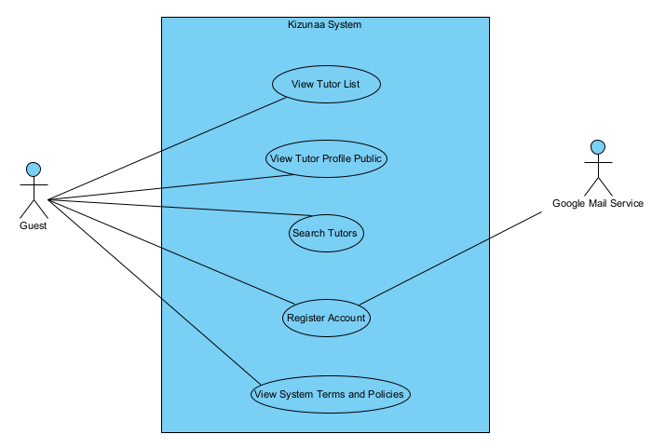
Figure 3-4.3.1:UCs for Guest

4.3.2 UCs for Register User
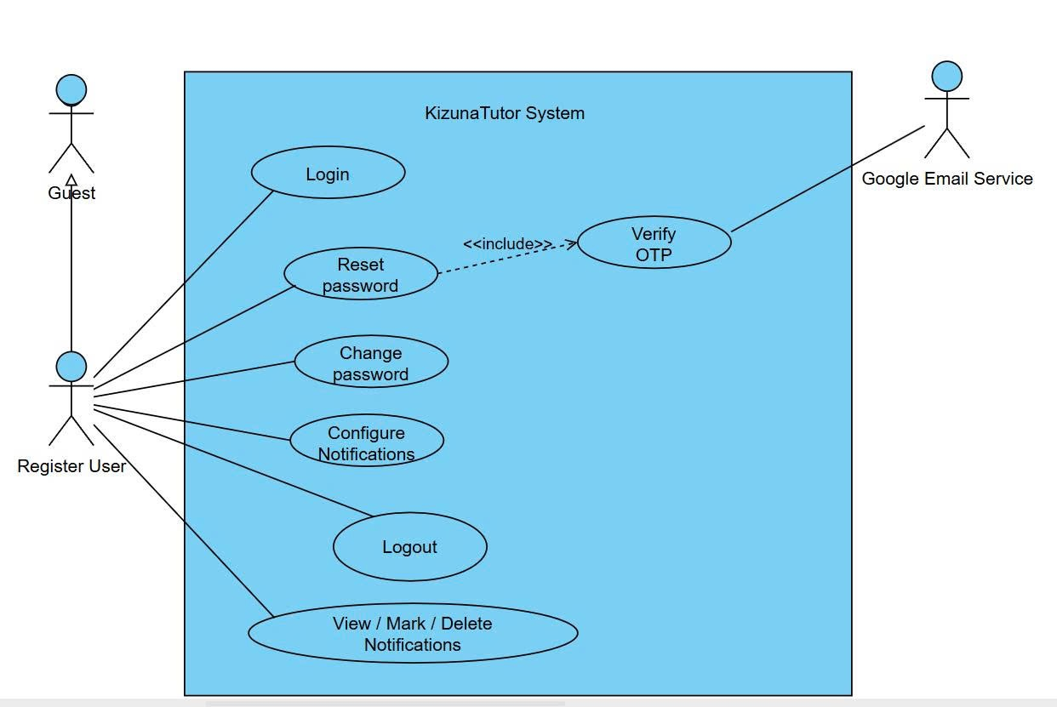
Figure 3- 4.3.2:UCs for Register User

4.3.3 UCs for Learner
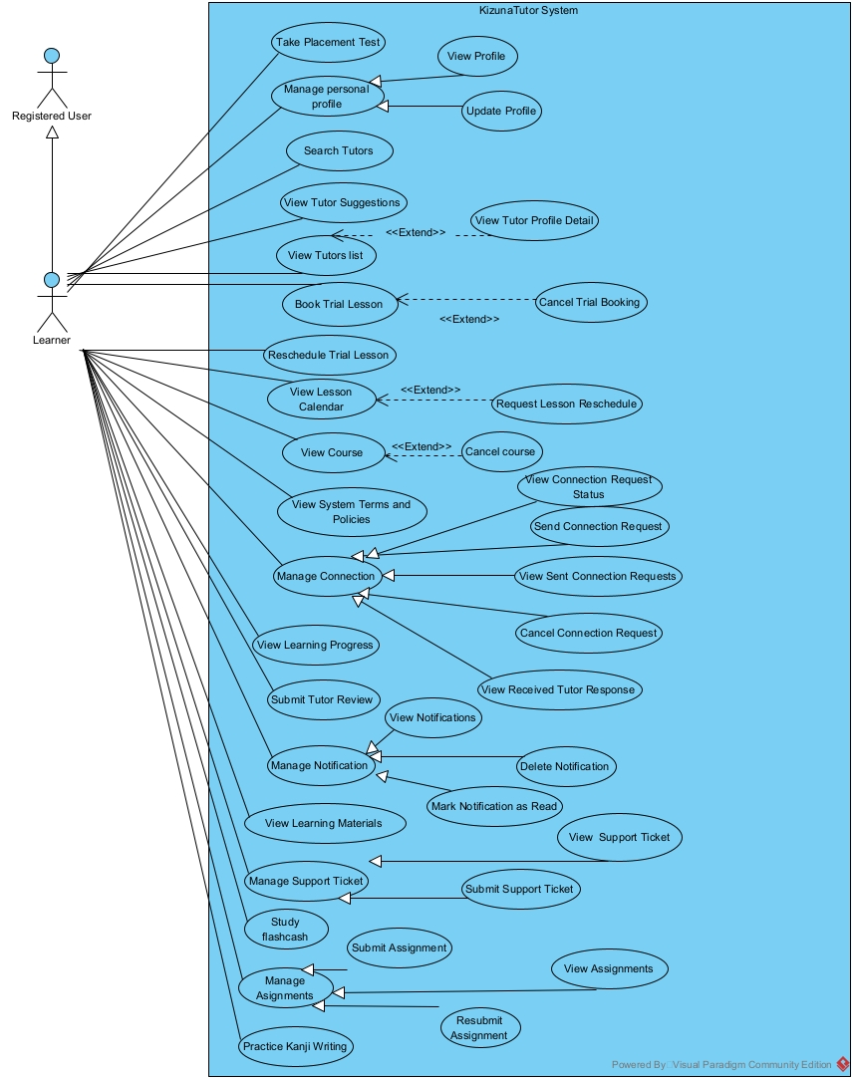
Figure 3-4.3.3: UCs for Learner

4.3.4 UCs for Tutor
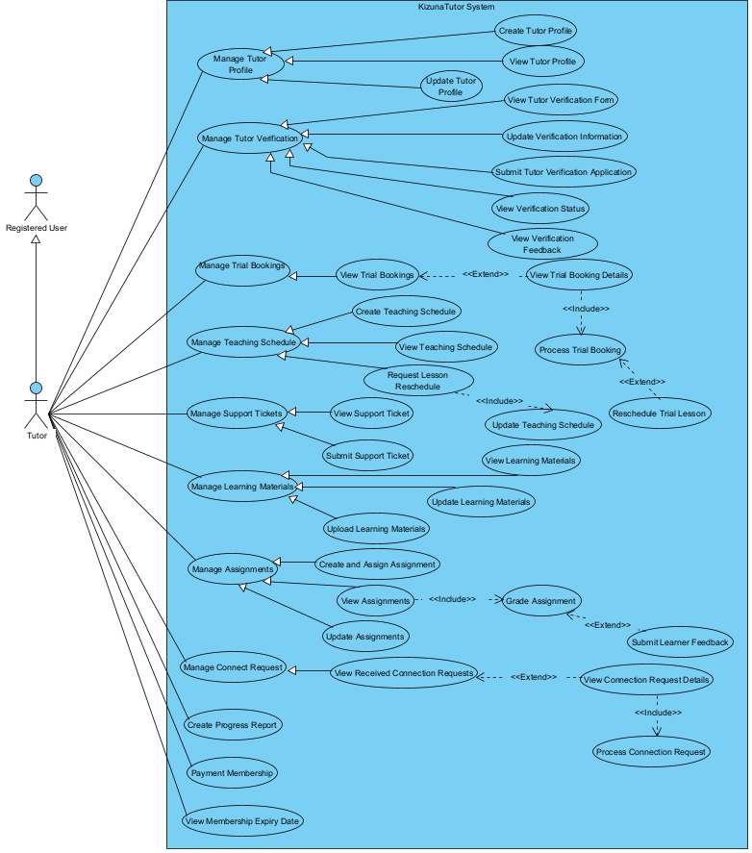
Figure 3-4.3.4: UCs for Tutor

4.3.5 UCs for Academic Officer
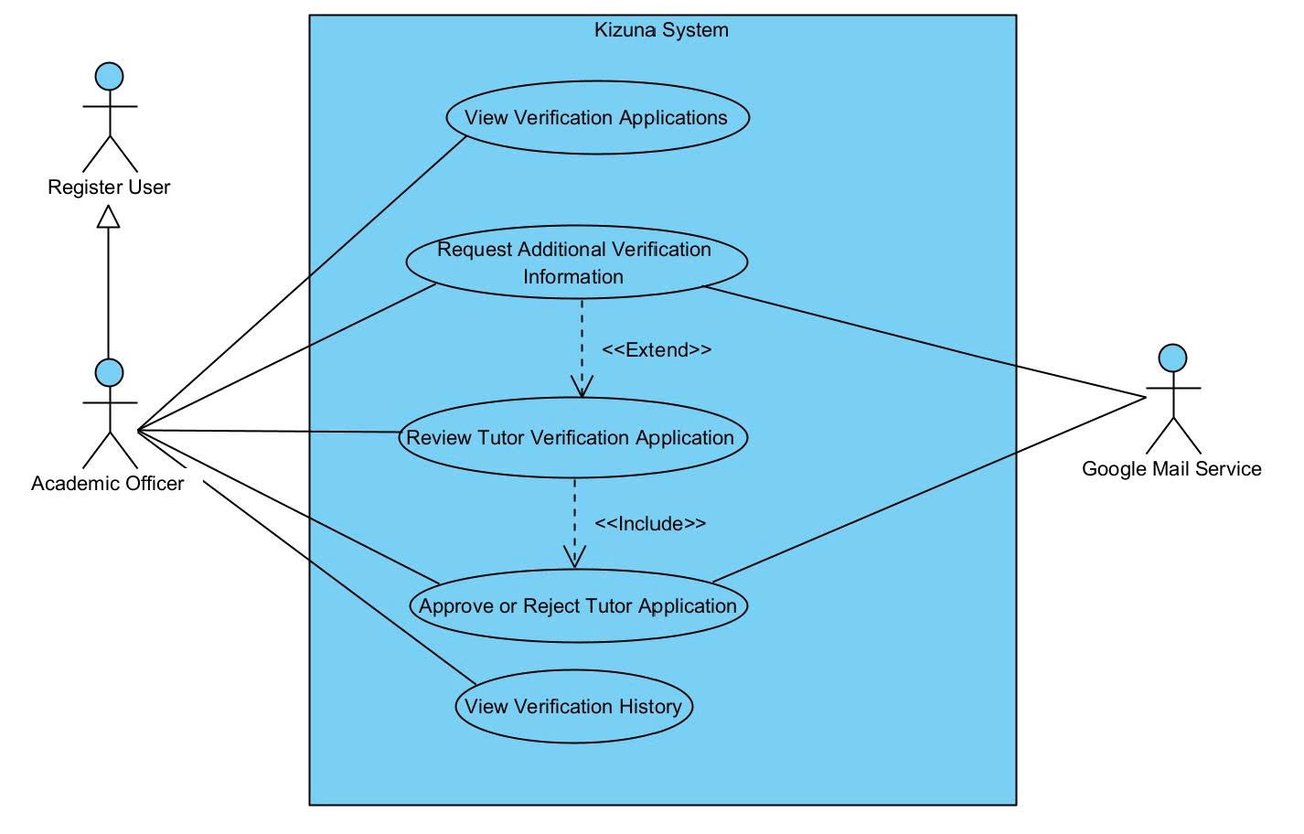
Figure 3-4.3.5: UCs for Academic Officer

4.3.6 UCs for CS Staff
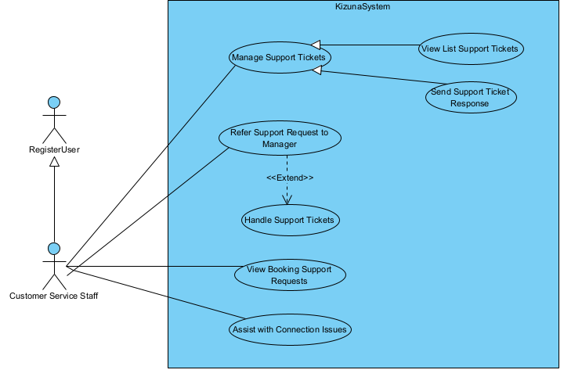
Figure 3-4.3.6: UCs for CS Staff

4.3.7 UCs for Admin
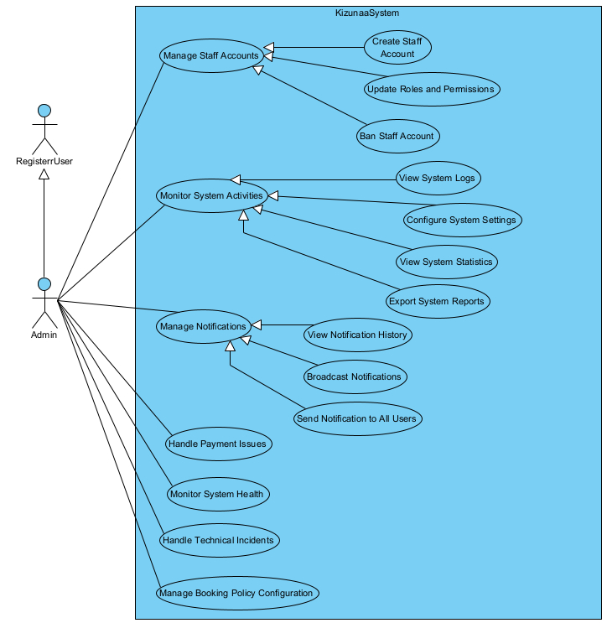
Figure 3-4.3.7: UCs for Admin

4.3.8 UCs for Manager
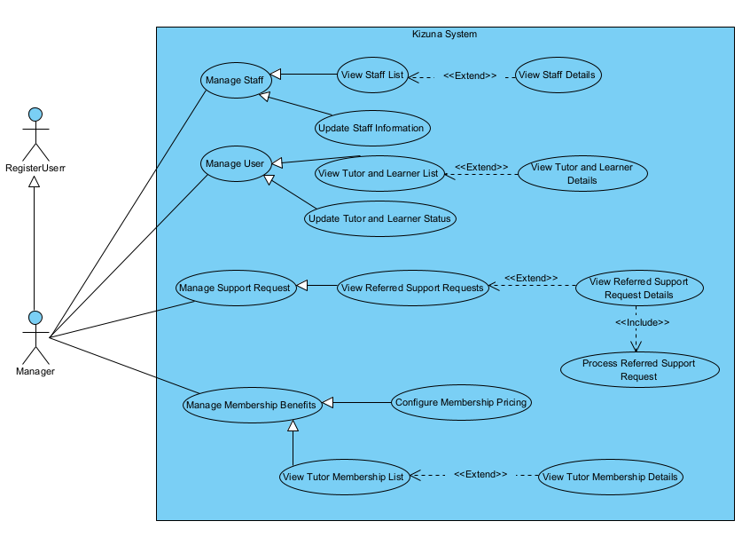
Figure 3-4.3.3: UCs for Manager

4.4 Permission Matrix
Full = unrestricted · Restricted = conditions apply (see footnotes) · No = denied
Entity | Action | Admin | HR Manager | Interviewer | Candidate | Guest
User account | Log in / Log out | Restricted | Restricted | Restricted | Restricted | Restricted
User account | Change / Reset password | Restricted | Restricted | Restricted | Restricted | Restricted
Staff account | Create | Full | No | No | No | No
Staff account | Ban | Full | No | No | No | No
Roles and permissions | Update | Full | No | No | No | No
Staff information | View list / View details | No | Full | No | No | No
Staff information | Update | No | Full | No | No | No
Tutor and learner account | Update status | No | Full | No | No | No
System logs | View | Full | Full | No | No | No
System settings | Configure | Full | No | No | No | No
System statistics | View | Full | Full | No | No | No
System reports | Export | Full | Full | No | No | No
Learning location | Set | No | No | No | No | No
Teaching profile | View own details | No | No | No | No | Restricted
Teaching profile | Update | No | No | No | No | Restricted
Tutor and learner profile | View list / View details | No | Full | No | No | No
Tutor verification form | View | No | No | No | No | Restricted
Tutor verification information | Update / Upload certificates and documents | No | No | No | No | Restricted
Tutor verification application | Submit | No | No | No | No | Restricted
Tutor verification application | View list / Review | No | No | Full | No | No
Tutor verification application | Request additional information | No | No | Full | No | No
Tutor verification application | Approve / Reject | No | No | Full | No | No
Tutor search category | Create / Update / Delete / View | Full | Full | No | No | No
Tutor search | Search / Smart search | No | No | No | No | No
Tutor suggestions | View | No | No | No | No | No
Tutor profile | Browse list / View details | No | No | No | No | No
Trial booking | Book | No | No | No | No | No
Trial booking | Cancel | No | No | No | No | No
Trial booking | View list / View details | No | No | No | No | Restricted
Trial booking | Accept / Reject | No | No | No | No | Restricted
Lesson calendar | View | No | No | No | No | No
Lesson schedule | Request reschedule | No | No | No | No | No
Course | Cancel | No | No | No | No | No
Teaching schedule | Create / View / Update | No | No | No | No | Restricted
Teaching session | Check in / Check out | No | No | No | No | Restricted
Tutoring agreement | Review / Sign | No | No | No | No | Restricted
Tutoring agreement | Request early termination | No | No | No | No | Restricted
Commission rate | Configure | Full | Full | No | No | No
Financial dashboard and reports | View | Full | Full | No | No | No
Trial lesson deposit | Pay | No | No | No | No | No
Tuition | Pay | No | No | No | No | No
Payment history and status | View | No | No | No | No | No
Refund request | View list / View details | No | Full | No | No | No
Refund request | Approve / Reject | No | Full | No | No | No
Approved refund | View / Process | No | Restricted⁵ | No | No | No
Session payment | View | No | Full | No | No | No
Session payment | Check disbursement eligibility | No | Full | No | No | No
Session payment | Disburse | No | Restricted | No | No | No
Tutor payout | View | No | Full | No | No | No
Tutor earnings | Review | No | Full | No | No | No
Tutor payout | Send payout order | No | Restricted | No | No | No
Operating cost | View list / View details / Record | No | Full | No | No | No
Complaint | Submit / Submit evidence | No | No | No | No | No
Support ticket | Submit | No | No | No | No | Restricted
Support ticket | View own ticket | No | No | No | No | No
Support work | Assign to staff | No | Full | No | No | No
Referred support request | View list / View details | No | Restricted | No | No | No
Referred support request | Process / Send handling result | No | Restricted | No | No | No
Support ticket | View list | No | No | No | Full | No
Support ticket | Handle / Send response | No | No | No | Restricted | No
Support ticket | Refer to Manager | No | No | No | Restricted | No
Complaint | Propose resolution | No | No | No | Restricted | No
Complaint | Track / Close | No | No | No | Restricted | No
Placement test | Take | No | No | No | No | No
Course | View | No | No | No | No | No
Learning progress | View | No | No | No | No | No
Tutor review | Submit | No | No | No | No | No
Learning material | View | No | No | No | No | Restricted
Learning material | Upload | No | No | No | No | Restricted
Flashcard | Study | No | No | No | No | No
Assignment | View | No | No | No | No | Restricted
Assignment | Create / Assign | No | No | No | No | Restricted
Assignment submission | Submit | No | No | No | No | No
Assignment submission | Grade / Publish feedback | No | No | No | No | Restricted
Learning progress report | Create | No | No | No | No | Restricted
Learner feedback | Submit | No | No | No | No | Restricted
Notification preferences | Configure | Restricted | Restricted | Restricted | Restricted | Restricted
Notification | View / Mark as read / Delete | Restricted | Restricted | Restricted | Restricted | Restricted
Notification | Broadcast to selected users | Full | No | No | No | No
Notification history | View | Full | No | No | No | No
Notification | Send to all users | Full | No | No | No | No

5. System Functionalities

5.1 Screen Inventory

a. Screen Flow
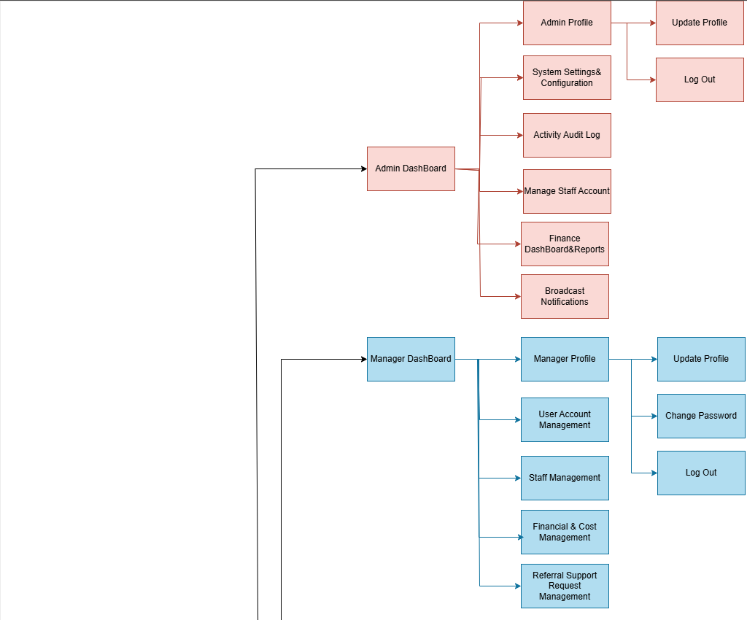
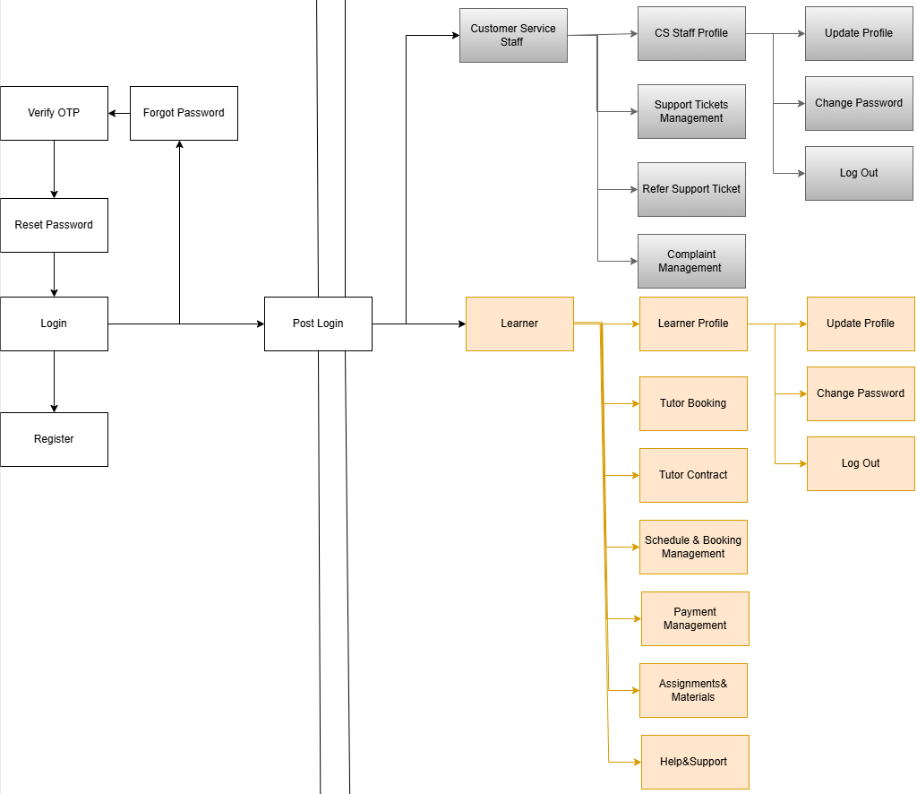
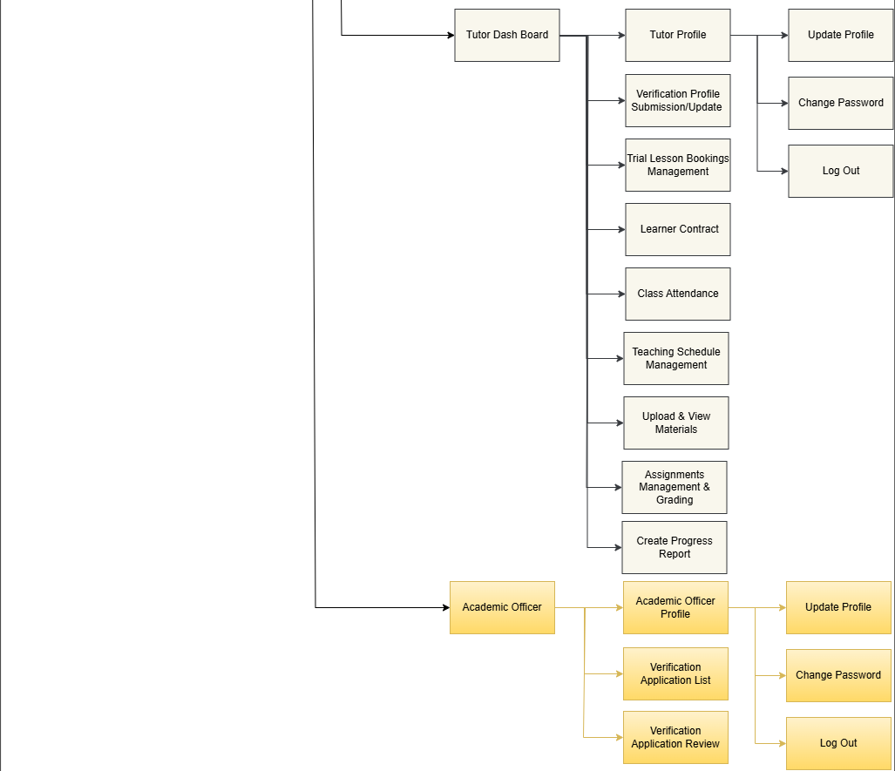
Figure 3-5.1: Screen Flow Diagram

b. Screen List
# | Screen Name | Feature | Description
1 | Sign In | Authentication | Allows any user to enter credentials to log in to the system.
2 | Register | Authentication | Allows new users to create a Learner or Tutor account.
3 | Forgot Password | Authentication | Allows users to enter their email to request a password reset.
4 | Verify OTP | Authentication | Allows users to enter the OTP sent to their email to confirm identity.
5 | Reset Password | Authentication | Allows users to set a new password after successful OTP verification.
6 | Post Login | Authentication | Directs users to their correct role-specific dashboard after logging in.
7 | User Profile & Password | Account Management | Allows users to view, update personal details, change password, or log out.
8 | Admin Dashboard | System Analytics | Displays key system metrics, activity overviews, and platform management tools.
9 | System Settings & Configuration | System Control | Allows Admin to set general system parameters, search categories, and commission rates.
10 | Activity Audit Log | Security & Tracking | Displays detailed logs of user activities and system actions for security auditing.
11 | Manage Staff Account | Account Management | Allows Admin to create, update roles, assign permissions, or ban staff accounts.
12 | Financial Dashboard & Reports | Finance Reporting | Displays total platform revenue, commission earnings, and exports system reports.
13 | Broadcast Notifications | Notification Management | Allows Admin to create and send mass notifications to all system users.
14 | Manager Dashboard | Operations Overview | Displays operational summary, pending approvals, and staff workload indicators.
15 | User Account Management | User Oversight | Allows Manager to view and update the operational status of learners and tutors.
16 | Staff Management | Staff Account Management | Allows Manager to view staff lists, check profile details, and assign tasks to staff.
17 | Financial & Cost Management | Payment Management | Centralizes refund approvals, session disbursements, tutor payouts, and operational expense tracking.
18 | Referral Support Request Management | Complaints & Support Ticket Management | Allows Manager to review and handle complex support requests referred by CS staff.
19 | CS Staff Dashboard | Support Overview | Displays daily incoming support tickets, assigned tasks, and complaint queues.
20 | Support Tickets Management | Complaints & Support Ticket Management | Allows CS staff to view, reply to, track, and close user support tickets.
21 | Refer Support Ticket | Complaints & Support Ticket Management | Allows CS staff to forward complex or high-priority tickets to the Manager.
22 | Complaint Management | Complaints & Support Ticket Management | Allows CS staff to process complaints, view evidence, and propose resolutions.
23 | Academic Officer Dashboard | Tutor Onboarding & Verification | Displays pending tutor verification applications and review status statistics.
24 | Verification Application List | Tutor Onboarding & Verification | Displays all submitted tutor verification files waiting for screening.
25 | Verification Application Review | Tutor Onboarding & Verification | Allows Academic Officer to review tutor credentials, request missing details, and approve or reject applications.
26 | Tutor Dashboard | Teaching Summary | Displays upcoming class schedules, trial bookings, student list, and total earnings.
27 | Verification Profile Submission | Tutor Onboarding & Verification | Allows tutors to upload degree certificates, ID documents, and submission details for academic officer approval.
28 | Trial Lesson Bookings Management | Lesson Scheduling & Attendance | Allows tutors to view, accept, process, or manage trial lesson requests from learners.
29 | Teaching Schedule Management | Lesson Scheduling & Attendance | Allows tutors to set up, update, and manage their available teaching time slots.
30 | Class Attendance | Lesson Scheduling & Attendance | Allows tutors to perform Check-In and Check-Out for each scheduled teaching session.
32 | Upload & View Materials | Learning Support | Allows tutors to upload documents, flashcards, and share study materials with students.
33 | Assignments Management & Grading | Learning Support | Allows tutors to create homework, view student submissions, and grade assignments.
34 | Create Progress Report | Learning Support | Allows tutors to write progress reports and submit feedback on student performance.
35 | Learner Dashboard | Student Overview | Displays upcoming lessons, enrolled courses, learning progress, and notifications.
36 | Tutor Booking | Tutor Search | Allows learners to search tutors (Smart Search), view detailed profiles, book trial lessons, and pay deposits.
37 | Schedule & Booking Management | Lesson Scheduling & Attendance | Displays personal class schedules, allows trial booking management, and handles lesson reschedule or cancellation requests.
39 | Payment Management | Payment Management | Allows learners to pay tuition fees and view complete payment status history.
40 | Assignments & Materials | Learning Supports | Allows learners to access shared study files, practice flashcards, and submit homework.
41 | Help & Support Center | Complaints & Support Ticket Management | Allows learners to submit support tickets, lodge complaints with evidence, and track resolution status.

5.2 External API Inventory

# | API Name | Calling Path | Description
1 | Payment Gateway API (VNPAY) | Tutor Platform -> Payment Gateway | Handles tuition deposits, course payments, and generates payment QR codes or checkout URLs for learners.
2 | Payment Webhook / IPN (Instant Payment Notification) | Payment Gateway -> Tutor Platform | Receives real-time payment status updates from the payment gateway to confirm successful transactions.
3 | Email Notification Service API | Tutor Platform -> Email Service | Sends automated system emails such as OTP verification, password resets, contract signatures, and booking confirmations.
4 | Maps & Location API (Google Maps) | Tutor Platform -> Maps Provider | Provides geocoding, distance calculation, and visual location mapping to help learners set learning locations and search nearby tutors.
5 | Storage Service API (SuperBase / Firebase Storage) | Tutor Platform -> Cloud Storage | Handles secure file uploads and retrieval for learning materials, assignments, verification certificates, and complaint evidence.

5.3 Background Job Inventory
# | Job Name | Group | Description
1 | Auto-Cancel Unpaid Trial Bookings | Scheduled | Runs every 15 minutes to automatically cancel trial lesson bookings if the deposit is not paid within the required time limit.
2 | Auto-Check-Out Expired Sessions | Scheduled | Runs daily at 11:59 PM to check and auto-close completed teaching sessions where Tutors forgot to manually Check-Out.
3 | Clean Up Expired Verification OTPs | Scheduled | Runs every 30 minutes to purge expired OTP codes and password reset tokens from the database.

II. Use Case Specifications

1. Authentication & Authorization

1.1 Login
Primary Actors | All User | Secondary Actors | None
Description | As a user, I want to log into the system using my credentials so that I can access my personalized dashboard and perform role-specific tasks.
Preconditions | The user must have a registered, verified, and active account in the system.
Normal Flow | 1. The user navigates to the Login page of the application.  2. The user enters their credentials (e.g., Email/Username and Password).  3. The user clicks/taps the "Login" button.  4. The system validates the entered credentials against the database.  5. The system successfully authenticates the user, retrieves their role, and redirects them to their respective homepage/dashboard.
Alternative Flows | AF-1 (Step 4): If the email or password is incorrect, system denies access, clears the password field, displays an error message (e.g., "Invalid email or password."), and prompts the user to try again.  AF-2 (Step 4): If the account has been banned by an Admin or is currently inactive, system denies access and displays an appropriate message (e.g., "Your account has been suspended. Please contact support.").
Postconditions | POST-1: The user is successfully authenticated and a session is created.  POST-2: The user is granted access to the system features based on their assigned role.

1.2 Register Account
Primary Actors | Guest | Secondary Actors | Email Service
Description | As a Guest, I want to register a new account by providing the required information, so that I can access the system's features according to my role
Preconditions | The Guest has accessed the system and their account doesn't exist
Normal Flow | 1. The Guest clicks on the "Register" button on the navigation bar.  2. The System displays the registration form.  3. The Guest enters the required information (Full Name, Email, Password, Role) and submits the form.  4. The System validates the input, generates a one-time password (OTP), requests the Email Service to send the OTP to the Guest's email, and displays the OTP verification screen.  5. The Email Service sends the OTP email to the Guest.  6. The Guest enters the OTP received in their email and submits.  7. The System verifies the OTP, creates a new account in the database with the initial status ('ACTIVE' or 'PENDING_VERIFICATION'), and redirects the user to the Login page with a success message.
Alternative Flows | AF-1 (Step 2) : If any required information is missing or invalid, the system displays appropriate validation messages and asks the Guest to correct the information  AF-2 (Step 4) : If the OTP is incorrect, the guest enters it again.  AF-3 (Step 4) : If the OTP expires, the guest requests a new one
Postconditions | POST-1: A new user record is persisted in the database with the corresponding role and credentials.  POST-2: The Guest is redirected to the Login page and can now authenticate using their registered credentials.

1.3 Logout
Primary Actors | All User | Secondary Actors | None
Description | As a logged-in user, I want to log out of the system so that I can securely end my session and prevent unauthorized access to my account from the current device.
Preconditions | The user must be currently authenticated and have an active session in the system.
Normal Flow | 1. The user clicks/taps on their profile icon or account menu.  2. The user selects the "Logout" option.  3. The system invalidates the user's current session and clears authentication tokens/cookies from the device.  4. The system redirects the user to the public Login page or the system's public landing page.
Alternative Flows | AF-1 (Any Step): If the user remains inactive for a predefined period without explicitly logging out, system automatically invalidates the session. Upon the next action attempt, system redirects the user to the Login page with a message (e.g., "Session expired. Please log in again.").
Postconditions | POST-1: The user's session is successfully terminated.  POST-2: The user is logged out and can no longer access restricted, role-specific features without logging in again.

1.4 Change Password
Primary Actors | All User | Secondary Actors | None
Description | As a user, I want to change my current password so that I can maintain the security of my account.
Preconditions | The user must be successfully logged into the system.
Normal Flow | 1. The user navigates to their Profile or Account Settings page.  2. The user selects the "Change Password" option.  3. The system displays a form requesting the user to enter their current password, a new password, and a confirmation of the new password.  4. The user fills in all required fields and clicks the "Save" or "Update Password" button.  5. The system verifies that the entered current password matches the one in the database.  6. The system validates that the new password meets the system's security requirements (e.g., minimum length, complexity) and matches the confirmation password.  7. The system updates the password in the database and displays a success message (e.g., "Password changed successfully.").  8. (Optional) The system sends an automated email notifying the user of the password change.
Alternative Flows | AF-1 (Step 5): If the user enters the wrong current password, system highlights the field, displays an error message ("The current password you entered is incorrect."), and stops the process until the user corrects it.  AF-2 (Step 6): If the new password does not meet security policies, system displays an error detailing the requirements (e.g., "Password must be at least 8 characters long and contain a number.").  AF-3 (Step 6): If the new password and the confirmation password do not match, system displays an error message ("New passwords do not match.").
Postconditions | POST-1: The user's account is securely updated with the new password.  POST-2: The user can use this new password for all subsequent logins.

1.5 Reset Password
Primary Actors | All User | Secondary Actors | Google Email
Description | As an unauthenticated user who forgot their password, I want to reset my password via email verification so that I can regain access to my account.
Preconditions | The user must have a registered account in the system with a valid email address. The user is currently on the Login screen and not authenticated.
Normal Flow | 1. The user clicks on the "Forgot Password?" or "Reset Password" link on the Login page.  2. The system redirects the user to the Password Reset Request page and prompts them to enter their registered email address.  3. The user enters their email address and clicks the "Send Reset Link" button.  4. The system verifies that the email exists in the database.  5. The system generates a secure, time-limited password reset token/link and sends it to the user's email address via the Email System.  6. The system displays a notification (e.g., "If your email is registered, a password reset link has been sent.").  7. The user opens their email, clicks on the reset link, and is redirected to the "Create New Password" page.  8. The user enters a new password, confirms it, and clicks "Submit".  9. The system validates the token (ensuring it is not expired or used) and verifies that the new password meets security policies and matches the confirmation.  10. The system updates the password in the database, invalidates the token, and displays a success message (e.g., "Password has been reset successfully. You can now log in.").
Alternative Flows | AF-1 (Step 4): If the email does not exist in the database, system will not send an email but will still display the generic success message in step 6 (to prevent email enumeration attacks).  AF-2 (Step 9): If the user clicks a link that has expired or was already used, system displays an error message ("This reset link is invalid or has expired.") and provides a button to request a new link.  AF-3 (Step 9): If the new password does not meet security requirements or doesn't match the confirmation field, system displays a specific error message and asks the user to re-enter.
Postconditions | POST-1: The user's account password is successfully changed to the new one and the user can log in with the new credentials.  POST-2: The reset token is destroyed/invalidated to prevent reuse.

1.6 Create Staff Account
Primary Actors | Admin | Secondary Actors | Google Email
Description | As an Admin, I want to create new staff accounts (e.g., Manager, Customer Service Staff, Academic Officer) and assign them specific roles so that internal employees can log in and perform their operational duties.
Preconditions | The Admin is authenticated, logged in, and has the authority to manage system users and staff accounts.
Normal Flow | - The Admin navigates to the "Staff Management" page from the admin dashboard.  - The Admin clicks the "Add New Staff" (or "Create Staff") button.  - The system displays a staff registration form requiring basic information (e.g., Full Name, Email Address, Phone Number) and Role assignment.  - The Admin fills in the required staff details and selects the appropriate role from a dropdown menu (e.g., Manager, Academic Officer).  - The Admin clicks the "Create Account" button.  - The system validates the input data (ensuring email format is correct and the email is not already registered in the database).  - The system creates the new staff account in the database with an auto-generated temporary password or an account setup token.  - The system triggers the Email System to send a welcome email to the new staff member, containing their login link and initial credentials.  - The system refreshes the staff list and displays a success message (e.g., "Staff account created successfully. An invitation email has been sent.").
Alternative Flows | Alternative 1 (Email Already Exists): In step 6, if the email entered by the Admin is already associated with an existing account in the system, the system highlights the email field and displays an error message: "An account with this email address already exists." The creation process is halted until a unique email is provided.  Alternative 2 (Missing Required Fields): In step 6, if the Admin leaves mandatory fields (like Name or Role) empty, the system prevents form submission and displays validation error messages next to the missing fields.
Postconditions | A new staff account is successfully created with the designated role. The new staff member is able to activate their account and log into the system to perform role-specific tasks.

1.7 Update Roles and Permissions
Primary Actors | Admin | Secondary Actors | None
Description | As an Admin, I want to update the assigned roles or specific access permissions of existing staff members so that their system access accurately reflects their current job responsibilities.
Preconditions | The Admin is authenticated, logged in, and has the authority to manage user roles. The target staff account must already exist in the system.
Normal Flow | 1. The Admin navigates to the "Staff Management" page.  2. The system retrieves and displays a list of all staff members along with their currently assigned roles.  3. The Admin locates a specific staff member and clicks the "Edit" or "Manage Role" button next to their name.  4. The system displays a form showing the staff member's details, their current role, and a list of assignable roles (e.g., Manager, Customer Service Staff, Academic Officer) or granular permission toggles.  5. The Admin selects a new role from the dropdown or adjusts the specific permission toggles.  6. The Admin clicks the "Save Changes" button.  7. The system validates the changes.  8. The system updates the staff member's role/permissions in the database and logs the action in the Activity Audit Log.  9. The system closes the form, refreshes the staff list, and displays a success message (e.g., "Staff role and permissions updated successfully.").
Alternative Flows | AF-1 (Step 6): If the email entered by the Admin is already associated with an existing account in the system, system highlights the email field, displays an error message ("An account with this email address already exists."), and halts the process until a unique email is provided.  AF-2 (Step 6): If the Admin leaves mandatory fields (like Name or Role) empty, system prevents form submission and displays validation error messages next to the missing fields.
Postconditions | POST-1: A new staff account is successfully created with the designated role.  POST-2: The new staff member is able to activate their account and log into the system to perform role-specific tasks.

1.8 Ban Staff Account
Primary Actors | Admin | Secondary Actors | None
Description | As an Admin, I want to ban or suspend a staff account so that the employee can no longer access the system, thereby protecting the platform's data upon their termination or during an internal investigation.
Preconditions | PRE-1: The Admin is authenticated and has the necessary permissions to manage staff accounts.  PRE-2: The target staff account must exist and currently be in an active state.
Normal Flow | 1. The Admin navigates to the "Staff Management" page.  2. The system retrieves and displays a list of all staff members.  3. The Admin locates the specific staff member they wish to suspend and clicks the "Ban" (or "Suspend") button next to their name.  4. The system displays a confirmation dialog, optionally prompting the Admin to enter a reason for the ban.  5. The Admin inputs the reason (if required) and clicks "Confirm Ban".  6. The system updates the staff account's status to "Banned" or "Suspended" in the database.  7. The system immediately invalidates any active authentication sessions for that specific staff member (forcing them to log out).  8. The system records the ban action, along with the reason and timestamp, in the Activity Audit Log.  9. The system closes the dialog, refreshes the staff list to reflect the new status, and displays a success message (e.g., "Staff account has been successfully banned.").
Alternative Flows | AF-1 (Step 4): If the Admin attempts to ban their own account, system blocks the action and displays an error message ("You cannot ban your own account.").  AF-2 (Step 3): If the target account is already in a "Banned" state, the action button displays as "Unban" or "Reactivate". If the Admin clicks it and confirms the action, system restores the account's status to "Active", allowing the staff member to log in again.
Postconditions | POST-1: The target staff member is denied access to the system and any ongoing sessions they had are terminated.  POST-2: Their account data remains in the system but is rendered inactive (unless AF-2 occurred).

1.9 View Staffs List
Primary Actors | Manager | Secondary Actors | None
Description | As a Manager, I want to view a comprehensive list of all system staff members (such as Customer Service Staff and Academic Officers) so that I can oversee the team, check their operational statuses, and prepare to assign or monitor work.
Preconditions | PRE-1: The Manager is authenticated, logged into the system, and has the appropriate managerial permissions to access the staff directory.
Normal Flow | 1. The Manager navigates to the "Staff Management", "Team Directory", or "HR" page from their dashboard.  2. The system queries the database to retrieve a list of all registered staff members (potentially excluding higher-level Admins, depending on hierarchy rules).  3. The system displays a paginated list or table of the staff. Each row presents basic information: Profile Picture, Full Name, Assigned Role, Email Address, and Current Status (e.g., "Active", "Offline", "Suspended").  4. The Manager uses provided search bars or dropdown filters (e.g., filtering by Role = "Customer Service Staff" or Status = "Active") to narrow down the list.  5. The system dynamically updates the list view to reflect the applied search or filter criteria.
Alternative Flows | AF-1 (Step 5): If the Manager searches for a name or applies a filter combination that yields no results, system displays an empty state message (e.g., "No staff members found matching your search criteria.") and clears the table.
Postconditions | POST-1: The Manager successfully reviews the staff directory.  POST-2: The database and system state remain entirely unchanged (read-only action).

1.10 View Staff Detail
Primary Actors | Manager | Secondary Actors | None
Description | As a Manager, I want to view the detailed profile and current activity metrics of a specific staff member so that I can evaluate their performance, check their current workload, and review their contact information.
Preconditions | PRE-1: The Manager is authenticated, logged into the system, and is currently viewing the staff directory.
Normal Flow | 1. From the "Staff Management" list, the Manager clicks on a specific staff member's name or clicks the "View Details" action button.  2. The system queries the database to retrieve comprehensive profile data and operational metrics linked to that specific staff ID.  3. The system renders the Staff Detail page, organizing the data into relevant sections. This includes:  4. Personal & Contact Information (Name, Phone, Email, Date Joined).  5. Role & Account Status (e.g., Academic Officer, Active).  6. Workload & Performance Metrics (e.g., number of open support tickets currently assigned to them, or number of verification forms they processed this week).  7. The Manager reviews the detailed information to assess the staff member's current operational capacity.
Alternative Flows | AF-1 (Step 2): If the specific staff account was recently hard-deleted by a system Admin or the database record is corrupted, system fails to retrieve the data. It displays an error message (e.g., "This staff profile is no longer available or has been removed.") and redirects the Manager back to the main staff list.
Postconditions | POST-1: The Manager successfully accesses and reviews the detailed information of the target staff member.  POST-2: The system state remains unchanged (read-only action).

1.11 Update Staff Information
Primary Actors | Manager | Secondary Actors | None
Description | As a Manager, I want to update a staff member's basic profile information (such as contact details, department assignment, or internal notes) so that the system's internal directory remains accurate and up-to-date.
Preconditions | PRE-1: The Manager is authenticated, logged into the system, and possesses the necessary HR permissions to edit subordinate staff profiles.
Normal Flow | 1. From the Staff Detail page, the Manager clicks the "Edit Information" or "Update Profile" button.  2. The system loads an editable form, pre-populated with the staff member's current details (e.g., Phone Number, Alternative Email, Department, and Internal Manager Notes).  3. The Manager modifies the desired fields to reflect the new information.  4. The Manager clicks the "Save Changes" button.  5. The system validates the inputs (e.g., ensuring phone numbers follow the correct format and no mandatory fields are left blank).  6. The system updates the staff record in the database.  7. The system records this update action in the internal Activity Audit Log for tracking purposes.  8. The system refreshes the Staff Detail page to show the new data and displays a success message (e.g., "Staff information updated successfully.").
Alternative Flows | AF-1 (Step 5): If the Manager enters an improperly formatted email or leaves a required field empty, system aborts the save process. It highlights the erroneous fields in red and displays a specific error message (e.g., "Please provide a valid phone number format.").  AF-2 (Step 1): If the Manager attempts to edit the profile of a staff member who holds a higher or equal privilege level (e.g., another Manager or a System Admin), system either hides the "Edit" button or blocks the action, displaying a warning ("You do not have the required permission to modify this user's profile.").
Postconditions | POST-1: The target staff member's profile is successfully updated in the system directory.

1.12 Update Tutor and Learner Status
Primary Actors | Manager | Secondary Actors | None
Description | As a Manager, I want to manually update the account status of a specific tutor or learner (e.g., Suspend, Ban, Reactivate) so that I can enforce platform policies, mitigate security risks, or restore access to compliant users.
Preconditions | PRE-1: The Manager is authenticated, logged into the system, and has the necessary permissions to modify user account statuses.
Normal Flow | 1. The Manager navigates to the User List or a specific User's Detail page.  2. The Manager clicks the "Update Status" or "Manage Account Status" button for the target user.  3. The system opens a configuration modal displaying the user's current status and a dropdown of available new statuses (e.g., "Active", "Suspended", "Permanently Banned").  4. The Manager selects the new status (e.g., "Suspended").  5. The system dynamically expands the form, prompting the Manager to provide an internal administrative reason and (optionally) a message to be sent to the user.  6. The Manager fills in the details and clicks "Confirm Status Change".  7. The system updates the user's account status in the database.  8. If the new status restricts access (Suspended or Banned), the system immediately invalidates all active authentication tokens for that user, effectively forcing them to log out of any current sessions.  9. The system logs the status change, along with the Manager's name and the internal reason, into the Activity Audit Log.  10. The system triggers the Notification Engine to send an automated email to the user, explaining the change in their account status.  11. The system refreshes the view and displays a success message (e.g., "User status updated to Suspended successfully.").
Alternative Flows | AF-1 (Step 4): If the Manager selects "Active" for a previously suspended user, system restores their login capabilities. Step 8 is bypassed (no sessions to invalidate), and the automated email explicitly informs the user that their account access has been restored.  AF-2 (Step 5 or 6): If the Manager clicks "Cancel" or closes the modal before confirming, system aborts the operation. The database remains untouched, and the user's status is unaltered.
Postconditions | POST-1: The target user's account status is officially updated, immediately impacting their ability to access and interact with the platform.  POST-2: A clear audit trail of the action is recorded.

1.13 View System Log
Primary Actors | Admin | Secondary Actors | None
Description | As an Admin, I want to view the system's activity audit log so that I can monitor user actions, track administrative changes, and investigate potential security issues or disputes.
Preconditions | PRE-1: The Admin is authenticated, logged in, and possesses the required permissions to access system logs.
Normal Flow | 1. The Admin navigates to the "Audit Logs" (or "Activity Logs") page from the admin dashboard.  2. The system retrieves and displays a paginated list of recent system activities. Each record includes essential details (e.g., Timestamp, User ID/Name, Role, Action Performed, Target Entity, and IP Address).  3. The Admin applies filters or uses the search function to narrow down the logs (e.g., filtering by a specific date range, a particular user, or an action type like "Delete" or "Update").  4. The system updates the table to display only the records matching the search criteria.  5. The Admin clicks on a specific log entry to view detailed information.  6. The system displays a modal or a detail page showing in-depth data (e.g., the exact data payload, previous values vs. new values).
Alternative Flows | AF-1 (Step 4): If the applied filters do not match any records in the database, system displays an empty table with a message (e.g., "No activity logs found for the selected criteria.").  AF-2 (Step 3): If the Admin clicks an "Export" button, system processes the currently filtered list, generates a file (e.g., CSV or Excel), and prompts the Admin to download it.
Postconditions | POST-1: The Admin successfully views the system activity logs.  POST-2: The state of the database remains unchanged (this is a read-only operation).

1.14 Configure System Settings
Primary Actors | Admin | Secondary Actors | None
Description | As an Admin, I want to configure global system settings (e.g., platform contact email, maintenance mode, standard operational policies) so that the application behaves according to the organization's current requirements.
Preconditions | PRE-1: The user is authenticated, logged in as an Admin, and has the necessary permissions to access the system configuration module.
Normal Flow | 1. The Admin navigates to the "System Settings" (or "General Settings") page from the admin dashboard.  2. The system retrieves and displays the current global configuration parameters in a form (e.g., platform name, support email, social media links, maintenance mode toggle).  3. The Admin modifies the necessary fields or toggle switches to reflect new configurations.  4. The Admin clicks the "Save Changes" button.  5. The system validates the input data (e.g., ensuring required fields are filled and email formats are correct).  6. The system updates the new settings in the database.  7. The system applies the changes globally and displays a success message (e.g., "System settings updated successfully.").
Alternative Flows | AF-1 (Step 5): If the Admin enters invalid data (e.g., malformed email address or leaves a mandatory field blank), system highlights the specific field, displays an error message, and halts the saving process until the Admin corrects it.  AF-2 (Step 3-4): If the Admin modifies settings but attempts to navigate away from the page without clicking "Save Changes", system displays a warning dialog (e.g., "You have unsaved changes. Are you sure you want to leave?").
Postconditions | POST-1: The system operates using the newly configured settings.  POST-2: Any affected user interface elements or backend logic across the platform reflect the changes immediately or upon the next page refresh.

1.15 View System Statistics
Primary Actors | Admin | Secondary Actors | None
Description | As an Admin, I want to view high-level system statistics (such as user growth, active sessions, and overall platform usage) so that I can quickly assess the platform's health and performance.
Preconditions | PRE-1: The Admin is authenticated, logged in, and has the required permissions to view system analytics.
Normal Flow | 1. The Admin navigates to the "System Dashboard" or "Statistics" page from the navigation menu.  2. The system queries the database to retrieve aggregated statistical data (e.g., total registered learners and tutors, number of new registrations today, total active courses, system uptime).  3. The system renders the retrieved data using visual elements such as summary cards, line charts, bar graphs, and pie charts.  4. The Admin interacts with the date range filter (e.g., selecting "Last 7 Days", "This Month", or a custom date range) to view specific periods.  5. The system dynamically fetches and updates the charts and figures to reflect the data for the newly selected date range.
Alternative Flows | AF-1 (Step 2 or 5): If the system takes too long or fails to retrieve the statistical data due to a database error, system displays a placeholder or error message in the affected widgets (e.g., "Failed to load statistics. Please try refreshing the page.") instead of crashing the entire page.
Postconditions | POST-1: The Admin successfully views the statistical data.  POST-2: The system state remains unchanged (read-only action).

1.16 Export System Reports
Primary Actors | Admin | Secondary Actors | None
Description | As an Admin, I want to export various system, financial, and user reports into downloadable files (e.g., CSV, Excel, PDF) so that I can perform offline data analysis, share information with external stakeholders, or maintain historical backups.
Preconditions | PRE-1: The Admin is authenticated, logged in, and has the necessary permissions to access and export sensitive system data.
Normal Flow | 1. The Admin navigates to the "Reports & Export" page, or clicks an "Export" button located on a specific dashboard (e.g., Financial Dashboard, Audit Logs, or User List).  2. The system displays an export configuration form or modal.  3. The Admin selects the type of report they wish to generate (e.g., "Monthly Financial Transactions", "Tutor Registrations", or "Platform Activity").  4. The Admin applies relevant data filters (e.g., selecting a specific Date Range, User Role, or Status).  5. The Admin chooses the desired output file format (e.g., CSV, XLSX) and clicks the "Generate Export" button.  6. The system queries the database, aggregates the filtered data, and formats it into the requested file type.  7. The system prompts the Admin's browser to download the generated file.  8. The system logs this export action (including the admin's name, report type, and timestamp) into the Activity Audit Log for data security tracking.
Alternative Flows | AF-1 (Step 6): If the requested report contains a massive amount of data that takes too long to process synchronously, system displays a message (e.g., "Your report is being generated in the background. You will receive a notification/email with the download link when it is ready."). The system continues processing and notifies the Admin upon completion.  AF-2 (Step 6): If the applied filters result in no matching records, system aborts the file generation and displays a warning message ("No data found for the selected criteria. Export cancelled.").
Postconditions | POST-1: A file containing the requested system data is successfully generated and downloaded by the Admin.  POST-2: The export event is recorded in the system's security logs.

2. Learner & Tutor Profile Management

2.1 View Profile
Primary Actors | Tutor, Learner | Secondary Actors | None
Description | As a Tutor or Learner, I want to view my public profile exactly, so that I can review my biography, subjects, pricing, and introduction video to ensure everything looks professional and appealing.
Preconditions | PRE-1: The Tutor is authenticated, logged into the system, and has an active or partially set up teaching profile.
Normal Flow | 1. The Tutor navigates to the "My Profile", "Teaching Profile", or clicks a "View Public Profile" link from their dashboard.  2. The system queries the database to retrieve all the Tutor's public-facing data (e.g., Profile Picture, Name, Tagline, Detailed "About Me" section, Education, Subjects Taught, Hourly Rate, Introduction Video, and aggregated Learner Reviews).  3. The system renders the profile page layout, mirroring the exact interface that a Learner sees when browsing tutors.  4. The Tutor scrolls through the page to review the formatting of their biography, verifies the accuracy of their listed subjects and rates, and plays their introduction video to check its playback quality.  5. The Tutor views their review section to see how past learners have rated their lessons.
Alternative Flows | AF-1 (Step 3): If the Tutor has just been verified but hasn't filled out their teaching profile yet, system displays a placeholder profile view with an alert message (e.g., "Your profile is currently incomplete and hidden from learners. Please click 'Update Profile' to add your information and go live.").
Postconditions | POST-1: The Tutor successfully reviews their public teaching profile.  POST-2: The database and system state remain entirely unchanged (read-only action).

2.2 Update Profile
Primary Actors | Tutor, Learner | Secondary Actors | None
Description | As a Learner or Tutor, I want to update my profile information, so that I can keep my personal and relevant learning or tutoring information accurate and up to date
Preconditions | The Learner or Tutor is authenticated, logged into the system, and has an existing profile
Normal Flow | - The Learner or Tutor navigates to the Profile page from the dashboard or account menu  - The system retrieves and displays the user's current profile information.  - The user selects the option to update their profile.  - The system displays an editable form containing the user's current profile information.  - The user modifies the desired information, such as their full name, profile picture, phone number, or other editable profile details.  - The user submits the updated information.  - The system validates the submitted information to ensure that all required fields and data formats are correct.  - The system saves the updated profile information to the database.  - The system displays a success message and refreshes the profile page to show the updated information.
Alternative Flows | AF-1 (Step 2): Profile access Failed  1. If the system cannot retrieve the user's profile information, it displays an error message.  2. The user can retry loading the profile.  AF-2 (Step 7): Invalid Information  1. If the submitted information is invalid or required fields are missing, the system displays an error message and highlights the fields that need correction.  2. The user corrects the invalid information and resubmits the form.  3. The use case resumes at Step 6.  AF-3 (Step 8): Update Failed  1. If the system fails to save the updated information due to a technical error, it displays an error message.  2. The user can retry submitting the changes.  3. The original profile information remains unchanged until the update succeeds.  AF-4 (Step 3–6): Cancel Update  1. The user selects the cancel option before submitting the changes.  2. The system discards the unsaved changes and returns to the Profile page.  3. The original profile information remains unchanged.
Postconditions | POST-1: If the update is successful, the new profile information is saved in the database and displayed on the Profile page.  POST-2: If the update is cancelled or fails, the original profile information remains unchanged

2.3 View Tutor and Learner List
Primary Actors | Manager | Secondary Actors | None
Description | As a Manager, I want to view the list of tutors and learners, so that I can monitor registered users and manage the platform's user base effectively
Preconditions | The Manager is authenticated, logged into the system, and has the appropriate permissions to access tutor and learner information
Normal Flow | - The Manager navigates to the "User Management" page from the dashboard  - The system retrieves the list of registered tutors and learners from the database.  - The system displays the list of tutors and learners in a table, including their full names, email addresses, registration dates, and account statuses.  - The Manager selects the category to view, either "Tutors" or "Learners".  - The system displays the list corresponding to the selected category.  - The Manager enters a name or email address in the search bar or applies available filters, such as account status.  - The system updates the displayed list according to the search criteria or applied filters.  - The Manager reviews the displayed information
Alternative Flows | AF-1 (Step 6–7): No Matching Results  1. If no users match the search criteria or applied filters, the system displays a message such as "No users found matching your search criteria."  2. The system displays an empty list.  AF-2 (Step 2): Data Retrieval Failed  1. If the system fails to retrieve user information due to a technical error, it displays an error message.  2. The Manager can retry loading the list.
Postconditions | POST-1: The Manager successfully views the list of tutors and learners according to the selected category and search criteria.  POST-2: No user information or account data is modified during this use case.

2.4 View Tutor and Learner Profile Details
Primary Actors | Manager | Secondary Actors | None
Description | As a Manager, I want to view a selected tutor's or learner's detailed profile information, so that I can review their personal information and account details for user management purposes
Preconditions | PRE-1: The Manager is authenticated, logged into the system, and has the appropriate permissions to access tutor and learner profile details.  PRE-2: The selected tutor or learner has an existing account in the system.
Normal Flow | - The Manager navigates to the "User Management" page from the dashboard  - The system displays the list of registered tutors and learners.  - The Manager selects a tutor or learner from the list.  - The Manager selects the "View Details" option.  - The system retrieves the selected user's detailed profile information from the database.  - The system displays the selected user's profile details  - The Manager reviews the displayed profile information.  - The Manager selects the option to return to the user list.  - The system returns to the "User Management" page.
Alternative Flows | AF-1 (Step 5): Data Retrieval Failed  If a technical error occurs while retrieving the profile information, the system displays an error message and allows the Manager to retry.
Postconditions | POST-1: The Manager successfully views the detailed profile information of the selected tutor or learner.  POST-2: No profile information or account data is modified during this use case.

3. Tutor Verification

3.1 View Tutor Verification Form
Primary Actors | Tutor | Secondary Actors | None
Description | As a Tutor, I want to view the current status and details of my submitted verification form so that I know whether my application to teach is approved, still pending review, or requires further information.
Preconditions | PRE-1: The Tutor has registered a basic account on the platform and has either started or completed the submission of their verification documents.
Normal Flow | 1. The Tutor logs into the system and is directed to the dashboard, or navigates specifically to the "Verification Status" (or "Onboarding") page.  2. The system queries the database to retrieve the Tutor's most recent verification application data.  3. The system displays the current overall status of the application prominently (e.g., "Pending Review", "Approved", "Rejected", or "Needs More Information").  4. The system renders a read-only summary of the information and documents the Tutor previously submitted (e.g., uploaded ID, teaching certificates, degree).  5. If the Academic Officer has reviewed the form and left notes, the system displays these specific comments (e.g., "Please re-upload a clearer picture of your passport.").  6. The Tutor reviews the status and any notes to determine their necessary next steps.
Alternative Flows | AF-1 (Step 3): If the Tutor has just registered and hasn't submitted any forms yet, system displays the status as "Not Started" and provides a clear call-to-action button (e.g., "Start Verification Process") instead of showing empty document fields.
Postconditions | POST-1: The Tutor successfully reviews their onboarding status and feedback.  POST-2: The system state remains unchanged (read-only action).

3.2 Update Verification Information
Primary Actors | Tutor | Secondary Actors | None
Description | As a Tutor, I want to update or correct my verification information (such as personal details, qualifications, or uploaded ID documents) so that I can fix errors or provide additional details requested by the Academic Officer.
Preconditions | PRE-1: The Tutor is authenticated and logged into the system.  PRE-2: The verification application must be in an editable state, such as "Draft" or "Needs More Information".
Normal Flow | 1. The Tutor navigates to the "Verification" page and clicks the "Edit Information" or "Update Documents" button.  2. The system loads the verification form, pre-filling it with the Tutor's previously entered data, and prominently displays any specific feedback notes left by the Academic Officer (e.g., "Please upload a clearer copy of your degree").  3. The Tutor modifies the text fields or replaces existing uploaded files with new ones (e.g., attaching a new PDF or JPG).  4. The Tutor clicks the "Save Changes" button.  5. The system validates the new inputs (checking for valid text lengths, allowed file formats, and maximum file sizes).  6. The system securely saves the updated information and files to the database and cloud storage.  7. The system displays a success message (e.g., "Verification information updated successfully. Please submit when ready.").
Alternative Flows | AF-1 (Step 1): If the Tutor's application is currently in a "Pending Review" or "Approved" state, system locks the form, disables the "Edit" button, and displays a notice ("Your application is currently under review and cannot be edited. Please contact support if you need to make urgent changes.").  AF-2 (Step 5): If the Tutor uploads a file that is too large or leaves a newly required field blank, system prevents saving, highlights the erroneous fields in red, and displays a specific error message (e.g., "File size exceeds 5MB").
Postconditions | POST-1: The Tutor's verification data is updated in the database.  POST-2: The form remains in an editable state until the Tutor officially submits it.

3.3 Submit Tutor Verification Information
Primary Actors | Tutor | Secondary Actors | Academic Officer
Description | As a Tutor, I want to officially submit my completed verification form and uploaded documents so that the Academic Officer can review my application and approve my teaching account on the platform.
Preconditions | The Tutor is authenticated, logged into the system, and has their application currently in a "Draft" or "Needs More Information" state. All mandatory fields must be filled and required documents uploaded.
Normal Flow | The Tutor navigates to the "Verification" page and reviews the drafted information to ensure accuracy.  The Tutor clicks the "Submit for Verification" (or "Submit Application") button.  The system performs a final validation check to ensure all mandatory text fields and required document uploads are present.  The system displays a final confirmation dialog, often containing a declaration statement (e.g., "I hereby declare that all the information and documents provided are genuine and accurate.").  The Tutor checks the agreement checkbox and clicks "Confirm Submission".  The system updates the status of the verification application in the database to "Pending Review".  The system locks the verification form, converting it into a read-only view to prevent any further edits by the Tutor during the review process.  The system triggers the Notification Engine to alert the Academic Officer queue that a new tutor application is ready for assessment.  The system redirects the Tutor to the status page and displays a success message (e.g., "Your application has been submitted successfully and is now under review. We will notify you of the result soon.").
Alternative Flows | Alternative 1 (Incomplete Application): In step 3, if the system detects missing mandatory data (e.g., the Tutor forgot to upload the back side of their ID card), it aborts the submission process. The system highlights the incomplete sections and displays an error message ("Cannot submit. Please complete all required fields and upload all mandatory documents before proceeding.").
Postconditions | The Tutor's verification data is officially submitted and queued for administrative review. The form is locked from further modifications by the Tutor.

3.4 View Verification Applications
Primary Actors | Academic Officer | Secondary Actors | None
Description | As an Academic Officer, I want to view a centralized, filterable list of all submitted tutor verification applications so that I can monitor the onboarding queue, prioritize my workload, and select profiles for detailed review.
Preconditions | PRE-1: The Academic Officer is authenticated, logged into the system, and possesses the necessary administrative permissions to access the tutor verification module.
Normal Flow | 1. The Academic Officer navigates to the "Verification Queue", "Tutor Applications", or "Onboarding" page from their main dashboard.  2. The system queries the database to retrieve a paginated list of all tutor applications submitted to the platform.  3. The system renders the list in a data table format. Each row displays essential metadata for an application: Application ID, Tutor Name, Subjects Applied For, Submission Date, and Current Status (e.g., "Pending Review", "Needs More Info", "Approved", "Rejected").  4. The Academic Officer interacts with provided search bars (e.g., searching for a specific Tutor by email or name) or uses dropdown filters (e.g., filtering strictly by Status = "Pending Review" or filtering by specific Subject categories).  5. The system dynamically sorts and updates the data table to reflect the applied search and filter criteria.  6. The Academic Officer browses the resulting list to identify which application needs to be processed next.
Alternative Flows | AF-1 (Step 3): If the platform has no submitted applications, or if the Officer filters for "Pending Review" but all applications have already been processed, system displays a positive empty state message (e.g., "There are no pending tutor applications to review at this time. The queue is clear!").
Postconditions | POST-1: The Academic Officer successfully accesses and reviews the queue of pending tutor verifications.  POST-2: The database and system state remain entirely unchanged (read-only action).

3.5 Request Additional Verification Information
Primary Actors | Academic Officer | Secondary Actors | Tutor
Description | As an Academic Officer, I want to request additional documents or clarifications from a tutor regarding their verification application (e.g., if a teaching certificate is blurry or missing) so that the tutor can correct their profile before I make a final approval or rejection decision.
Preconditions | PRE-1: The Academic Officer is authenticated, logged into the system, and is actively reviewing a specific tutor's verification application that is currently in a "Pending Review" state.
Normal Flow | 1. While evaluating the application data, the Academic Officer determines that the provided information is incomplete, illegible, or requires further clarification.  2. The Academic Officer clicks the "Request More Info" or "Return for Correction" action button.  3. The system displays a feedback request modal or form.  4. The Academic Officer types detailed instructions into the text area, explicitly stating exactly what needs to be fixed or added (e.g., "The uploaded university degree is blurry. Please re-upload a high-resolution PDF or scan.").  5. The Academic Officer clicks the "Send Request" button.  6. The system updates the application's status in the database from "Pending Review" to "Needs More Information" (or "Draft/Returned").  7. The system temporarily unlocks the verification form on the Tutor's portal, re-enabling their ability to upload files and edit text fields.  8. The system triggers the Notification Engine to dispatch an automated email and in-app alert to the Tutor, containing the Officer's specific feedback and a call-to-action link to update their application.  9. The system redirects the Academic Officer back to the main Verification Queue and displays a success message (e.g., "Request for additional information sent successfully.").
Alternative Flows | AF-1 (Step 5): If the Academic Officer attempts to submit the request without writing any feedback in the mandatory text area, system aborts the process. It highlights the text box in red and displays an error message (e.g., "Please provide specific instructions explaining what information is missing before sending this request.").
Postconditions | POST-1: The application workflow is paused and returned to the Tutor. The status is updated to "Needs More Information".  POST-2: The Tutor is promptly notified to make the required corrections.

3.6 Review Tutor Verification Application
Primary Actors | Academic Officer | Secondary Actors | None
Description | As an Academic Officer, I want to deeply review the detailed profile, qualifications, and uploaded evidence documents of a specific tutor verification application, so that I can accurately evaluate their teaching competency and ensure they meet the platform's academic standards.
Preconditions | PRE-1: The Academic Officer is authenticated, logged into the system, and is currently viewing the "Verification Queue" with at least one application in the "Pending Review" status.
Normal Flow | 1. From the "Verification Queue", the Academic Officer clicks on a specific tutor's name or the "Review Application" action button.  2. The system securely queries the database and cloud file storage to retrieve the tutor's complete application dossier (including text fields, selected subjects, and attached media files).  3. The system renders the Application Detail page. The interface organizes the data into clear sections:  • Personal Information: Full Name, Contact Details, and Profile Picture.  • Professional Biography: "About Me" text and self-reported teaching experience.  • Subject Expertise: The specific subjects and academic levels the tutor wishes to teach.  • Uploaded Documents: Embedded PDF viewers or image galleries displaying sensitive documents like Government ID, University Degrees, and Teaching Certificates.  • Introduction Video: An embedded media player to watch the tutor's introductory pitch (if required).  4. The Academic Officer reads through the biography, watches the video to assess communication skills, and clicks to zoom in on the attached certificates to verify their authenticity.  5. The Academic Officer cross-references the tutor's requested teaching subjects against their provided educational background to confirm they are highly qualified for those specific topics.
Alternative Flows | AF-1 (Step 3 or 4): If a specific uploaded document or video fails to load due to a file processing error or cloud storage timeout, system displays a placeholder error within that specific section (e.g., "Media unavailable. The file may be corrupted or unsupported."). This signals the Academic Officer to pause the review and use the "Request Additional Verification Information" feature to ask for a re-upload.
Postconditions | POST-1: The Academic Officer successfully examines all submitted onboarding materials, acquiring the full context necessary to make an authoritative approval or rejection decision.  POST-2: The database and system state remain entirely unchanged (read-only action).

3.7 Approve or Reject Tutor Application
Primary Actors | Academic Officer | Secondary Actors | None
Description | As an Academic Officer, I want to make a final, authoritative decision to either approve or reject a tutor's verification application after reviewing their credentials, so that qualified tutors can begin teaching on the platform while unqualified ones are securely filtered out.
Preconditions | PRE-1: The Academic Officer is authenticated, logged into the system, and has fully reviewed a tutor verification application that is currently in a "Pending Review" status.
Normal Flow | 1. From the Application Detail page, the Academic Officer clicks the "Process Application" or "Final Decision" action button.  2. The system opens a decision modal presenting two primary actions: "Approve Application" and "Reject Application".  3. The Academic Officer selects their final decision.  4. The system dynamically updates the form based on the selected choice:  • If Approving: The Officer reviews the requested teaching subjects. They can choose to approve all subjects, or specifically uncheck certain subjects if the tutor's degree doesn't cover them (e.g., approving Math but denying Physics).  • If Rejecting: The Officer must select a primary rejection reason from a dropdown (e.g., "Insufficient Qualifications", "Fraudulent Documents", "Failed Background Check") and write a brief internal justification note.  5. The Academic Officer clicks the "Confirm Decision" button.  6. The system permanently updates the application's status in the database to either "Approved" or "Rejected".  7. (If Approved): The system automatically triggers a role upgrade for the user account, changing their permissions from a restricted applicant state to a fully active "Tutor" role, thereby unlocking scheduling and teaching features.  8. The system triggers the Notification Engine to send an automated email to the applicant, formally informing them of the final decision (and welcoming them to the platform if approved).  9. The system redirects the Academic Officer back to the Verification Queue and displays a success message (e.g., "Application processed successfully.").
Alternative Flows | AF-1 (Step 5): If the Officer selects "Reject" but attempts to confirm without selecting a mandatory rejection reason or writing the required internal note, system aborts the save process. It highlights the missing fields in red and displays an error message (e.g., "You must provide a valid reason for rejecting this applicant.").
Postconditions | POST-1: The tutor verification application lifecycle is formally concluded.  POST-2: The user is either granted full operational access to the platform as an active Tutor or permanently denied.  POST-3: The decision and any associated notes are securely logged in the audit trail.

3.8 View Verification Status
Primary Actors | Tutor | Secondary Actors | None
Description | As a Tutor, I want to view the verification status of my profile, so that I can track the verification progress and know whether further action is required
Preconditions | PRE-1: The Tutor is authenticated and logged into the system.  PRE-2: The Tutor has submitted a profile for verification.
Normal Flow | - 1. The Tutor navigates to the profile verification section from their dashboard  - The system retrieves the Tutor's current verification status and related information from the database.  - The system displays the verification status, such as Pending, Approved, or Rejected.  - If available, the system displays the verification submission date and feedback from the Academic Officer.  - The Tutor reviews the verification status and any provided feedback.  - The Tutor exits the verification status page or returns to the dashboard
Alternative Flows | AF-1 (Step 2): Verification Information Unavailable  If the system cannot retrieve the verification information due to a technical error, it displays an error message and allows the Tutor to retry.  AF-2 (Step 3): Profile Not Yet Submitted  If the Tutor has not submitted a profile for verification, the system informs the Tutor that no verification request has been submitted and provides an option to proceed to the profile submission process.  AF-3 (Step 4): No Verification Feedback Available  If no feedback is available, the system displays the current verification status without additional feedback.
Postconditions | POST-1: The Tutor successfully views the current verification status and any available feedback.  POST-2: No verification status or profile information is modified during this use case

3.9 View Verification Feedback
Primary Actors | Tutor | Secondary Actors | None
Description | As a Tutor, I want to view feedback on my verification submission, so that I can understand the reasons for rejection or identify additional information and documents required to complete the verification process.
Preconditions | PRE-1: The Tutor is authenticated and logged into the system.  PRE-2: The Tutor has submitted a profile or verification application for review.
Normal Flow | - The Tutor navigates to the profile verification section from their dashboard.  - The Tutor selects the option to view verification feedback.  - The system retrieves the feedback associated with the Tutor's verification submission.  - The system displays the feedback, including the rejection reasons or requests for additional information and documents provided by the Academic Officer.  - The Tutor reviews the feedback and identifies the necessary corrections or additional information required.  - The Tutor exits the feedback page or proceeds to the profile update or resubmission process if applicable.
Alternative Flows | AF-1 (Step 3): Feedback Not Available  If no feedback has been provided for the verification submission, the system informs the Tutor that no feedback is currently available.  AF-2 (Step 3): Feedback Retrieval Failed  If the system encounters a technical error while retrieving the feedback, it displays an error message and allows the Tutor to retry.  AF-3 (Step 4): Additional Information Required  If the Academic Officer requests additional information or documents, the system displays the specific requirements and allows the Tutor to proceed to the relevant update or resubmission function.
Postconditions | POST-1: The Tutor successfully views the available feedback regarding their verification submission

3.10 View verification History
Primary Actors | Academic Officer | Secondary Actors | None
Description | As an Academic Officer, I want to view the verification history of tutor applications, so that I can review previous verification decisions, track application progress, and maintain consistency in the verification process
Preconditions | PRE-1: The Academic Officer is authenticated, logged into the system, and has the appropriate permissions to access verification records.  PRE-2: Verification records exist in the system, or tutor applications have been submitted for review
Normal Flow | 1. The Academic Officer navigates to the "Verification Management" section from the dashboard.  2. The system retrieves the available tutor verification records and their review histories from the database.  3. The system displays a list of tutor applications with relevant information, including tutor name, application submission date, current verification status, and latest review date.  4. The Academic Officer selects a tutor application to view its verification history.  5. The system retrieves the previous verification reviews and decisions associated with the selected application.  6. The system displays the verification history in chronological order, including review dates, decisions, feedback, and the Academic Officer responsible for each review, where available.  7. The Academic Officer reviews the historical records to understand previous decisions and changes in verification status.  8. The Academic Officer returns to the verification records list.
Alternative Flows | AF-1 (Step 2): No Verification Records Available  If no tutor verification records exist, the system displays a message indicating that no verification records are available.  AF-2 (Step 5): History Retrieval Failed  If a technical error occurs while retrieving the verification history, the system displays an error message and allows the Academic Officer to retry.
Postconditions | POST-1: The Academic Officer successfully views the available verification history for the selected tutor application

4. Tutor Search & Connection
4.1 Search Tutor
Primary Actors | Learner | Secondary Actors | None
Description | As a Learner, I want to manually search for tutors using keywords and standard filters (e.g., subject, price range, availability, ratings) so that I can find an instructor who meets my specific learning requirements and budget.
Preconditions | PRE-1: The Learner is accessing the system (typically authenticated, but may also be available for guest users depending on system policy).
Normal Flow | 1. The Learner navigates to the "Find a Tutor" or "Search Tutors" page from the main menu.  2. The system displays a search interface featuring a keyword search bar and various filter options (e.g., Subject category, Price per hour, Availability days, Language).  3. The Learner inputs a search keyword and/or selects specific criteria from the filter dropdowns.  4. The Learner clicks the "Search" button (or the system automatically triggers the search upon filter selection).  5. The system queries the database for active, verified tutor profiles that match all the provided criteria.  6. The system retrieves and displays a paginated list of matching tutor cards. Each card shows basic information (Tutor Name, Profile Picture, Subject, Hourly Rate, and Average Rating).  7. The Learner browses through the search results.
Alternative Flows | AF-1 (Step 5): If the database query yields no results that match the highly specific filters, system displays an empty state message (e.g., "We couldn't find any tutors matching your criteria. Try adjusting your filters or searching with different keywords.").  AF-2 (Step 7): If the Learner interacts with the sorting dropdown (e.g., sort by "Price: Low to High" or "Highest Rated") or clicks to view the next page of results, system re-orders or fetches the next batch of data and updates the list display accordingly.
Postconditions | POST-1: The Learner is presented with a tailored list of tutors based on their manual input.  POST-2: The system state remains unchanged (read-only action).

4.2 View Tutor List
Primary Actors | Learner | Secondary Actors | None
Description | As a Learner, I want to browse the list of available tutors and their basic information, so that I can explore tutoring options and identify tutors who match my learning needs
Preconditions | PRE-1: The Learner is authenticated and logged into the system.  PRE-2: Tutor profiles are available in the system
Normal Flow | 1. The Learner navigates to the "Tutor List" page from the dashboard.  2. The system retrieves the list of tutors whose profiles are available for learners to browse.  3. The system displays the available tutors and their basic information
Alternative Flows | AF-1 (Step 2): No Available Tutors  If no tutors are available, the system displays a message indicating that no tutors are currently available.  AF-2 (Step 2): Data Retrieval Failed  If the system encounters a technical error while retrieving the tutor list, it displays an error message and allows the Learner to retry.
Postconditions | POST-1: The Learner successfully views the list of available tutors and their basic information

4.3 View Tutor Profile Details
Primary Actors | Learner | Secondary Actors | None
Description | As a Learner, I want to view a tutor's detailed profile, qualifications, and teaching experience, so that I can evaluate the tutor's suitability for my learning needs before sending a connection request.
Preconditions | PRE-1: The Learner is authenticated and logged into the system.  PRE-2: The selected tutor has an existing profile available in the system.
Normal Flow | 1. The Learner navigates to the "Tutor List" page.  2. The system displays the list of available tutors.  3. The Learner selects a tutor whose profile they want to view.  4. The Learner selects the option to view the tutor's profile details.  5. The system retrieves the selected tutor's profile information from the database.  6. The system displays the tutor's detailed profile  7. The Learner reviews the tutor's profile information.  8. The Learner returns to the tutor list or proceeds to another available function.
Alternative Flows | AF-3 (Step 5): Data Retrieval Failed  If a technical error occurs while retrieving the tutor's profile information, the system displays an error message and allows the Learner to retry.
Postconditions | POST-1: The Learner successfully views the selected tutor's detailed profile information

4.4 View Connection Request Status
Primary Actors | Learner | Secondary Actors | None
Description | As a Learner, I want to view the current status of my connection requests, so that I can track their progress and know whether a tutor has accepted, rejected, or not yet responded to my requests
Preconditions | PRE-1: The Learner is authenticated and logged into the system.  PRE-2: The Learner has submitted at least one tutor connection request
Normal Flow | 1. The Learner navigates to the "Connection Requests" section from the dashboard.  2. The Learner selects the option to view sent connection requests.  3. The system retrieves the Learner's connection requests from the database.  4. The system displays the list of sent connection requests, including the tutor's name, request submission date, and current status.  5. The Learner selects a connection request to view its details.  6. The system displays the selected request's details and current status, such as Pending, Accepted, or Rejected.  7. The Learner reviews the connection request status.  8. The Learner returns to the connection request list or navigates to another available function.
Alternative Flows | AF-1 (Step 3): No Connection Requests Found  If the Learner has not submitted any connection requests, the system displays a message indicating that no connection requests are available.  AF-2 (Step 3): Data Retrieval Failed  If a technical error occurs while retrieving the connection requests, the system displays an error message and allows the Learner to retry.
Postconditions | POST-1: The Learner successfully views the current status of their connection requests.

4.5 View Received Tutor Response
Primary Actors | Learner | Secondary Actors | None
Description | As a Learner, I want to view Tutors' responses to my connection requests, so that I can know whether my requests have been accepted or rejected and decide on my next steps
Preconditions | PRE-1: The Learner is authenticated and logged into the system.  PRE-2: The Learner has submitted at least one tutor connection request.
Normal Flow | 1. The Learner navigates to the "Connection Requests" section from the dashboard.  2. The Learner selects the option to view received tutor responses.  3. The system retrieves the responses associated with the Learner's connection requests.  4. The system displays the list of tutor responses, including the tutor's name, request submission date, response date, and response status.  5. The Learner selects a response to view its details.  6. The system displays the selected tutor's response, including the decision and any message provided by the Tutor, if available.  7. The Learner reviews the response and determines the next action.  8. The Learner returns to the response list or navigates to another available function.
Alternative Flows | AF-1 (Step 3): No Responses Available  If no Tutors have responded to the Learner's connection requests, the system displays a message indicating that no responses are currently available.  AF-2 (Step 3): Response Retrieval Failed  If a technical error occurs while retrieving tutor responses, the system displays an error message and allows the Learner to retry.
Postconditions | POST-1: The Learner successfully views the available responses to their connection requests

4.6 View Received Connection Request
Primary Actors | Tutor | Secondary Actors | None
Description | As a Tutor, I want to view connection requests received from Learners, so that I can review their requests and decide whether to accept or reject them
Preconditions | PRE-1: The Tutor is authenticated and logged into the system.  PRE-2: The Tutor has a profile registered in the system
Normal Flow | 1. The Tutor navigates to the "Connection Requests" section from the dashboard.  2. The Tutor selects the option to view received connection requests.  3. The system retrieves the connection requests sent by Learners to the Tutor.  4. The system displays the list of received requests, including the Learner's name, request submission date, and request status.  5. The Tutor selects a connection request to view its details.  6. The system displays the selected request's details and the Learner's available profile information.
Alternative Flows | AF-1 (Step 3): No Requests Available  If the Tutor has not received any connection requests, the system displays a message indicating that no requests are currently available.  AF-2 (Step 3): Request Retrieval Failed  If a technical error occurs while retrieving connection requests, the system displays an error message and allows the Tutor to retry.
Postconditions | POST-1: The Tutor successfully views the received connection requests and their available details

4.7 View Connection Request Details
Primary Actors | Tutor | Secondary Actors | None
Description | As a Tutor, I want to view Learners' learning needs and connection request details, so that I can evaluate whether I am suitable for their learning goals before responding to their requests.
Preconditions | PRE-1: The Tutor is authenticated and logged into the system.  PRE-2: The Tutor has received at least one connection request from a Learner
Normal Flow | 1. The Tutor navigates to the "Connection Requests" section from the dashboard.  2. The Tutor selects a connection request from the received request list.  3. The system retrieves the selected connection request and the associated Learner's available information.  4. The system displays the connection request details, including the request submission date, current status, and any message provided by the Learner.  5. The system displays the Learner's learning needs, including learning goals, current Japanese proficiency level, and preferred learning requirements, if provided.  6. The Tutor reviews the request details and the Learner's learning needs.  7. The Tutor returns to the received request list or proceeds to another available action.
Alternative Flows | AF-1 (Step 3): Request Not Found  If the selected connection request cannot be found or is no longer available, the system displays an error message and allows the Tutor to return to the request list.  AF-2 (Step 3): Request Retrieval Failed  If a technical error occurs while retrieving the request details, the system displays an error message and allows the Tutor to retry.
Postconditions | POST-1: The Tutor has viewed the selected connection request details and the Learner's available learning needs.

4.8 Accept Connection Request
Primary Actors | Tutor | Secondary Actors | None
Description | As a Tutor, I want to accept connection requests from Learners, so that I can establish a connection with Learners whose learning needs match my teaching capabilities
Preconditions | PRE-1: The Tutor is authenticated and logged into the system.  PRE-2: The Tutor has received a connection request from a Learner.  PRE-3: The selected connection request has a Pending status
Normal Flow | 1. The Tutor navigates to the "Connection Requests" section.  2. The system displays the received connection requests.  3. The Tutor selects a pending connection request.  4. The system displays the connection request details and the Learner's available learning needs.  5. The Tutor selects the "Accept" option.  6. The system validates the connection request and checks that its status is still Pending.  7. The system updates the connection request status to Accepted.  8. The system notifies the Learner that the connection request has been accepted.  9. The system displays a confirmation message to the Tutor.
Alternative Flows | AF-3 (Step 6): Request Not Found  If the selected request cannot be found, the system displays an error message and allows the Tutor to return to the request list.  AF-4 (Step 7): Update Failed  If the system cannot update the request status due to a technical error, it displays an error message and allows the Tutor to retry.
Postconditions | POST-1: The selected connection request status is updated to Accepted.

4.9 Reject Connection Request
Primary Actors | Tutor | Secondary Actors | None
Description | As a Tutor, I want to reject connection requests according to applicable policies, so that I can decline requests that do not match my teaching capabilities or availability.
Preconditions | PRE-1: The Tutor is authenticated and logged into the system.  PRE-2: The Tutor has received a connection request from a Learner.  PRE-3: The selected connection request has a Pending status
Normal Flow | 1. The Tutor navigates to the "Connection Requests" section.  2. The system displays the received connection requests.  3. The Tutor selects a pending connection request.  4. The system displays the request details and the Learner's available learning needs.  5. The Tutor selects the "Reject" option.  6. The system asks the Tutor to confirm the rejection and optionally provide a reason.  7. The Tutor confirms the rejection and submits the optional reason.  8. The system validates the request status and updates it to Rejected.  9. The system notifies the Learner of the rejection.  10. The system displays a confirmation message to the Tutor.
Alternative Flows | AF-1 (Step 7): Rejection Cancelled  If the Tutor cancels the rejection, the system returns to the request details without changing the request status.  AF-2 (Step 8): Update Failed  If a technical error prevents the system from updating the request status, the system displays an error message and allows the Tutor to retry.
Postconditions | POST-1: The selected connection request status is updated to Rejected.  POST-2: The Learner is notified of the rejection, or the notification is available for retry if delivery fails.

4.10 View Sent Connection request
Primary Actors | Learner | Secondary Actors | None
Description | As a Learner, I want to view my sent connection requests and track their statuses, so that I can monitor Tutors' responses and know the current state of each request.
Preconditions | PRE-1: The Learner is authenticated and logged into the system.  PRE-2: The Learner has submitted at least one tutor connection request.
Normal Flow | 1. The Learner navigates to the "Connection Requests" section from the dashboard.  2. The Learner selects the option to view sent connection requests.  3. The system retrieves all connection requests submitted by the Learner.  4. The system displays the list of sent requests, including the Tutor's name, request submission date, and current status.  5. The Learner selects a request to view its details.  6. The system displays the selected request's details, including the Tutor's information, request status, and response date or message, if available.  7. The Learner reviews the request information and tracks its status.  8. The Learner returns to the request list or navigates to another available function.
Alternative Flows | AF-1 (Step 3): No Requests Available  If the Learner has not submitted any connection requests, the system displays a message indicating that no requests are available  AF-2 (Step 3): Request Retrieval Failed  If a technical error occurs while retrieving the requests, the system displays an error message and allows the Learner to retry.
Postconditions | POST-1: The Learner has viewed their sent connection requests and their current statuses

4.11 Cancel Connection Reqeuest
Primary Actors | Learner | Secondary Actors | None
Description | As a Learner, I want to cancel my sent connection requests and record the reasons, so that I can withdraw requests that I no longer wish to pursue and keep a record of my decisions.
Preconditions | PRE-1: The Learner is authenticated and logged into the system.  PRE-2: The Learner has submitted at least one connection request.  PRE-3: The selected connection request has a Pending status.
Normal Flow | 1. The Learner navigates to the "Connection Requests" section.  2. The system displays the Learner's sent connection requests and their current statuses.  3. The Learner selects a pending connection request to cancel.  4. The system displays the selected request's details.  5. The Learner selects the "Cancel Request" option.  6. The system asks the Learner to confirm the cancellation and provide a cancellation reason.  7. The Learner enters the cancellation reason and confirms the cancellation.  8. The system validates the request status and records the cancellation reason.  9. The system updates the connection request status to Cancelled.  10. The system notifies the Tutor about the cancellation.  11. The system displays a cancellation confirmation message to the Learner
Alternative Flows | AF-1 (Step 2): No Requests Available  If the Learner has not submitted any connection requests, the system displays a message indicating that no requests are available.
Postconditions | POST-1: The selected connection request status is updated to Cancelled.  POST-2: The cancellation reason is recorded in the system

4.12 View Recommended Tutors
Primary Actors | Learner | Secondary Actors | None
Description | As a Learner, I want to view tutors recommended according to my learning needs and goals, so that I can find suitable tutors more easily
Preconditions | PRE-1: The Learner is authenticated and logged into the system.  PRE-2: The Learner has provided learning needs or goals in their profile or learning preferences
Normal Flow | 1. The Learner navigates to the "Recommended Tutors" section.  2. The system retrieves the Learner's available learning needs, goals, and preferences.  3. The system identifies available tutors whose teaching subjects, proficiency levels, experience, and other relevant information match the Learner's needs.  4. The system displays the recommended tutors, including their names, profile pictures, qualifications, teaching experience, and relevant matching information.  5. The Learner reviews the recommended tutors.  6. The Learner selects a tutor to view their profile details.  7. The system displays the selected tutor's profile.  8. The Learner returns to the recommended tutor list or navigates to another available function.
Alternative Flows | AF-1 (Step 3): No Suitable Tutors Found  If no available tutors match the Learner's needs, the system displays a message and may suggest browsing the full tutor list.  AF-2 (Step 3): Recommendation Retrieval Failed  If a technical error occurs while retrieving tutor information or generating recommendations, the system displays an error message and allows the Learner to retry.
Postconditions | POST-1: The Learner has viewed the recommended tutors and their available matching information

4.13 Send Connection Request
Primary Actors | Learner | Secondary Actors | None
Description | As a Learner, I want to send connection requests to selected Tutors, so that I can connect with suitable Tutors to discuss my Japanese learning needs.
Preconditions | PRE-1: The Learner is authenticated and logged into the system.  PRE-2: The selected Tutor has an available and verified profile.  PRE-3: The Learner has not already submitted an active connection request to the selected Tutor.
Normal Flow | 1. The Learner navigates to the tutor list or recommended tutors section.  2. The Learner selects a Tutor and views their profile details.  3. The Learner selects the "Send Connection Request" option.  4. The system displays a form for the Learner to provide relevant learning needs, goals, or an optional message.  5. The Learner enters the required information and submits the connection request.  6. The system validates the submitted information and checks whether an active request already exists for the selected Tutor.  7. The system creates the connection request with a Pending status and records the submission date.  8. The system notifies the Tutor about the new connection request.  9. The system displays a confirmation message to the Learner.
Alternative Flows | AF-1 (Step 7): Request Creation Failed  If a technical error prevents the system from creating the request, the system displays an error message and allows the Learner to retry
Postconditions | POST-1: A connection request with Pending status is recorded for the selected Tutor

5. Trial Lesson Booking & Learning Activation

5.1 Book Trial Lesson
Primary Actors | Learner | Secondary Actors | None
Description | As a Learner, I want to select an available time slot on a specific tutor's calendar to book a trial lesson, so that I can evaluate their teaching style and compatibility before committing to a long-term course.
Preconditions | PRE-1: The Learner is authenticated, logged into the system, and is currently viewing the profile of a Tutor who has available time slots configured for trial lessons.
Normal Flow | 1. The Learner navigates to a specific Tutor's Profile Details page.  2. The Learner scrolls to the integrated calendar/availability widget on the profile.  3. The Learner clicks on an open, available time block that works for their schedule.  4. The system displays a booking request form/modal, prompting the Learner to optionally enter their current proficiency level, primary learning goals, or a direct message to the tutor (e.g., "I want to focus on conversational English").  5. The Learner fills out the information and clicks the "Book Trial Lesson" button.  6. The system temporarily locks that specific time slot in the database (e.g., for 15 minutes) to prevent another user from double-booking it concurrently.  7. The system creates a new trial booking record with the status set to "Pending Deposit".  8. The system redirects the Learner to the Checkout/Payment page (triggering the Pay Trial Lesson Deposit Use Case) and displays a message: "Time slot reserved! Please complete your deposit within 15 minutes to confirm the booking."
Alternative Flows | AF-1 (Step 3): If another learner successfully booked or locked the exact same time slot mere seconds before this Learner clicked it, system rejects the selection. It displays an error message (e.g., "Sorry, this time slot is no longer available. Please select a different time.") and instantly refreshes the calendar to show the most up-to-date availability.
Postconditions | POST-1: A trial booking record is successfully created in the system under a "Pending Deposit" state.  POST-2: The requested time slot is temporarily reserved on the Tutor's calendar, awaiting financial confirmation from the Learner.

5.2 Cancel Trial Booking
Primary Actors | Learner | Secondary Actors
Description | As a Learner, I want to cancel an upcoming confirmed trial lesson if my schedule changes, so that the tutor's time slot is freed up and I can trigger a potential refund or credit (based on the platform's cancellation policy).
Preconditions | PRE-1: The Learner is authenticated, logged in, and has an upcoming, confirmed trial booking scheduled in the future.
Normal Flow | 1. The Learner navigates to the "My Bookings" or "Lesson Calendar" page from their dashboard.  2. The Learner locates and selects the specific upcoming trial lesson they wish to cancel.  3. The Learner clicks the "Cancel Booking" button.  4. The system calculates the time difference between the current time and the scheduled lesson time to determine refund eligibility according to the platform's cancellation policy (e.g., fully refundable if cancelled >24 hours in advance).  5. The system displays a confirmation dialog summarizing the cancellation consequences (e.g., "Are you sure? You are cancelling 48 hours in advance, so your deposit will be fully refunded to your wallet/card.").  6. The Learner clicks "Confirm Cancellation".  7. The system updates the booking status to "Cancelled" in the database.  8. The system automatically releases the time slot on the Tutor's availability calendar.  9. The system queues a refund request to the Manager (if eligible) or automatically credits the Learner's system wallet.  10. The system triggers the Notification Engine to send cancellation emails/alerts to both the Tutor and the Learner.  11. The system closes the dialog and displays a success message ("Booking cancelled successfully.").
Alternative Flows | AF-1 (Step 4 & 5): If the system determines the cancellation is made past the allowed penalty-free window (e.g., within 24 hours of the lesson), the dialog in step 5 warns: "Late Cancellation: Because you are cancelling less than 24 hours before the lesson, your deposit will be forfeited and paid to the tutor." If the Learner confirms, step 9 is skipped (no refund to the Learner), and the payment is routed to the tutor as a penalty fee.  AF-2 (Pre-payment State): If the Learner cancels a booking that is still in the "Pending Deposit" state (payment not yet made), the system simply deletes or marks the booking as cancelled and frees the time slot without any refund calculations or warnings.
Postconditions | POST-1: The trial lesson is officially cancelled and the tutor's schedule is updated.  POST-2: The financial settlement (refund or penalty) is processed or queued based on policy rules.

5.3 Reschedule Trial Lesson
Primary Actors | Learner, Tutor | Secondary Actors | None
Description | As a Learner or Tutor, I want to request a change to the date or time of a trial lesson, so that both parties can agree on a suitable schedule.
Preconditions | PRE-1: The Learner or Tutor is authenticated and logged into the system.  PRE-2: A trial lesson has been scheduled between the Learner and Tutor.  PRE-3: The trial lesson has not yet taken place or been cancelled.
Normal Flow | 1. The Learner or Tutor navigates to the trial lesson schedule.  2. The user selects the trial lesson they want to reschedule.  3. The system displays the current trial lesson details.  4. The user selects the "Reschedule Trial Lesson" option.  5. The system prompts the user to enter a proposed new date, time, and reason for the change.  6. The user submits the rescheduling request.  7. The system validates the proposed schedule and checks its availability.  8. The system records the rescheduling request and notifies the other party for confirmation.  9. The other party reviews the proposed schedule and confirms the change.  10. The system updates the trial lesson date and time and notifies both parties of the updated schedule.
Alternative Flows | AF-1 (Step 2): Trial Lesson Not Found  If the selected trial lesson cannot be found, the system displays an error message and allows the user to return to the schedule.
Postconditions | POST-1: If the rescheduling request is approved, the trial lesson is updated with the agreed date and time.  POST-2: Both the Learner and Tutor are notified of the final schedule or the request outcome

5.4 View Lesson Calendar
Primary Actors | Learner | Secondary Actors | None
Description | As a Learner, I want to view a personalized calendar displaying all my upcoming and past scheduled lessons, so that I can manage my time effectively and easily access meeting links or location details for my classes.
Preconditions | PRE-1: The Learner is authenticated and logged into the system.
Normal Flow | 1. The Learner navigates to the "My Calendar" or "My Schedule" page from the main dashboard.  2. The system retrieves all of the Learner's booked lessons (including Trial lessons and regular Course lessons) from the database.  3. The system renders an interactive calendar interface (defaulting to a Monthly or Weekly view), populated with color-coded event blocks representing the lessons.  4. The Learner interacts with the calendar controls to toggle between views (Month/Week/Day) or navigate to future/past months.  5. The Learner clicks on a specific lesson event on the calendar.  6. The system displays a pop-over or modal containing the lesson details: Tutor Name, Subject, Date & Time, Status (e.g., Scheduled, Completed, Cancelled), and the Virtual Meeting Link (if online) or physical address (if in-person).
Alternative Flows | AF-1 (Step 3): If the Learner has no booked lessons for the currently viewed time frame, the calendar displays without any events, and the system may present a call-to-action message (e.g., "Your schedule is clear! Click here to browse tutors and book your next lesson.").  AF-2 (Optional Action): If the Learner clicks a "Sync Calendar" button on the page, the system generates an iCal (.ics) link or provides instructions allowing the Learner to synchronize their platform schedule with personal tools like Google Calendar or Apple Calendar.
Postconditions | POST-1: The Learner successfully reviews their learning schedule.  POST-2: The database and system state remain unchanged (read-only operation).

5.5 Request Lesson Reschedule
Primary Actors | Learner | Secondary Actors | Tutor
Description | As a Learner, I want to request a reschedule for an upcoming lesson so that I can change the date and time without having to cancel the booking entirely, allowing for flexibility in case of unexpected conflicts.
Preconditions | PRE-1: The Learner is authenticated and logged into the system.  PRE-2: The Learner has an upcoming, confirmed lesson.  PRE-3: The request must be made within the allowed timeframe specified by the platform's rescheduling policy (e.g., at least 24 hours in advance).
Normal Flow | 1. The Learner navigates to "My Calendar" or the specific "Lesson Details" page.  2. The Learner selects an upcoming lesson and clicks the "Request Reschedule" button.  3. The system validates the request against the platform's rescheduling policy (e.g., checking if the current time is beyond the penalty-free deadline).  4. The system loads and displays the Tutor's current availability calendar.  5. The Learner selects a new date and an available time slot.  6. The Learner enters an optional message explaining the reason for the reschedule.  7. The Learner clicks "Submit Request".  8. The system updates the lesson status to "Reschedule Requested" (the original time slot is kept as a backup until the tutor responds).  9. The system queues the request and uses the Notification Engine to alert the Tutor.  10. The system displays a success message to the Learner (e.g., "Reschedule request submitted. Waiting for your tutor's approval.").
Alternative Flows | AF-1 (Step 3): If the Learner attempts to reschedule a lesson too close to its start time (violating the minimum notice policy), system blocks the action and displays an error message (e.g., "Lessons cannot be rescheduled less than 24 hours before the start time. Please cancel the booking instead.").  AF-2 (Step 8): If the platform or the specific Tutor has configured a rule to automatically accept reschedule requests within certain parameters, system instantly updates the lesson to the new time slot, skips the "Pending Approval" state, and immediately notifies both parties of the confirmed change.
Postconditions | POST-1: A reschedule request is successfully created and forwarded to the Tutor for approval, or the lesson is immediately updated to the new time (if auto-approval applies).

5.6 View Trial Bookings
Primary Actors | Tutor | Secondary Actors | None
Description | As a Tutor, I want to view a comprehensive list of all my pending, confirmed, and past trial lesson bookings so that I can keep track of new learners who are interested in my classes.
Preconditions | PRE-1: The Tutor is authenticated and logged into the system.
Normal Flow | 1. The Learner navigates to the "My Calendar" or "My Schedule" page from the main dashboard.  2. The system retrieves all of the Learner's booked lessons (including Trial lessons and regular Course lessons) from the database.  3. The system renders an interactive calendar interface (defaulting to a Monthly or Weekly view), populated with color-coded event blocks representing the lessons.  4. The Learner interacts with the calendar controls to toggle between views (Month/Week/Day) or navigate to future/past months.  5. The Learner clicks on a specific lesson event on the calendar.  6. The system displays a pop-over or modal containing the lesson details: Tutor Name, Subject, Date & Time, Status (e.g., Scheduled, Completed, Cancelled), and the Virtual Meeting Link (if online) or physical address (if in-person).
Alternative Flows | AF-1 (Step 3): If the Learner has no booked lessons for the currently viewed time frame, the calendar displays without any events, and the system may present a call-to-action message (e.g., "Your schedule is clear! Click here to browse tutors and book your next lesson.").  AF-2 (Optional Action): If the Learner clicks a "Sync Calendar" button on the page, the system generates an iCal (.ics) link or provides instructions allowing the Learner to synchronize their platform schedule with personal tools like Google Calendar or Apple Calendar.
Postconditions | POST-1: The Learner successfully reviews their learning schedule.  POST-2: The database and system state remain unchanged (read-only operation).

5.7 View Trial Booking Details
Primary Actors | Tutor | Secondary Actors | None
Description | As a Tutor, I want to view the comprehensive details of a specific trial booking (including the learner's profile, their stated goals, and the exact schedule) so that I can adequately prepare for the lesson and decide whether to accept or decline the request.
Preconditions | PRE-1: The Tutor is authenticated, logged into the system, and has at least one trial booking request in their list.
Normal Flow | 1. The Tutor navigates to the "Trial Bookings" page and locates a specific booking they wish to review.  2. The Tutor clicks on the specific booking card or "View Details" button.  3. The system queries the database to retrieve all relevant details linked to that specific booking ID.  4. The system renders the Trial Booking Details page or modal. The displayed information includes: Learner's Name, Profile Picture, Date and Time of the lesson, Subject, Booking Status, and specifically any "Learning Goals" or personal messages the Learner wrote during the booking process.  5. The Tutor reads the provided information to understand the Learner's current level and expectations.  6. (Optional) The Tutor clicks on the Learner's name to view their full public profile (e.g., previous courses taken, placement test results) for deeper context.
Alternative Flows | AF-1 (Step 3): If the Learner happened to cancel the booking moments before the Tutor clicked on it, system detects the status change. It blocks the detailed view, displays an alert message (e.g., "This booking has just been cancelled by the learner."), and redirects the Tutor back to the refreshed booking list.
Postconditions | POST-1: The Tutor successfully reviews the detailed information of the trial booking.  POST-2: The database and system state remain unchanged (read-only action).

5.8 Process Trial Bookings
Primary Actors | Tutor | Secondary Actors | Manager/Admin (for potential refunds)
Description | As a Tutor, I want to process pending trial bookings by either formally accepting or declining them, so that learners are informed promptly and my teaching schedule is accurately maintained.
Preconditions | PRE-1: The Tutor is authenticated, logged into the system, and is viewing a trial booking that is currently in a "Pending Approval" state (typically after the Learner has paid the required deposit).
Normal Flow | 1. The Tutor navigates to the Trial Booking Details page of a "Pending Approval" request.  2. The system displays two primary action buttons: "Accept Booking" and "Decline Booking".  3. The Tutor clicks "Accept Booking".  4. The system displays a confirmation dialog (e.g., "Are you sure you want to accept this trial lesson with [Learner Name] on [Date/Time]?").  5. The Tutor clicks "Confirm".  6. The system updates the booking status from "Pending Approval" to "Confirmed" in the database.  7. The system permanently locks the time slot on the Tutor's calendar.  8. The system triggers the Notification Engine to send a confirmation email and in-app alert to the Learner, providing the meeting link or location details.  9. The system refreshes the page and displays a success message ("Trial booking accepted successfully.").
Alternative Flows | AF-1 (Step 3): If the Tutor clicks "Decline Booking", system prompts the Tutor to select a reason for the rejection (e.g., "Schedule Conflict", "Subject not matching expertise") and optionally enter a brief message for the Learner. After confirmation, system updates the status to "Declined", frees up the time slot on the calendar, triggers a full refund process for the Learner's deposit, and notifies the Learner of the decision.  AF-2 (System Event/Timeout): If the Tutor fails to process the request within the platform's required SLA (e.g., 24 hours before the scheduled lesson time), system automatically changes the booking status to "Auto-Declined". It then releases the calendar slot, initiates a refund for the Learner, and sends notifications to both parties indicating that the booking expired due to no response.
Postconditions | POST-1: The trial booking is either finalized (securing the lesson) or rejected (freeing the schedule and refunding the learner).  POST-2: The system state and user calendars are updated accordingly.

5.9 Create Teaching Schedule
Primary Actors | Tutor | Secondary Actors | None
Description | As a Tutor, I want to create my teaching schedule by defining my available working hours or specific time slots, so that learners can see when I am free and book lessons accordingly.
Preconditions | PRE-1: The Tutor is authenticated, logged into the system, and has an approved account that allows them to receive bookings.
Normal Flow | 1. The Tutor navigates to the "Availability", "Calendar", or "Schedule Management" page from their dashboard.  2. The system displays an interactive calendar interface, typically showing a standard week (Monday to Sunday) and a configuration panel.  3. The Tutor selects specific days and inputs their available time blocks (e.g., clicking on Monday and setting availability from "09:00 AM" to "12:00 PM").  4. The Tutor configures whether these hours are a recurring weekly schedule or specific to certain dates.  5. The Tutor clicks the "Save Schedule" or "Apply Availability" button.  6. The system validates the input time blocks (ensuring end times are after start times, and no duplicate entries exist).  7. The system saves the newly created available time slots into the database.  8. The system instantly reflects these available slots on the Tutor's public-facing profile calendar.  9. The system displays a success message (e.g., "Teaching schedule created successfully. Learners can now book these slots.").
Alternative Flows | AF-1 (Step 6): If the Tutor accidentally creates time blocks that overlap on the same day (e.g., "13:00 - 15:00" and "14:00 - 16:00"), system aborts the save process. It highlights the conflicting slots in red and displays an error message ("Time slots cannot overlap. Please adjust your hours before saving.").  AF-2 (Step 6): If the Tutor sets an End Time that is earlier than the Start Time (e.g., Start: 10:00 AM, End: 09:00 AM), system prevents submission and displays an error ("The End Time must be later than the Start Time.").
Postconditions | POST-1: The Tutor's availability is officially established in the system, enabling the booking engine to accept Learner requests for those specific hours.

5.10 View Teaching Schedule
Primary Actors | Tutor | Secondary Actors | None
Description | As a Tutor, I want to view my entire teaching schedule (including my designated availability and my booked lessons) in an organized calendar format, so that I can efficiently plan my day and prepare for upcoming classes.
Preconditions | PRE-1: The Tutor is authenticated and logged into the system.
Normal Flow | 1. The Tutor navigates to the "My Calendar" or "Teaching Schedule" page from the main dashboard.  2. The system queries the database to retrieve the Tutor's configured availability blocks and all associated lesson bookings (both Trial and Regular courses).  3. The system renders an interactive calendar interface (typically defaulting to a Weekly or Daily view).  4. The calendar visually distinguishes different types of time blocks using colors or icons:  • Open/Available slots (e.g., outlined or light green).  • Confirmed Bookings (e.g., solid blue).  • Pending Booking Requests (e.g., yellow/orange).  5. The Tutor interacts with the calendar controls to toggle between Month, Week, or Day views, or navigates to future dates.  6. The Tutor clicks on a specific "Confirmed Booking" event block on the calendar.  7. The system displays a pop-over or modal containing a quick summary of the lesson (e.g., Learner Name, Subject, Exact Time, and the virtual meeting room link).
Alternative Flows | AF-1 (Step 3): If the Tutor has never set up their availability and has zero bookings, the calendar is rendered completely blank. The system displays a call-to-action banner (e.g., "Your schedule is currently empty. Click 'Create Schedule' to set your availability and start accepting students!").  AF-2 (Optional Action): If the Tutor clicks a "Sync Calendar" button, system generates an iCal (.ics) link or initiates an integration flow, allowing the Tutor to export their platform schedule to a personal external calendar (like Google Calendar or Apple Calendar).
Postconditions | POST-1: The Tutor successfully reviews their availability and upcoming teaching obligations.  POST-2: The system state remains unchanged (read-only action).

5.11 Update Teaching Schedule
Primary Actors | Tutor | Secondary Actors | None
Description | As a Tutor, I want to update my teaching schedule by adding, modifying, or removing available time slots (or marking specific dates as "Time Off") so that my public calendar always reflects my most current real-world availability.
Preconditions | PRE-1: The Tutor is authenticated, logged into the system, and has previously created a teaching schedule.
Normal Flow | 1. The Tutor navigates to the "Availability" or "Schedule Management" page from their dashboard.  2. The system loads the Tutor's currently configured recurring schedule and any specific overrides.  3. The Tutor interacts with the scheduling interface to make changes (e.g., extending working hours on Fridays from 17:00 to 19:00, or deleting an available block on Tuesday mornings).  4. The Tutor clicks the "Save Changes" or "Update Availability" button.  5. The system validates the input, checking for logical errors (e.g., overlapping blocks or incorrect time formats).  6. The system checks the database to ensure the newly removed availability slots do not conflict with any already booked lessons.  7. The system updates the availability records in the database.  8. The system refreshes the Tutor's public-facing calendar so that new Learners see the updated time slots.  9. The system displays a success message (e.g., "Teaching schedule updated successfully.").
Alternative Flows | AF-1 (Step 6): If the Tutor attempts to delete an available time slot that already contains a "Confirmed" or "Pending" lesson booking, system prevents the deletion of that specific block. It displays a warning message (e.g., "You cannot remove availability for [Date/Time] because a lesson is already booked. Please cancel or reschedule the lesson with the learner first.").  AF-2 (Step 3): Instead of altering their recurring weekly schedule, the Tutor uses a "Time Off" feature to select specific calendar dates (e.g., a one-week holiday) and marks them as unavailable. The system applies this as a temporary override, blocking bookings for those days without changing the core weekly template.
Postconditions | POST-1: The Tutor's updated availability is saved in the system.  POST-2: The booking engine will now only accept requests based on the newly adjusted schedule parameters.

6. Classroom & Learning Materials Management

6.1 Access Classroom
Primary Actors | Tutor | Secondary Actors | None
Description | As a Tutor, I want to add eligible Learners to a classroom and activate learning support features for them, so that they can access Japanese learning materials and practice activities associated with their tutoring course
Preconditions | PRE-1: The Tutor is authenticated and logged into the system.  PRE-2: The Tutor has an active tutoring course or an eligible connection with the Learner.  PRE-3: The Learner is registered in the system and is eligible for classroom access.
Normal Flow | 1. The Tutor navigates to the "Classroom Management" section.  2. The system displays the Tutor's available classrooms and associated courses.  3. The Tutor selects a classroom.  4. The Tutor selects the option to add a Learner to the classroom.  5. The system displays eligible Learners who can be added to the selected classroom.  6. The Tutor selects a Learner and confirms the action.  7. The system validates the Learner's eligibility and checks whether the Learner has already been added to the classroom.  8. The system adds the Learner to the classroom and activates the learning support features permitted for the associated course.  9. The system notifies the Learner that classroom access has been activated.  10. The system displays a confirmation message to the Tutor.
Alternative Flows | AF-1 (Step 8): Classroom Update Failed  If a technical error prevents the system from adding the Learner or activating the permitted learning support features, the system displays an error message and allows the Tutor to retry.
Postconditions | POST-1: The eligible Learner is added to the selected classroom.

6.2 Update Learning Materials
Primary Actors | Tutor | Secondary Actors | None
Description | As a Tutor, I want to edit or replace previously uploaded learning materials, so that I can keep classroom resources accurate and up to date for my Learners
Preconditions | PRE-1: The Tutor is authenticated and logged into the system.  PRE-2: The Tutor has access to a classroom or course containing previously uploaded learning materials.  PRE-3: The selected learning material belongs to the Tutor or is available for the Tutor to manage.
Normal Flow | 1. The Tutor navigates to the "Learning Materials" section of the classroom or course.  2. The system displays the learning materials available for the selected classroom or course.  3. The Tutor selects a learning material to update.  4. The system displays the material's current information and available editing options.  5. The Tutor edits the material's information or uploads a replacement file.  6. The Tutor submits the changes.  7. The system validates the updated information and any replacement file.  8. The system saves the changes and updates the learning material.  9. The system displays a confirmation message to the Tutor.
Alternative Flows | AF-1 (Step 5–7): Invalid Information or File  If the updated information is incomplete or the replacement file has an unsupported format or exceeds the permitted size, the system displays an error message and asks the Tutor to correct the input.
Postconditions | POST-1: The selected learning material is updated with the submitted changes if the operation succeeds

6.3 View Course
Primary Actors | Learner | Secondary Actors | None
Description | As a Learner, I want to view course information and related learning activities, so that I can understand my course details and keep track of my learning progress.
Preconditions | PRE-1: The Learner is authenticated and logged into the system.  PRE-2: The Learner has access to at least one course or classroom
Normal Flow | 1. The Learner navigates to the "My Courses" section.  2. The system retrieves the courses accessible to the Learner.  3. The system displays the course list, including course names, Tutor names, course dates, and course statuses.  4. The Learner selects a course to view its details.  5. The system retrieves the selected course information and related learning activities.  6. The system displays the course details, including the course description, schedule, available learning materials, and related activities.  7. The Learner reviews the course information
Alternative Flows | AF-1 (Step 5): Course Information Retrieval Failed  If a technical error occurs while retrieving course information, the system displays an error message and allows the Learner to retry
Postconditions | POST-1: The Learner has viewed the selected course information and available learning activities

6.4 View Learning Materials
Primary Actors | Tutor, Learner | Secondary Actors | None
Description | As a Learner or Tutor, I want to access learning materials available to me, so that I can review and use relevant resources to support Japanese language learning and teaching.
Preconditions | PRE-1: The user is authenticated and logged into the system.  PRE-2: The user has access to a classroom or course containing learning materials.
Normal Flow | 1. The user navigates to the "Learning Materials" section of an accessible classroom or course.  2. The system verifies the user's access permissions.  3. The system retrieves the learning materials available to the user.  4. The system displays the materials list, including material titles, descriptions, upload dates, and file types.  5. The user selects a learning material to view.  6. The system retrieves and displays the selected material or provides an option to open or download it.  7. The user reviews the learning material.
Alternative Flows | AF-1 (Step 3): No Materials Available  If no learning materials are available, the system displays a message indicating that no materials are currently available
Postconditions | POST-1: The user has viewed or accessed the selected learning materials

6.5 View Assignments
Primary Actors | Tutor, Learner | Secondary Actors | None
Description | As a Learner or Tutor, I want to view assignments and their submission or grading statuses, so that I can track learning tasks and monitor assignment progress.
Preconditions | PRE-1: The user is authenticated and logged into the system.  PRE-2: The user has access to a classroom or course with assignments.
Normal Flow | 1. The user navigates to the "Assignments" section of an accessible classroom or course.  2. The system verifies the user's access permissions.  3. The system retrieves the assignments associated with the selected classroom or course.  4. The system displays the assignment list, including titles, descriptions, due dates, and relevant submission or grading statuses.  5. The user selects an assignment to view its details.  6. The system displays the assignment instructions, due date, available attachments, and the user's submission or grading information, as applicable.  7. The user reviews the assignment details and status.
Alternative Flows | AF-1 (Step 3): No Assignments Available  If no assignments are available, the system displays a message indicating that there are currently no assignments
Postconditions | POST-1: The user has viewed the available assignments and their relevant statuses

6.6 Submit Assignment
Primary Actors | Learner | Secondary Actors | None
Description | As a Learner, I want to upload and submit my completed assignment work, so that my Tutor can review and grade my work
Preconditions | PRE-1: The Learner is authenticated and logged into the system.  PRE-2: The Learner has access to the classroom or course containing the assignment.  PRE-3: The selected assignment is available for submission and has not passed its submission deadline, unless late submissions are permitted.
Normal Flow | 1. The Learner navigates to the "Assignments" section of the relevant classroom or course.  2. The system displays the available assignments and their submission statuses.  3. The Learner selects an assignment to submit.  4. The system displays the assignment instructions, due date, and submission requirements.  5. The Learner uploads the completed assignment file and provides any required information.  6. The Learner reviews the uploaded file and selects the "Submit Assignment" option.  7. The system validates the file format, file size, and submission deadline.  8. The system saves the submission, records the submission date and time, and updates the assignment status to Submitted.  9. The system displays a submission confirmation to the Learner.
Alternative Flows | AF-1 (Step 3): Assignment Not Found  If the selected assignment cannot be found or is no longer available, the system displays an error message and returns the Learner to the assignment list.  AF-2 (Step 5–7): Invalid File  If the uploaded file has an unsupported format, exceeds the permitted file size, or cannot be uploaded, the system displays an error message and asks the Learner to upload a valid file.
Postconditions | POST-1: The completed assignment is stored in the system and associated with the Learner and selected assignment.  POST-2: The submission date and time are recorded, and the assignment status is updated to Submitted.

6.7 Upload Learning Materials
Primary Actors | Tutor | Secondary Actors | None
Description | As a Tutor, I want to upload learning materials for Learners to access, so that I can provide resources to support their Japanese language learning.
Preconditions | PRE-1: The Tutor is authenticated and logged into the system.  PRE-2: The Tutor has access to a classroom or course where learning materials can be uploaded.  PRE-3: The selected classroom or course is active and available for learning material management.
Normal Flow | 1. The Tutor navigates to the "Learning Materials" section of the selected classroom or course.  2. The system displays the existing learning materials and the option to upload new materials.  3. The Tutor selects the "Upload Learning Materials" option.  4. The system displays an upload form requesting the material title, description, and file.  5. The Tutor enters the material information and uploads the file.  6. The Tutor submits the learning material.  7. The system validates the required information, file format, and file size.  8. The system stores the learning material and associates it with the selected classroom or course.  9. The system displays a confirmation message to the Tutor.
Alternative Flows | AF-1 (Step 2): Classroom or Course Unavailable  If the selected classroom or course is unavailable, the system displays an error message and prevents the upload.  AF-2 (Step 5–7): Invalid or Missing Information  If required information is missing or the uploaded file has an unsupported format or exceeds the permitted size, the system prompts the Tutor to correct the information or upload a valid file.
Postconditions | POST-1: The learning material is stored and associated with the selected classroom or course.  POST-2: Eligible Learners can access the uploaded material according to their classroom or course permissions.

6.8 Create and Assign Assignment
Primary Actors | Tutor | Secondary Actors | None
Description | As a Tutor, I want to create an assignment, attach learning materials, set a deadline, and assign it to a Learner, so that I can provide practice activities and track the Learner's progress.
Preconditions | PRE-1: The Tutor is authenticated and logged into the system.  PRE-2: The Tutor has access to an active classroom or course associated with the Learner.  PRE-3: The selected Learner is enrolled in or authorized to access the selected classroom or course.
Normal Flow | 1. The Tutor navigates to the "Assignments" section of the selected classroom or course.  2. The system displays existing assignments and the option to create a new assignment.  3. The Tutor selects the "Create Assignment" option.  4. The system displays a form requesting the assignment title, description, deadline, and optional learning materials or attachments.  5. The Tutor enters the assignment information, sets the deadline, attaches relevant materials if needed, and selects the Learner.  6. The Tutor submits the assignment.  7. The system validates the required information, deadline, attachments, and the Learner's access to the selected classroom or course.  8. The system creates the assignment and associates it with the selected classroom or course and Learner.  9. The system notifies the Learner that a new assignment has been assigned.  10. The system displays a confirmation message to the Tuto
Alternative Flows | AF-1 (Step 4–5): Missing or Invalid Information  If required information is missing or invalid, the system displays validation messages and prompts the Tutor to correct the information.
Postconditions | POST-1: The assignment is created and associated with the selected classroom or course and Learner.  POST-2: The assignment details, deadline, and attached materials are available to the assigned Learner according to access permissions.  POST-3: The system records the assignment and its submission status for progress tracking

6.9 Grade Assignment
Primary Actors | Tutor | Secondary Actors | None
Description | As a Tutor, I want to review a Learner's assignment submission, assign a grade, and provide feedback, so that I can evaluate the Learner's performance
Preconditions | PRE-1: The Tutor is authenticated and logged into the system.  PRE-2: The Tutor has access to the classroom or course associated with the assignment.  PRE-3: The assigned Learner has submitted the assignment.  PRE-4: The assignment has not already been finalized for grading, or the system allows the Tutor to update the existing grade
Normal Flow | 1. The Tutor navigates to the "Assignments" section of the selected classroom or course.  2. The system displays the assignments and their submission statuses.  3. The Tutor selects an assignment and opens a Learner's submission.  4. The system displays the submitted files or answers, submission time, and relevant assignment details.  5. The Tutor reviews the submission.  6. The Tutor enters a grade and written feedback.  7. The Tutor submits the grade and feedback.  8. The system validates the grade and required information.  9. The system saves the grade and feedback and updates the submission status to "Graded."  10. The system notifies the Learner that the assignment has been graded.  11. The system displays a confirmation message to the Tutor.
Alternative Flows | AF-1 (Step 9): Saving Failed  If the system cannot save the grade or feedback, it displays an error message and allows the Tutor to retry. The previous grading result, if any, remains unchanged.
Postconditions | POST-1: The grade and feedback are saved and associated with the Learner's submission.  POST-2: The submission status is updated to "Graded" after successful grading.  POST-3: The Learner can view the published grade and feedback according to the system's access permissions

7. Homework, Assessment & Progress Tracking

7.1 Update Assignments
Primary Actors | Tutor | Secondary Actors | None
Description | As a Tutor, I want to modify assignment content, attached materials, or deadlines under permitted conditions, so that I can keep assignments accurate and appropriate for Learners.
Preconditions | PRE-1: The Tutor is authenticated and logged into the system.  PRE-2: The Tutor has permission to manage the selected assignment.  PRE-3: The assignment exists and is associated with an active classroom or course.  PRE-4: The assignment meets the system's conditions for modification, such as its current status and submission activity.
Normal Flow | 1. The Tutor navigates to the "Assignments" section of the selected classroom or course.  2. The system displays the available assignments.  3. The Tutor selects an assignment and chooses the "Edit Assignment" option.  4. The system checks whether the assignment is eligible for modification and displays its current details.  5. The Tutor modifies the assignment title, description, attached materials, or deadline as permitted.  6. The Tutor submits the changes.  7. The system validates the updated information, attachments, and deadline.  8. The system saves the changes and updates the assignment details.  9. The system notifies the assigned Learner of the changes.  10. The system displays a confirmation message to the Tutor.
Alternative Flows | AF-1 (Step 5–7): Invalid Information  If required information is missing or invalid, the system displays validation messages and asks the Tutor to correct the information.  AF-2 (Step 8): Saving Failed  If the system cannot save the changes, it displays an error message and allows the Tutor to retry. The original assignment details remain unchanged.
Postconditions | POST-1: The assignment details are updated successfully if all validation and permission checks pass.  POST-2: The updated assignment content, materials, or deadline is available according to the Learner's access permissions.  POST-3: The assigned Learner is notified of the changes when notification delivery succeeds.  POST-4: If the update fails, the original assignment details remain unchanged.

7.2 Resubmit Assignments
Primary Actors | Learner | Secondary Actors | None
Description | As a Learner, I want to resubmit a revised assignment after making corrections, so that I can improve my work based on the Tutor's feedback.
Preconditions | PRE-1: The Learner is authenticated and logged into the system.  PRE-2: The assignment is assigned to the Learner and is accessible through an active or permitted course.  PRE-3: The Learner has previously submitted the assignment.  PRE-4: Resubmission is permitted by the Tutor or system rules, and the assignment is eligible for resubmission.
Normal Flow | 1. The Learner navigates to the "Assignments" section of the selected classroom or course.  2. The system displays the Learner's assignments and their submission and grading statuses.  3. The Learner selects an assignment eligible for resubmission.  4. The system displays the previous submission, the Tutor's feedback, and the resubmission requirements.  5. The Learner revises the assignment and uploads the corrected file or enters the updated answers.  6. The Learner submits the revised assignment.  7. The system validates the submission, including required content, file format, file size, deadline, and resubmission permissions.  8. The system saves the revised submission, records the submission date and time, and updates the submission status to "Resubmitted."  9. The system notifies the Tutor that the Learner has resubmitted the assignment.  10. The system displays a confirmation message to the Learner.
Alternative Flows | AF-1 (Step 8): Saving Failed  If the system cannot save the revised submission, it displays an error message and allows the Learner to retry. The previous submission remains available.
Postconditions | POST-1: The revised assignment submission is saved and associated with the correct assignment and Learner.  POST-2: The system records the resubmission date and time and updates the submission status to "Resubmitted."  POST-3: The Tutor can access the revised submission and review it according to the system's permissions.  POST-4: If resubmission fails, the previous submission remains unchanged

8. Learning Support

8.1 Practice Kanji Writing
Primary Actors | Learner | Secondary Actors | None
Description | As a Learner, I want to practice writing Japanese Kanji characters, so that I can improve my Kanji writing skills and remember the correct character forms.
Preconditions | PRE-1: The Learner is authenticated and logged into the system.  PRE-2: The Learner has permission to access the Japanese learning support features.  PRE-3: Kanji writing exercises are available in the system.
Normal Flow | 1. The Learner navigates to the "Practice Kanji Writing" section.  2. The system displays available Kanji writing exercises, categorized by learning level or difficulty.  3. The Learner selects an exercise.  4. The system displays the target Kanji, its meaning, reading, and writing instructions.  5. The Learner practices writing the Kanji using the provided writing area or input tool.  6. The Learner submits the completed writing exercise for evaluation.  7. The system checks the submitted writing against the expected Kanji form and displays the evaluation result and correct writing reference.  8. The Learner reviews the result and may practice the same Kanji again or continue to the next exercise.  9. The system records the exercise result and practice progress
Alternative Flows | None
Postconditions | POST-1: The Learner receives an evaluation result and a reference showing the correct Kanji form, if evaluation succeeds.  POST-2: The system records the Learner's practice result and progress when saving succeeds.

8.2 Take Placement Test
Primary Actors | Learner | Secondary Actors | Customer Service Staff
Description | As a Learner, I want to take a Japanese placement test, so that I can assess my current proficiency level and identify my learning needs.
Preconditions | PRE-1: The Learner is authenticated and logged into the system.  PRE-2: The Learner has permission to access the Japanese learning support features.  PRE-3: A placement test is available in the system.
Normal Flow | 1. The Learner navigates to the "Placement Test" section.  2. The system displays the available placement test and its instructions, duration, and requirements.  3. The Learner selects the test and starts the assessment.  4. The system displays the test questions and answer options or input fields.  5. The Learner answers the questions and navigates through the test.  6. The Learner submits the completed test.  7. The system validates the answers and checks whether all required questions have been completed.  8. The system evaluates the submitted answers and determines the Learner's Japanese proficiency level based on the test scoring rules.  9. The system displays the test score, assessed proficiency level, and relevant result details.  10. The system saves the test attempt and result in the Learner's learning history
Alternative Flows | AF-1 (Step 10): Result Saving Failed  If the system cannot save the result, it displays an error message and allows the Learner to retry. The system does not confirm that the result has been saved until the operation succeeds.
Postconditions | POST-1: The Learner's answers are evaluated and a proficiency result is generated if the test is submitted successfully.  POST-2: The test score, assessed proficiency level, and attempt details are stored in the Learner's learning history.  POST-3: The Learner can review the placement test result to understand their current Japanese proficiency.  POST-4: If evaluation or saving fails, the system does not publish an incomplete or unverified result.

8.3 View Learning Progress
Primary Actors | Learner | Secondary Actors | None
Description | As a Learner, I want to review my learning progress and assessment results, so that I can track my improvement and identify areas that need further practice.
Preconditions | PRE-1: The Learner is authenticated and logged into the system.  PRE-2: The Learner has permission to access the Japanese learning support features.  PRE-3: Learning progress data or assessment results are available, if the Learner has completed any learning activities or assessments
Normal Flow | 1. The Learner navigates to the "Learning Progress" section.  2. The system retrieves the Learner's learning activity records and assessment results.  3. The system displays an overview of the Learner's learning progress, including completed activities, assignment results, placement test results, and other available assessments.  4. The Learner selects a progress category or assessment to view more details.  5. The system displays the selected details, including scores, completion status, and recorded dates where available.  6. The Learner reviews the information to identify strengths and areas for improvement.  7. The Learner returns to the progress overview or selects another category.
Alternative Flows | AF-2 (Step 2): Failed to Retrieve Progress Data  If the system cannot retrieve the Learner's progress data, it displays an error message and allows the Learner to retry.
Postconditions | POST-1: The Learner can view their available learning progress records and assessment results.  POST-2: No learning records are modified by viewing progress information

8.4 Submit Tutor Review
Primary Actors | Learner | Secondary Actors | Customer Service Staff
Description | As a Learner, I want to submit a rating and review of my Tutor, so that I can share my learning experience and help other Learners evaluate the Tutor
Preconditions | PRE-1: The Learner is authenticated and logged into the system.  PRE-2: The Learner has completed a tutoring course or meets the system's review eligibility requirements for the Tutor.  PRE-3: The Learner has not already submitted a review for the same tutoring course, unless review updates are permitted.
Normal Flow | 1. The Learner navigates to the "Tutor Reviews" section or the selected Tutor's profile.  2. The system displays the Tutor's information and the option to submit a review if the Learner is eligible.  3. The Learner selects the "Submit Review" option.  4. The system displays a review form with a rating field and an optional comment field.  5. The Learner selects a rating and enters a review comment if desired.  6. The Learner submits the review.  7. The system validates the rating, comment, eligibility, and whether a review already exists for the same tutoring course.  8. The system saves the review and associates it with the Learner, Tutor, and relevant tutoring course.  9. The system publishes the review according to the platform's review rules and displays a confirmation message to the Learner.
Alternative Flows | AF-1 (Step 8): Saving Failed  If the system cannot save the review, it displays an error message and allows the Learner to retry. No incomplete review is published.
Postconditions | POST-1: The review is saved and associated with the correct Learner, Tutor, and tutoring course.  POST-2: The review is published or marked as pending moderation according to the platform's review rules.  POST-3: The Tutor's profile can display the review once it is approved or published.  POST-4: If submission fails, no incomplete review is published.

8.5 Study Flashcards
Primary Actors | Learner | Secondary Actors | None
Description | As a Learner, I want to study and review Japanese learning content using flashcards, so that I can memorize vocabulary, Kanji, and other learning concepts more effectively.
Preconditions | PRE-1: The Learner is authenticated and logged into the system.  PRE-2: The Learner has permission to access the Japanese learning support features.  PRE-3: Flashcard sets are available in the system.
Normal Flow | 1. The Learner navigates to the "Study Flashcards" section.  2. The system displays available flashcard sets, categorized by topic, proficiency level, or learning content.  3. The Learner selects a flashcard set to study.  4. The system displays the first flashcard with the Japanese word, Kanji, or question.  5. The Learner reveals the reverse side of the flashcard to view its meaning, reading, translation, or answer.  6. The Learner reviews the flashcard and indicates whether they have remembered the content, if this option is available.  7. The system displays the next flashcard in the set.  8. The Learner repeats the process until all flashcards in the set have been reviewed.  9. The system displays a session summary and records the Learner's study progress.
Alternative Flows | AF-1 (Step 2): No Flashcard Sets Available  If no flashcard sets are available, the system informs the Learner and allows them to return to the Japanese learning section.
Postconditions | POST-1: The Learner can review the selected flashcard set and access the learning content.  POST-2: The system records the study session and progress when saving succeeds.  POST-3: If progress recording fails, the system informs the Learner and does not confirm that the progress has been saved.

8.6 Create Progress Report
Primary Actors | Tutor | Secondary Actors | None
Description | As a Tutor, I want to create a progress report summarizing a Learner's learning performance and areas for improvement, so that I can help the Learner understand their progress and identify what they need to improve.
Preconditions | PRE-1: The Tutor is authenticated and logged into the system.  PRE-2: The Tutor has an active or permitted tutoring course associated with the Learner.  PRE-3: The system contains relevant learning activity records, assignment results, or assessment results for the Learner.
Normal Flow | 1. The Tutor navigates to the "Progress Reports" section of the selected classroom or course.  2. The system displays the Learners associated with the Tutor's classroom or course.  3. The Tutor selects a Learner and chooses the "Create Progress Report" option.  4. The system retrieves the Learner's available learning activities, assignment results, assessment results, and previous progress reports, if any.  5. The system displays the available progress data for the Tutor to review.  6. The Tutor enters the report content, including learning achievements, current performance, strengths, and areas for improvement.  7. The Tutor reviews and submits the progress report.  8. The system validates the report content and the Tutor's permission to create the report for the selected Learner.  9. The system saves the progress report and associates it with the Learner and relevant tutoring course.  10. The system makes the report available to the Learner and displays a confirmation message to the Tutor.
Alternative Flows | AF-1 (Step 9): Saving Failed  If the system cannot save the report, it displays an error message and allows the Tutor to retry. No incomplete report is made available to the Learner.
Postconditions | POST-1: The progress report is saved and associated with the correct Learner and tutoring course.  POST-2: The report summarizes the Learner's performance, achievements, and areas for improvement.  POST-3: The Learner can access the report once it is successfully published

8.7 Submit Learner Feedback
Primary Actors | Tutor | Secondary Actors | None
Description | As a Tutor, I want to provide feedback on a Learner's performance and participation, so that I can help the Learner recognize their strengths and improve their learning habits.
Preconditions | PRE-1: The Tutor is authenticated and logged into the system.  PRE-2: The Tutor has an active or permitted tutoring course associated with the Learner.  PRE-3: The selected Learner has participated in learning activities or lessons that the Tutor can evaluate.
Normal Flow | 1. The Tutor navigates to the "Learner Feedback" section of the selected classroom or course.  2. The system displays the Learners associated with the Tutor's classroom or course.  3. The Tutor selects a Learner and chooses the "Submit Feedback" option.  4. The system displays a feedback form.  5. The Tutor enters feedback about the Learner's performance, participation, strengths, and areas for improvement.  6. The Tutor reviews and submits the feedback.  7. The system validates the feedback content and the Tutor's permission to provide feedback for the selected Learner.  8. The system saves the feedback and associates it with the Learner and relevant tutoring course.  9. The system makes the feedback available to the Learner and displays a confirmation message to the Tutor.
Alternative Flows | AF-1 (Step 8): Saving Failed  If the system cannot save the feedback, it displays an error message and allows the Tutor to retry. No incomplete feedback is published.
Postconditions | POST-1: The feedback is saved and associated with the correct Learner and tutoring course.  POST-2: The Learner can view the feedback once it is successfully published.  POST-3: The feedback provides information about the Learner's performance, participation, and areas for improvement.  POST-4: If submission fails, no incomplete feedback is published

9. Membership & Payment Management

9.1 View Membership Expiry Date
Primary Actors | Tutor | Secondary Actors | None
Description | As a Tutor, I want to view the expiration date of my current membership, so that I can track its validity and renew it before it expires
Preconditions | PRE-1: The Tutor is authenticated and logged into the system.  PRE-2: The Tutor has a membership record in the system
Normal Flow | 1. The Tutor navigates to the "Membership" section.  2. The system retrieves the Tutor's current membership information.  3. The system displays the membership type, current status, start date, and expiration date.  4. The Tutor reviews the expiration date and membership status.  5. The system allows the Tutor to return to the membership page or proceed to the renewal option if available.
Alternative Flows | AF-1 (Step 2): No Membership Record  If the Tutor has no membership record, the system informs the Tutor that no current membership is available and displays the option to register for a membership if applicable.  AF-2 (Step 2–3): Membership Expired  If the membership has expired, the system displays its expiration date and updates or reflects its status as "Expired."  AF-3 (Step 2–3): Membership Information Unavailable  If the system cannot retrieve the membership information, it displays an error message and allows the Tutor to retry.
Postconditions | POST-1: The Tutor can view their membership expiration date and current membership status when the information is available.  POST-2: Viewing membership information does not modify the membership record.  POST-3: If the membership information cannot be retrieved, the system displays an appropriate error message.

9.2 Handle Payment Issues
Primary Actors | Administrator | Secondary Actors | None
Description | As an Administrator, I want to investigate and resolve technical issues related to payment processing, so that payment transactions can be processed accurately and payment disruptions can be minimized.
Preconditions | PRE-1: The Administrator is authenticated and logged into the system.  PRE-2: The Administrator has permission to access payment records and handle payment issues.  PRE-3: A payment issue or transaction requiring investigation has been reported or detected by the system
Normal Flow | 1. The Administrator navigates to the "Payment Management" section.  2. The system displays payment transactions and their statuses.  3. The Administrator selects a problematic transaction to investigate.  4. The system displays the transaction details, payment status, error messages, and available transaction logs.  5. The Administrator reviews the information and checks the transaction status with the Payment Gateway if necessary.  6. The Administrator identifies the cause of the payment issue and selects an appropriate resolution, such as retrying a status check, synchronizing transaction information, or escalating the issue.  7. The system validates the requested action and processes the resolution when permitted.  8. The system updates the transaction status or records the investigation outcome, according to the result.  9. The system displays the resolution result and records the handling activity for auditing purposes.
Alternative Flows | AF-1 (Step 2–3): Transaction Not Found  If the transaction cannot be found, the system informs the Administrator and allows them to search using other available transaction details.
Postconditions | OST-1: The payment issue is resolved or its investigation outcome is recorded.  POST-2: The transaction status is updated only when the result is verified and the action is permitted.

9.3 Configure Membership Pricing
Primary Actors | Manager | Secondary Actors | None
Description | As a Manager, I want to configure membership plan prices, so that I can manage membership fees and keep the platform's pricing information up to date.
Preconditions | PRE-1: The Manager is authenticated and logged into the system.  PRE-2: The Manager has permission to manage membership plans and pricing.  PRE-3: At least one membership plan exists in the system, or the system allows the Manager to create a plan before configuring its price.
Normal Flow | 1. The Manager navigates to the "Membership Management" section.  2. The system displays the available membership plans and their current prices.  3. The Manager selects a membership plan to configure.  4. The system displays the plan's details, including its current price, duration, and status.  5. The Manager enters a new price for the selected membership plan.  6. The Manager submits the changes.  7. The system validates the new price and checks the Manager's permission to update the plan.  8. The system saves the updated price and applies it according to the platform's pricing rules.  9. The system displays a confirmation message and the updated membership plan details.
Alternative Flows | AF-1 (Step 8): Saving Failed  If the system cannot save the updated price, it displays an error message and allows the Manager to retry. The existing price remains unchanged.
Postconditions | POST-1: The membership plan's new price is saved successfully.  POST-2: The updated price is displayed wherever the current membership plan price is shown, according to the platform's pricing rules.

9.4 Manage Membership Benefits
Primary Actors | Manager | Secondary Actors | None
Description | As a Manager, I want to configure the benefits associated with each membership plan, so that I can define the privileges and features available to Tutors under each plan.
Preconditions | PRE-1: The Manager is authenticated and logged into the system.  PRE-2: The Manager has permission to manage membership plans and benefits.  PRE-3: At least one membership plan exists in the system
Normal Flow | 1. The Manager navigates to the "Membership Management" section.  2. The system displays the available membership plans and their current benefits.  3. The Manager selects a membership plan to manage.  4. The system displays the plan details and its existing benefits.  5. The Manager adds, edits, or removes benefits associated with the selected plan.  6. The Manager submits the changes.  7. The system validates the benefit information and checks the Manager's permissions.  8. The system saves the updated benefits and associates them with the selected membership plan.  9. The system displays a confirmation message and the updated benefit list.
Alternative Flows | AF-1 (Step 8): Saving Failed  If the system cannot save the updated benefits, it displays an error message and allows the Manager to retry. The existing benefits remain unchanged.
Postconditions | POST-1: The updated benefits are saved and associated with the selected membership pla

9.5 View Tutor Membership List
Primary Actors | Manager | Secondary Actors | None
Description | As a Manager, I want to view the list of Tutors who have registered for paid memberships, so that I can monitor membership registrations and manage Tutor membership information.
Preconditions | PRE-1: The Manager is authenticated and logged into the system.  PRE-2: The Manager has permission to view Tutor membership information.
Normal Flow | 1. The Manager navigates to the "Membership Management" section.  2. The system displays the list of Tutors who have registered for paid memberships.  3. The system displays relevant information for each Tutor, such as Tutor name, membership plan, registration date, membership status, and expiry date.  4. The Manager reviews the displayed membership information.  5. The Manager may search for or filter Tutors by name, membership plan, or membership status.  6. The system displays the matching membership records based on the Manager's search or filter criteria.
Alternative Flows | AF-1 (Step 3): Membership Information Unavailable  If some membership information cannot be retrieved, the system displays the available information and notifies the Manager that certain details are unavailable.  AF-2 (Step 5–6): No Matching Tutors Found  If no Tutors match the search or filter criteria, the system displays a message indicating that no matching records were found and allows the Manager to modify the criteria
Postconditions | POST-1: The Manager has viewed the available Tutor membership records.  POST-2: No membership information is modified during this use case.

9.6 View Tutor Membership Details
Primary Actors | Manager | Secondary Actors | None
Description | As a Manager, I want to view detailed information about a Tutor's membership, so that I can monitor the Tutor's membership status, subscription history, and payment information.
Preconditions | PRE-1: The Manager is authenticated and logged into the system.  PRE-2: The Manager has permission to view Tutor membership details.  PRE-3: The selected Tutor has a membership record in the system
Normal Flow | 1. The Manager navigates to the "Membership Management" section.  2. The system displays the list of Tutors who have registered for paid memberships.  3. The Manager selects a Tutor whose membership details they want to view.  4. The system retrieves the selected Tutor's membership information.  5. The system displays the membership details, including Tutor information, membership plan, registration date, start date, expiry date, membership status, and payment history.  6. The Manager reviews the displayed information
Alternative Flows | AF-1 (Step 5): Payment History Unavailable  If the payment history cannot be retrieved, the system displays the available membership details and notifies the Manager that the payment history is unavailable.
Postconditions | POST-1: The Manager has viewed the selected Tutor's membership details.

9.7 Payment Membership
Primary Actors | Tutor | Secondary Actors | VNPay
Description | As a Tutor, I want to select a membership plan and complete the payment, so that I can activate the membership benefits and access the features included in the selected plan.
Preconditions | PRE-1: The Tutor is authenticated and logged into the system.  PRE-2: The Tutor has permission to register for a paid membership.  PRE-3: At least one available membership plan exists in the system
Normal Flow | 1. The Tutor navigates to the "Membership Management" section.  2. The system displays the available membership plans, including their prices, durations, and benefits.  3. The Tutor selects a membership plan.  4. The system displays the selected plan's details and total payment amount.  5. The Tutor reviews the information and confirms the membership registration.  6. The system creates a membership payment transaction with a pending status.  7. The system redirects the Tutor to the Payment Gateway to complete the payment.  8. The Tutor completes the payment through the Payment Gateway.  9. The Payment Gateway sends the payment result to the system.  10. The system verifies the payment result and updates the transaction status to successful.  11. The system activates the selected membership plan and records its start date and expiry date.  12. The system displays a payment confirmation and membership details to the Tutor.
Alternative Flows | AF-1 (Step 10–11): Payment Processing Error  If the payment succeeds but the system fails to activate the membership, the system records the payment result and allows the membership activation to be retried without charging the Tutor again.
Postconditions | POST-1: The Tutor can access the benefits associated with the active membership plan.  POST-2: The payment transaction and membership status are stored in the system for future reference

10. Support Ticket & Escalation

10.1 View Support Ticket
Primary Actors | Learner, Tutor | Secondary Actors | None
Description | As a Learner or Tutor, I want to view the details, responses, and status of my support ticket, so that I can track my support request and review updates from the support team
Preconditions | PRE-1: The Learner or Tutor is authenticated and logged into the system.  PRE-2: The Learner or Tutor has at least one support ticket associated with their account
Normal Flow | 1. The Learner or Tutor navigates to the "Support Tickets" section.  2. The system displays the list of support tickets created by the current user.  3. The Learner or Tutor selects a support ticket to view.  4. The system verifies that the selected ticket belongs to the current user or that the user is authorized to access it.  5. The system retrieves and displays the ticket details, including the subject, description, creation date, current status, and assigned support staff if available.  6. The system displays the response history associated with the selected ticket in chronological order.  7. The Learner or Tutor reviews the ticket information and responses
Alternative Flows | AF-1 (Step 5–6): Ticket Information Unavailable  If some ticket details or responses cannot be retrieved, the system displays the available information and notifies the user that certain details are unavailable.
Postconditions | POST-1: The Learner or Tutor has viewed the selected support ticket's details, responses, and status

10.2 Submit Support Ticket
Primary Actors | Learner, Tutor | Secondary Actors | None
Description | As a Learner or Tutor, I want to submit a support ticket, so that I can request assistance with issues or questions related to the system
Preconditions | PRE-1: The Learner or Tutor is authenticated and logged into the system.  PRE-2: The support ticket submission function is available
Normal Flow | 1. The Learner or Tutor navigates to the "Support Tickets" section.  2. The system displays the support ticket submission form.  3. The Learner or Tutor enters the ticket subject, describes the issue or question, and provides any relevant supporting information.  4. The Learner or Tutor reviews the entered information and submits the form.  5. The system validates the submitted information.  6. The system creates a support ticket, assigns it a unique ticket ID, records the creation date, and sets its initial status to "Open".  7. The system stores the ticket and displays a confirmation message with the ticket ID and current status
Alternative Flows | AF-1 (Step 6–7): Ticket Creation Failed  If the system fails to create or save the ticket, it displays an error message and allows the user to retry. No ticket is created unless the information is successfully saved.
Postconditions | POST-2: The ticket is available for the support team to review and handle.  POST-3: The Learner or Tutor can view the submitted ticket and track its status

10.3 View Referred Support Requests
Primary Actors | Manager | Secondary Actors | None
Description | As a Manager, I want to view support requests referred by Customer Service Staff, so that I can review escalated issues and determine the appropriate actions to resolve them.
Preconditions | PRE-1: The Manager is authenticated and logged into the system.  PRE-2: The Manager has permission to view referred support requests.  PRE-3: Support requests can be referred by Customer Service Staff to the Manager.
Normal Flow | 1. The Manager navigates to the "Support Request Management" section.  2. The system retrieves and displays the list of support requests referred by Customer Service Staff.  3. The system displays relevant information for each request, including the ticket ID, subject, requester, referral date, referral reason, and current status.  4. The Manager selects a referred support request to review.  5. The system displays the selected request's details, conversation history, referral reason, and previous handling actions.  6. The Manager reviews the request and its referral information.  7. The Manager may return to the referred support request list or select another request.
Alternative Flows | AF-1 (Step 4–5): Request Not Found or Unavailable  If the selected support request no longer exists or cannot be retrieved, the system displays an appropriate message and returns the Manager to the request list.
Postconditions | POST-1: The Manager has viewed the available referred support requests and their details.

10.4 View Referred Support Request Details
Primary Actors | Manager | Secondary Actors | None
Description | As a Manager, I want to view the details and previous handling history of a referred support request, so that I can understand the issue and make informed decisions about its resolution.
Preconditions | PRE-1: The Manager is authenticated and logged into the system.  PRE-2: The Manager has permission to view referred support request details.  PRE-3: The selected support request has been referred by Customer Service Staff.
Normal Flow | 1. The Manager navigates to the "Support Request Management" section.  2. The system displays the list of referred support requests.  3. The Manager selects a support request to view its details.  4. The system verifies that the selected request exists and is accessible to the Manager.  5. The system retrieves the request details, including the ticket ID, subject, description, requester information, creation date, and current status.  6. The system displays the referral information, including the referral reason, referral date, and Customer Service Staff member who referred the request.  7. The system displays the previous handling history, including responses, actions taken, and relevant updates.  8. The Manager reviews the request details and previous handling history.  9. The Manager returns to the referred support request list or selects another request
Alternative Flows | AF-1 (Step 5–7): Incomplete Request Information  If some request details or handling records are unavailable, the system displays the available information and notifies the Manager about the missing details.
Postconditions | POST-1: The Manager has viewed the selected referred support request's details and previous handling history.

10.5 Process Referred Support Request
Primary Actors | Manager | Secondary Actors | None
Description | As a Manager, I want to determine a handling approach or approve a proposed solution for a referred support request, so that the issue can be resolved appropriately and consistently with system policies.
Preconditions | PRE-1: The Manager is authenticated and logged into the system.  PRE-2: The Manager has permission to process referred support requests.  PRE-3: At least one support request has been referred by Customer Service Staff and is awaiting the Manager's decision.
Normal Flow | 1. The Manager navigates to the "Support Request Management" section.  2. The system displays the list of referred support requests awaiting review or a decision.  3. The Manager selects a support request to process.  4. The system displays the request details, referral reason, conversation history, and previous handling actions.  5. The Manager reviews the information and determines an appropriate handling approach or reviews the proposed solution.  6. The Manager enters the decision, handling instructions, or approved solution and provides a reason if required.  7. The Manager submits the decision.  8. The system validates the decision and verifies the Manager's authorization.  9. The system records the decision, handling instructions, and processing timestamp.  10. The system updates the support request status according to the decision and makes the result available to the responsible Customer Service Staff member.  11. The system displays a confirmation message to the Manager.
Alternative Flows | AF-1 (Step 6–8): Invalid or Incomplete Decision  If the decision or required handling instructions are missing or invalid, the system displays validation messages and asks the Manager to correct the information.
Postconditions | POST-1: The Manager's decision or approved solution is recorded in the system.  POST-2: The support request status is updated according to the decision

10.6 Send Support Resolution
Primary Actors | Manager | Secondary Actors | None
Description | As a Manager, I want to send the handling result of a referred support request to Customer Service Staff, so that they can follow up with the requester and communicate the resolution
Preconditions | PRE-1: The Manager is authenticated and logged into the system.  PRE-2: The Manager has permission to send support resolutions.  PRE-3: The referred support request has been reviewed and a handling decision or solution has been recorded.
Normal Flow | 1. The Manager navigates to the "Support Request Management" section.  2. The system displays referred support requests with recorded handling decisions.  3. The Manager selects a support request for which the resolution needs to be sent.  4. The system displays the request details and the recorded handling decision or approved solution.  5. The Manager reviews the resolution and enters any additional instructions for Customer Service Staff.  6. The Manager confirms sending the resolution.  7. The system validates the resolution information and the Manager's authorization.  8. The system records the sent resolution and associates it with the relevant support request.  9. The system notifies Customer Service Staff that the resolution is available for follow-up.  10. The system updates the request's handling status and displays a confirmation message to the Manager
Alternative Flows | AF-1 (Step 8–9): Sending Failed  If the system fails to save the resolution or notify Customer Service Staff, it displays an error message and allows the Manager to retry. The system must avoid creating duplicate resolution records when retrying.
Postconditions | POST-1: The handling resolution is recorded and associated with the relevant support request.  POST-2: Customer Service Staff can access the resolution and use it to follow up with the requester.

10.7 View Support Ticker List
Primary Actors | Customer Service Staff | Secondary Actors | None
Description | As a Customer Service Staff member, I want to view the list of support tickets requiring review or follow-up, so that I can prioritize and manage support requests efficiently.
Preconditions | PRE-1: The Customer Service Staff member is authenticated and logged into the system.  PRE-2: The Customer Service Staff member has permission to view support tickets.
Normal Flow | 1. The Customer Service Staff member navigates to the "Support Ticket Management" section.  2. The system retrieves and displays the list of support tickets available for review or follow-up.  3. The system displays relevant information for each ticket, including ticket ID, subject, requester, creation date, assigned staff member, and current status.  4. The Customer Service Staff member reviews the displayed ticket list.  5. The Customer Service Staff member searches for or filters tickets by status, creation date, or other available criteria.  6. The system displays the tickets matching the search or filter criteria.
Alternative Flows | AF-1 (Step 2–3): Ticket Information Unavailable  If some ticket information cannot be retrieved, the system displays the available information and notifies the Customer Service Staff member about the missing details.
Postconditions | POST-1: The Customer Service Staff member has viewed the available support ticket list.  POST-2: The system applies any selected search or filter criteria to the displayed list.

10.8 Send Support Ticket Response
Primary Actors | Customer Service Staff | Secondary Actors | Learner, Tutor
Description | As a Customer Service Staff member, I want to send a response or guidance to the requester, so that I can address their questions or help resolve their support issues.
Preconditions | PRE-1: The Customer Service Staff member is authenticated and logged into the system.  PRE-2: The Customer Service Staff member has permission to respond to support tickets.  PRE-3: The selected support ticket exists and is available for handling.
Normal Flow | 1. The Customer Service Staff member navigates to the "Support Ticket Management" section.  2. The system displays the list of support tickets requiring review or follow-up.  3. The Customer Service Staff member selects a support ticket.  4. The system displays the ticket details, requester information, and previous conversation history.  5. The Customer Service Staff member reviews the issue and enters a response or guidance.  6. The Customer Service Staff member submits the response.  7. The system validates the response content and verifies the staff member's authorization.  8. The system saves the response and associates it with the selected support ticket.  9. The system updates the ticket's status and records the response timestamp.  10. The system notifies the requester that a response has been provided.  11. The system displays a confirmation message to the Customer Service Staff member.
Alternative Flows | AF-1 (Step 8–10): Response Sending Failed  If the system fails to save the response or notify the requester, it displays an error message and allows the staff member to retry. The system avoids creating duplicate responses when retrying.
Postconditions | POST-1: The response is saved and associated with the selected support ticket.  POST-2: The ticket status and response timestamp are updated according to the system's rules.

10.9 Refer Support Request to Manager
Primary Actors | Customer Service Staff | Secondary Actors | Manager
Description | As a Customer Service Staff member, I want to refer a support request to the Manager, so that issues requiring managerial authority or assistance can be reviewed and resolved appropriately
Preconditions | PRE-1: The Customer Service Staff member is authenticated and logged into the system.  PRE-2: The Customer Service Staff member has permission to refer support requests to the Manager.  PRE-3: The selected support request exists and requires managerial review or assistance.
Normal Flow | 1. The Customer Service Staff member navigates to the "Support Ticket Management" section.  2. The system displays the list of support tickets available for handling.  3. The Customer Service Staff member selects a support request that requires the Manager's authority or assistance.  4. The system displays the request details and previous handling history.  5. The Customer Service Staff member enters the referral reason and provides relevant information for the Manager's review.  6. The Customer Service Staff member submits the referral.  7. The system validates the referral information and verifies the staff member's authorization.  8. The system records the referral, including the referral reason, referring staff member, and referral timestamp.  9. The system updates the support request status to indicate that it has been referred for managerial review.  10. The system notifies the Manager that a support request requires review.  11. The system displays a confirmation message to the Customer Service Staff member.
Alternative Flows | AF-1 (Step 8–10): Referral Failed  If the system fails to save the referral or notify the Manager, it displays an error message and allows the staff member to retry. The system avoids creating duplicate referrals.
Postconditions | POST-1: The referral information is recorded and associated with the support request.  POST-2: The support request status indicates that it has been referred for managerial review.  POST-3: The Manager is notified and can access the referred request and its supporting information

10.10 Handel Support Ticket
Primary Actors | Customer Service Staff | Secondary Actors | Learner, Tutor, Manager
Description | As a Customer Service Staff member, I want to review support tickets, obtain additional information, provide assistance, and record the handling outcome, so that I can resolve user issues effectively and maintain accurate support records.
Preconditions | PRE-1: The Customer Service Staff member is authenticated and logged into the system.  PRE-2: The Customer Service Staff member has permission to handle support tickets.  PRE-3: The selected support ticket exists and is available for handling
Normal Flow | 1. The Customer Service Staff member navigates to the "Support Ticket Management" section.  2. The system displays support tickets requiring review or follow-up.  3. The Customer Service Staff member selects a support ticket to handle.  4. The system displays the ticket details, requester information, conversation history, and current status.  5. The Customer Service Staff member reviews the issue and determines whether additional information is required.  6. If additional information is needed, the Customer Service Staff member requests clarification from the requester.  7. The requester provides the requested information, and the system records it in the ticket conversation.  8. The Customer Service Staff member reviews the available information and provides appropriate assistance or guidance.  9. The Customer Service Staff member records the handling actions and outcome.  10. The system saves the response and handling records and updates the ticket status accordingly.  11. The system notifies the requester of the response or outcome.  12. The system displays a confirmation message to the Customer Service Staff member.
Alternative Flows | AF-1 (Step 9–10): Invalid Handling Records  If the handling outcome or required information is incomplete or invalid, the system displays validation messages and asks the staff member to correct the information.
Postconditions | POST-1: The support ticket contains the recorded responses, handling actions, and outcome.  POST-2: The ticket status reflects its current handling state.  POST-3: The requester can view available responses and updates through the support ticket

10.11 View Booking Support Request
Primary Actors | Customer Service Staff | Secondary Actors | None
Description | As a Customer Service Staff member, I want to view support requests related to trial lesson bookings, so that I can understand booking issues and provide appropriate assistance to the requester.
Preconditions | PRE-1: The Customer Service Staff member is authenticated and logged into the system.  PRE-2: The Customer Service Staff member has permission to view booking support requests.  PRE-3: Booking-related support requests exist in the system or can be retrieved
Normal Flow | 1. The Customer Service Staff member navigates to the "Support Ticket Management" section.  2. The system displays the available support tickets.  3. The Customer Service Staff member selects the option to view booking-related support requests.  4. The system retrieves and displays support requests related to trial lesson bookings.  5. The system displays relevant information, including ticket ID, requester, booking details, issue description, creation date, and current status.  6. The Customer Service Staff member selects a request to review its details.  7. The system displays the selected request's details, related trial booking information, and conversation history.
Alternative Flows | AF-1 (Step 6–7): Request Not Found  If the selected support request no longer exists or is unavailable, the system displays an error message and returns the staff member to the request list.
Postconditions | POST-1: The Customer Service Staff member has viewed the available booking-related support requests and their details

10.12 Assist with Connection Issues
Primary Actors | Customer Service Staff | Secondary Actors | Learner, Tutor
Description | As a Customer Service Staff member, I want to assist with issues arising during tutor–learner connection, so that I can help users resolve connection problems and complete the connection process successfully.
Preconditions | PRE-1: The Customer Service Staff member is authenticated and logged into the system.  PRE-2: The Customer Service Staff member has permission to assist with tutor–learner connection issues.  PRE-3: A Learner or Tutor has reported an issue related to the connection process.
Normal Flow | 1. The Customer Service Staff member navigates to the "Support Ticket Management" section.  2. The system displays support tickets related to tutor–learner connection issues.  3. The Customer Service Staff member selects a support request to review.  4. The system displays the request details, including the reported issue, requester information, connection request status, and relevant history.  5. The Customer Service Staff member reviews the issue and identifies the cause of the connection problem.  6. The Customer Service Staff member provides guidance or takes permitted actions to help resolve the issue.  7. If additional information is required, the Customer Service Staff member requests clarification from the Learner or Tutor.  8. The Customer Service Staff member records the assistance provided and the outcome in the support ticket.  9. The system saves the handling records and updates the ticket status accordingly.  10. The system notifies the requester of the response or outcome.  11. The system displays a confirmation message to the Customer Service Staff member.
Alternative Flows | AF-1 (Step 8–9): Saving Failed  If the system fails to save the handling records or update the ticket status, it displays an error message and allows the staff member to retry.
Postconditions | POST-1: The assistance provided and its outcome are recorded in the support ticket.  POST-2: The support ticket status reflects the current handling state.  POST-3: The requester is informed of the response or outcome when notification succeeds.

11 System Administration & Operational Reporting

11.1 Manage Booking Policy Configuration
Primary Actors | Administrator | Secondary Actors | None
Description | As an Administrator, I want to configure system parameters for approved booking policies, so that the system can enforce consistent booking rules for Learners and Tutors.
Preconditions | PRE-1: The Administrator is authenticated and logged into the system.  PRE-2: The Administrator has permission to manage booking policy configurations.  PRE-3: Approved booking policies have been defined and are available for configuration.
Normal Flow | 1. The Administrator navigates to the Booking Policy Configuration section.  2. The system displays the current booking policy parameters.  3. The Administrator selects the parameters to configure, such as booking time limits, trial booking rules, or cancellation deadlines.  4. The system displays the current values and permitted configuration ranges for the selected parameters.  5. The Administrator updates the parameter values according to the approved booking policies.  6. The Administrator submits the changes.  7. The system validates the updated values and checks that they comply with the approved policies.  8. The system saves the configuration and applies the updated parameters to relevant booking processes.  9. The system displays a confirmation message and the updated configuration.
Alternative Flows | AF-1 (Step 8): Saving Failed  If the system fails to save the configuration, it displays an error message and allows the Administrator to retry. The existing configuration remains unchanged
Postconditions | POST-1: The updated booking policy parameters are saved successfully.

11.2 Monitor System Health
Primary Actors | Administrator | Secondary Actors | None
Description | As an Administrator, I want to monitor system performance, availability, and operational health, so that I can identify potential issues and maintain the system's stability and reliability.
Preconditions | PRE-1: The Administrator is authenticated and logged into the system.  PRE-2: The Administrator has permission to access system monitoring information.  PRE-3: System monitoring data and health metrics are available.
Normal Flow | 1. The Administrator navigates to the System Health Monitoring section.  2. The system retrieves the latest available monitoring data.  3. The system displays system performance metrics, service availability, resource utilization, and operational status.  4. The Administrator reviews the displayed information to identify performance issues or service disruptions.  5. The Administrator selects a specific metric or service to view more detailed information.  6. The system displays detailed monitoring data, including relevant warnings or detected issues.  7. The Administrator reviews the details and determines whether further investigation or corrective action is required.
Alternative Flows | AF-1 (Step 3): System Issue Detected  If the system detects abnormal performance, resource utilization, or service unavailability, it highlights the affected metrics and displays relevant warnings.
Postconditions | POST-1: The Administrator can view the available system health and performance information.

11.3 Handle Technical Incidents
Primary Actors | Administrator | Secondary Actors | None
Description | As an Administrator, I want to investigate and resolve technical incidents, so that I can restore normal system operations and maintain service reliability.
Preconditions | PRE-1: The Administrator is authenticated and logged into the system.  PRE-2: The Administrator has permission to handle technical incidents.  PRE-3: A technical incident has been detected or reported.
Normal Flow | 1. The Administrator navigates to the Technical Incident Management section.  2. The system displays the list of reported or detected technical incidents and their current statuses.  3. The Administrator selects an incident to investigate.  4. The system displays the incident details, including its description, occurrence time, affected services, and available diagnostic information.  5. The Administrator investigates the incident using the available logs and diagnostic data.  6. The Administrator identifies the cause and performs the appropriate corrective actions.  7. The system records the investigation details and updates the incident status.  8. The Administrator verifies whether the affected service has returned to normal operation.  9. The Administrator marks the incident as resolved.  10. The system saves the resolution details and updates the incident status to Resolved.
Alternative Flows | AF-1 (Step 7–10): Saving Failed  If the system fails to save the investigation or resolution details, it displays an error message and allows the Administrator to retry. The incident status remains unchanged until the update succeeds.
Postconditions | POST-3: A successfully resolved incident is marked as Resolved after the affected service is verified to be operational.

11.4 View System Terms and Policies
Primary Actors | Learner, Tutor | Secondary Actors | None
Description | As a Learner or Tutor, I want to view the system's terms of service, usage policies, and relevant regulations, so that I can understand the rules and responsibilities of using the platform.
Preconditions | PRE-1: The system is accessible to the User.  PRE-2: System terms and policies have been published and are available for viewing.
Normal Flow | 1. The User navigates to the Terms and Policies section.  2. The system retrieves the currently published terms and policies.  3. The system displays the available documents, including terms of service, usage policies, and relevant system regulations.  4. The User selects a document to view.  5. The system displays the selected document and its latest published version.  6. The User reads the document and may return to the list to view other terms or policies.
Alternative Flows | None
Postconditions | POST-1: The User can view the selected published terms or policies

12. Notification Management

12.1 Configure Notifications Preferences
Primary Actors | All User | Secondary Actors | None
Description | As a logged-in user, I want to configure my notification preferences so that I can control what types of alerts (e.g., system updates, booking reminders, messages) and which channels (e.g., in-app, email) I receive from the system.
Preconditions | PRE-1: The user is authenticated and successfully logged into the system.
Normal Flow | 1. The user navigates to their Account Settings or a dedicated "Notification Settings" page.  2. The system retrieves the user's current settings from the database and displays a list of configurable notification types with toggle buttons or checkboxes (e.g., Email Notifications, In-App Notifications for New Messages, Payment Alerts, etc.).  3. The user modifies their preferences by turning the toggles on or off according to their needs.  4. The user clicks the "Save" or "Update Preferences" button.  5. The system processes the request and updates the user's preferences in the database.  6. The system displays a success message (e.g., "Notification preferences updated successfully.").
Alternative Flows | AF-1 (Step 4 - Auto-save): Instead of a manual "Save" button, the system may use an auto-save feature. As soon as the user toggles an option, the system updates the database immediately in the background and briefly shows a "Saved" toast notification.  AF-2 (Step 5 - Network Error): If the database is unreachable or a network error occurs, system displays an error message ("Failed to save changes. Please try again later.") and reverts the toggle to its previous state.
Postconditions | POST-1: The user's notification preferences are securely saved.  POST-2: Future notifications triggered by the system will strictly adhere to these updated settings.

12.2 View Notification
Primary Actors | Admin | Secondary Actors | None
Description | As an Admin, I want to view a comprehensive financial dashboard and detailed revenue reports so that I can monitor the platform's overall income, commission earnings, tutor payouts, and general financial health.
Preconditions | PRE-1: The Admin is authenticated, logged in, and has the specific high-level permissions required to view sensitive financial data.
Normal Flow | 1. The Admin navigates to the "Financial Dashboard" (or "Revenue Reports") section from the admin menu.  2. The system queries the database and payment gateways to retrieve aggregated financial data (e.g., Total Gross Revenue, Total Platform Commission, Total Paid to Tutors, Pending Payouts).  3. The system renders this data using visual widgets, such as line charts showing revenue trends over time, and summary cards for quick metrics.  4. The Admin uses a date range filter (e.g., "This Month", "Last Quarter", or a "Custom Date Range") to narrow down the data.  5. The system dynamically updates all charts and summary figures to reflect the selected time period.  6. The Admin scrolls down to view a tabular list of the most recent financial transactions (e.g., learner payments, approved refunds, tutor payouts).  7. The Admin clicks on a specific transaction row to view its detailed breakdown (e.g., transaction ID, date, associated users, base fee, and commission applied).
Alternative Flows | AF-1: Alternative 1 (No Data for Selected Period): In step 5, if there were no transactions made during the custom date range selected by the Admin, the system displays empty charts and a message (e.g., "No financial transactions found for the selected period.").  Alternative 2 (Data Retrieval Timeout): In step 2 or 5, if the database query takes too long due to a massive volume of historical transactions, the system displays a timeout message (e.g., "Data retrieval timed out. Please select a shorter date range or use the Export function.").
Postconditions | POST-1: The Admin successfully reviews the financial performance of the platform.  POST-2: The system's financial records and database state remain unchanged (read-only action).

12.3 Mark Notification as Read
Primary Actors | All User | Secondary Actors | None
Description | As a User, I want to mark a notification as read, so that I can keep track of notifications I have already viewed.
Preconditions | PRE-1: The User is authenticated and logged into the system.  PRE-2: The User has access to the notification list.  PRE-3: At least one unread notification exists in the User's notification list
Normal Flow | 1. The User navigates to the notification list.  2. The system displays the notifications belonging to the User, including their read statuses.  3. The User selects an unread notification.  4. The system displays the selected notification and its details.  5. The User chooses the "Mark as Read" option.  6. The system updates the notification's status to read and records the read timestamp.  7. The system displays a confirmation message and updates the notification list
Alternative Flows | AF-1 (Step 3–5): Notification Already Read  If the selected notification has already been marked as read, the system displays its current status without making unnecessary changes.
Postconditions | POST-1: The selected notification is marked as read, and its read timestamp is recorded.

12.4 Delete Notification
Primary Actors | All User | Secondary Actors | None
Description | As a User, I want to delete a notification from my notification list, so that I can keep my notification list organized and remove notifications I no longer need.
Preconditions | PRE-1: The User is authenticated and logged into the system.  PRE-2: The User has access to the notification list.  PRE-3: At least one notification exists in the User's notification list
Normal Flow | 1. The User navigates to the notification list.  2. The system displays the notifications belonging to the User.  3. The User selects a notification to delete.  4. The system displays the selected notification and a delete option.  5. The User chooses the delete option.  6. The system asks the User to confirm the deletion.  7. The User confirms the deletion.  8. The system removes the notification from the User's notification list.  9. The system displays a confirmation message and refreshes the notification list
Alternative Flows | AF-1 (Step 8): Deletion Failed  If the system fails to delete the notification, it displays an error message and allows the User to retry. The notification remains in the list.
Postconditions | POST-1: The selected notification is removed from the User's notification list

12.5 Broadcast Notifications
Primary Actors | Admin | Secondary Actors | Google Email
Description | As an Admin, I want to broadcast announcements or notifications to specific target groups (e.g., all active Tutors, all Learners, or a specific user segment) so that relevant users are informed about important updates, promotions, or system maintenance.
Preconditions | PRE-1: The Admin is authenticated, logged in, and possesses the necessary privileges to send system-wide or group-specific communications.
Normal Flow | 1. The Admin navigates to the "Broadcast Notifications" or "Announcements" page from the admin dashboard.  2. The Admin clicks the "Create New Broadcast" button.  3. The system displays a composition form requiring a Title, Message Content, Target Audience selection (e.g., dropdown to select "Learners", "Tutors", or "Managers"), and Delivery Channel (e.g., "In-App Notification", "Email", or "Both").  4. The Admin inputs the message details and selects the desired audience and channels.  5. The Admin clicks the "Send Broadcast" button.  6. The system displays a confirmation dialog summarizing the action (e.g., "Are you sure you want to send this broadcast to all Tutors?").  7. The Admin clicks "Confirm".  8. The system validates the input and queues the message in the Notification Engine for delivery to the selected user group.  9. The system saves a record of this broadcast into the database.  10. The system displays a success message (e.g., "Broadcast message successfully queued for delivery.").
Alternative Flows | AF-1 (Step 4): Instead of sending immediately, the Admin chooses the "Schedule for later" option and selects a future date and time. After confirmation, the system saves the broadcast with a "Scheduled" status, and the Notification Engine will automatically dispatch it at the specified time.  AF-2 (Step 5): If the Admin forgets to fill in the Title, Message, or select a Target Audience, the system prevents the submission, highlights the missing fields, and displays an error message.
Postconditions | POST-1: The notification is dispatched or scheduled for the specified target group.  POST-2: A record of the broadcast is created and can be tracked in the Notification History.

12.6 View Notification History
Primary Actors | Admin | Secondary Actors | None
Description | As an Admin, I want to view a historical log of all broadcasted notifications so that I can track what messages were sent, when they were sent, to which target audience, and monitor their delivery statuses.
Preconditions | PRE-1: The Admin is authenticated, logged in, and possesses the highest level of administrative privileges required to execute system-wide mass communications.
Normal Flow | 1. The Admin navigates to the "Notification History" (or "Broadcast Logs") page from the admin dashboard.  2. The system retrieves and displays a paginated list or table of previously created notifications. Each record includes a Timestamp, Title, Target Audience, Delivery Channel, and Status (e.g., Sent, Scheduled, Draft, Failed).  3. The Admin applies filters (e.g., Date Range, Target Audience, or Status) or uses a search bar to locate a specific broadcast.  4. The system dynamically updates the list to show only the records matching the selected criteria.  5. The Admin clicks on a specific notification record to view more details.  6. The system opens a modal or a detail page displaying the full message content, exact delivery metrics (e.g., number of recipients, number of failed deliveries), and the name of the Admin who created it.
Alternative Flows | AF-1 (Step 6 or 7): If the Admin realizes a mistake or decides not to proceed, they click "Cancel". The system closes the dialog and halts the dispatch process immediately.  AF-2 (Step 10): Because sending to all users might take time, the system may append a notice to the success message: "Due to the large volume of recipients, email delivery may take several minutes to complete."
Postconditions | POST-1: The critical notification is queued for delivery to every active user in the database.  POST-2: The action is recorded in the system logs and notification history.

12.7 Send Notification to All Users
Primary Actors | Admin | Secondary Actors | Google Email
Description | As an Admin, I want to send an urgent, system-wide notification to absolutely all registered users on the platform (Learners, Tutors, and Staff) simultaneously, so that critical information (such as severe system outages, security alerts, or major policy changes) reaches everyone immediately.
Preconditions | PRE-1: The Admin is authenticated, logged in, and possesses the highest level of administrative privileges required to execute system-wide mass communications.
Normal Flow | 1. The Admin navigates to the "System Alerts" or "Broadcast Notifications" page.  2. The Admin selects the explicit "Notify All Users" option (or selects "All Users" from the audience dropdown).  3. The system displays a warning message indicating that this action will reach every single registered account on the platform.  4. The Admin inputs the Title, Message Content, and selects the delivery channels (typically forcing both In-App and Email for critical alerts).  5. The Admin clicks the "Send to All Users" button.  6. The system displays a strict confirmation dialog to prevent accidental mass spam (e.g., "CRITICAL ACTION: You are about to send a message to ALL [Total_Number] users. Please type 'CONFIRM' to proceed.").  7. The Admin types the required confirmation word and clicks "Confirm".  8. The system processes the request, tags it with high priority, and queues the massive batch of messages into the Notification Engine.  9. The system saves the record in the Notification History.  10. The system displays a success message (e.g., "System-wide notification has been initiated and is currently being dispatched.").
Alternative Flows | AF-1 (Step 6 or 7): If the Admin realizes a mistake or decides not to proceed, they click "Cancel". The system closes the dialog and halts the dispatch process immediately.  AF-2 (Step 10): Because sending to all users might take time, the system may append a notice to the success message: "Due to the large volume of recipients, email delivery may take several minutes to complete."
Postconditions | POST-1: The critical notification is queued for delivery to every active user in the database.  POST-2: The action is recorded in the system logs and notification history.

III. Functional Requirements

1. Authentication & Authorization

1.1 User Register

1.1.1 Register Account
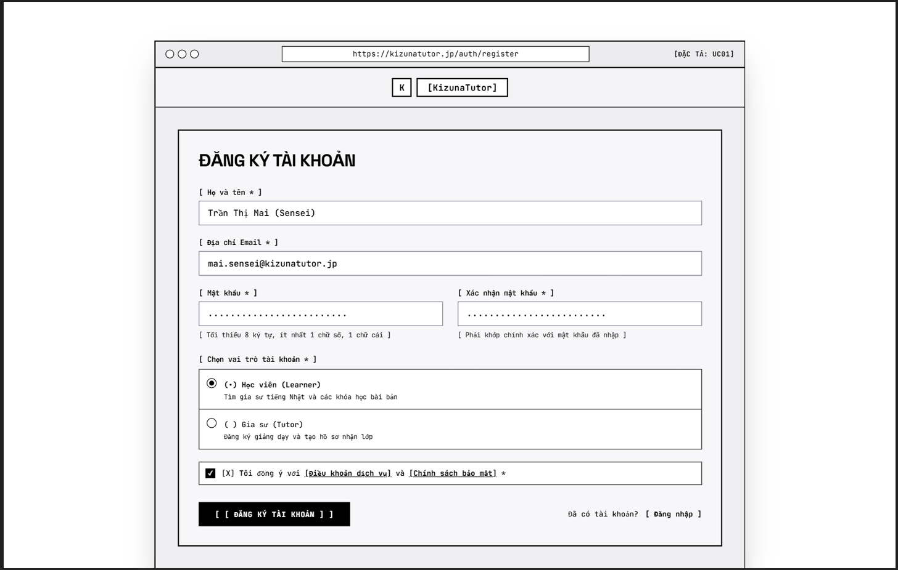
This screen is displayed when a Guest clicks the Register button in the page header (UC-001 Register Account, steps 1–4). It allows the Guest to:
● Enter Registration Details: type in Full Name, Email and Password.
● Select Role: choose one role – Learner, Tutor – for the new account.
● Submit Registration: click Register; the system validates the input and checks that the email is not already used (UC-001 step 5, Data Business Rule “Unique email”). If valid, the system sends a 6-digit OTP to the email and moves to the OTP Verification screen (MSG05).
● Go to Login: click the Log in link if the Guest already has an account.

Field Description
Field Name | Description
(1) Full Name | Text box, required. Data type: string, min 2 – max 50 characters. Initial value: empty (placeholder “Enter your full name”).  Empty: MSG02. Longer than max / shorter than min: MSG06 / MSG07.
(2) Email | Text box, required. Data type: email format (name@domain), max 100 characters. Initial value: empty.  Must be unique across the system (UC-001 Alternative flow “Email already exists”): show inline error “This email is already registered. Please log in or use a different email.” (new message – to be added to System Messages).  Empty: MSG02.
(3) Password | Password box (masked), required. Data type: string, min 8 – max 64 characters, with at least 1 uppercase letter, 1 digit and 1 special symbol. Stored hashed (BCrypt, work factor ≥ 12).  Show / Hide toggle to reveal the typed value.  Empty: MSG02. Does not meet complexity: MSG11.
(4) Role | Radio group, required. Values: Learner, Tutor. Initial value: Learner. Exactly one value can be selected.
(5) Register button | Button. Validates all fields; on success calls the email service to send the OTP and navigates to the OTP Verification screen with toast MSG05. On failure stays on the screen and shows the error messages under the relevant fields.
(6) Log in link | Link. Navigates to the Login screen.

2. Learner & Tutor Profile Management

3. Tutor Onboarding & Verification

3.1 Tutor Application Review

3.1.1 Application Review Dashboard
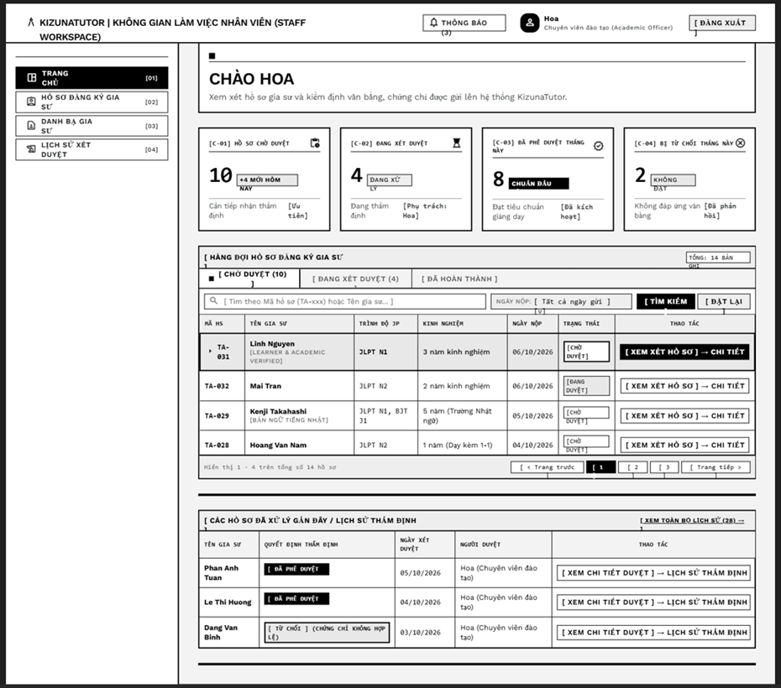
(3)
(2)
(1)
This is the home screen of the Staff Workspace for the Academic Staff. It supports the review of tutor applications submitted through the onboarding process (UC-015 Upload Credentials, UC-016 Verify Credentials, UC-017 Schedule Interview, UC-018 Record Evaluation, UC-019 Issue Approval Decision). The screen allows the Academic Officer to:
● View Summary: see the number of pending, in-review, approved and rejected applications at a glance.
● Browse Application Queue: switch between the Pending, In Review and Completed tabs to see applications in each stage.
● Search Applications: enter a profile code (TA-xxx) or tutor name to find an application.
● Filter Applications: filter the queue by submission date.
● Open Application: click Review Profile to open the Application Detail screen, where credentials are verified, interviews scheduled and the approval decision is issued.
● View Review History: see recently processed applications and open the full Review History.
Field Description
Field Name | Description
Header & Navigation
Workspace title | Text, read-only: “KizunaTutor | Staff Workspace”.
Notifications button | Button with unread counter (e.g. “Notifications (3)”). Click to open the notification list. The counter shows the number of unread notifications; hidden when 0.
User info | Avatar, display name and role of the signed-in staff (e.g. “Hoa – Academic Officer”). Read-only, taken from the account profile.
Logout button | Button. Ends the session and navigates to the Login screen.
Sidebar menu | Menu items: Home [01], Tutor Registration Profiles [02], Tutor Directory [03], Review History [04]. The current item is highlighted (initial: Home). Items shown depend on the role permissions.
Welcome banner
Greeting | Text, read-only: “Hello {display name}” with a short instruction line about reviewing submitted credentials and certificates.
Summary cards
[C-01] Pending applications | Number, read-only. Count of applications with status Pending Review. Sub-label shows the number newly received today (e.g. “+4 today”) and the note “Needs assessment – Priority”.
[C-02] In review | Number, read-only. Count of applications currently being reviewed. Sub-label shows the assigned officer (e.g. “Assigned: Hoa”).
[C-03] Approved this month | Number, read-only. Count of applications approved in the current month; the tutor account is activated after approval.
[C-04] Rejected this month | Number, read-only. Count of applications rejected in the current month; applicants are notified of the result.
Application queue
Tab: Pending / In Review / Completed | Tab group with the record count in brackets, e.g. “Pending (10)”. Initial tab: Pending. Changing the tab reloads the table with the applications in that status.
Search box | Text box, optional, max 100 characters. Placeholder: “Search by profile code (TA-xxx) or tutor name…”. Matches profile code or tutor name (partial, case-insensitive).
Submitted date | Dropdown, optional. Initial value: “All dates”. Filters applications by submission date range.
Search button | Button. Applies the search keyword and date filter. If there is no result, show MSG01.
Reset button | Button. Clears the keyword, resets Submitted date to “All dates” and reloads the list.
Total records | Text, read-only: “Total: {n} records” for the current tab and filter.
Profile ID | Text, read-only. Format TA-{3-digit number}, e.g. TA-031.
Tutor name | Text, read-only, with verification tags under the name (e.g. “Learner & Academic Verified”, “Native Japanese speaker”).
JP level | Text, read-only. Highest Japanese certificate declared, e.g. “JLPT N1”, “JLPT N1, BJT J1”.
Experience | Text, read-only. Declared teaching experience, e.g. “3 years”.
Submitted date (column) | Date, read-only, format dd/MM/yyyy. Default sort: oldest first so that long-waiting applications are handled first.
Status | Badge, read-only. Values: Pending, In Review (and Approved / Rejected in the Completed tab).
Action: Review Profile | Button on each row. Navigates to the Application Detail screen. The first row is highlighted as the next application to handle.
Pagination | Text “Showing 1–4 of 14 records” with Previous / page numbers / Next. Page size: 4 records (configurable). Initial page: 1.
Recent review history
Tutor name | Text, read-only. Name of the tutor whose application was recently processed.
Review decision | Badge, read-only. Values: Approved; Rejected, followed by the rejection reason (e.g. “Rejected – invalid certificate”).
Review date | Date, read-only, format dd/MM/yyyy.
Reviewer | Text, read-only. Name and role of the staff who made the decision (e.g. “Hoa (Academic Officer)”).
Action: View review detail | Button on each row. Navigates to the Review History detail of that application.
Link: View all history | Link with total count (e.g. “View all history (28)”). Navigates to the Review History screen.

4. Tutor Search & Suggest

4.1 Tutor Discovery

4.1.1 Homepage – Quick Tutor Search & Featured Tutors
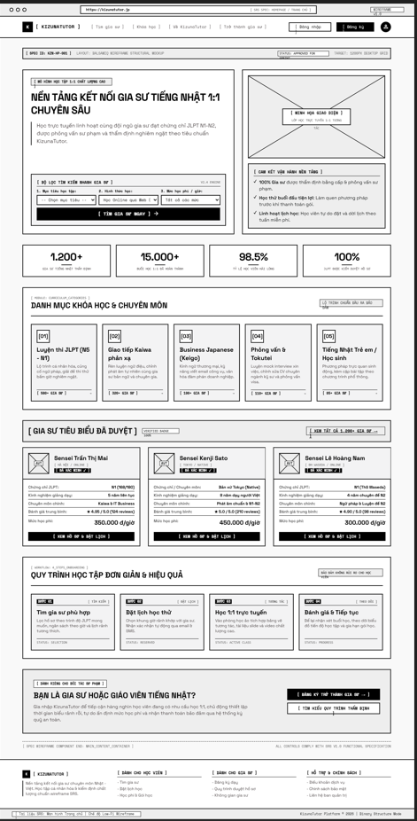
This is the public Homepage. It is the entry point for finding tutors: a Guest or Learner can set quick search criteria, browse course categories and see featured verified tutors (UC-024 Search Tutors with Filters, UC-023 View Tutor Profile Public, UC-028 Request / Book Trial Lesson). The screen allows the user to:
● Search Tutors Quickly: choose learning goal, learning mode and fee range, then click Find Tutor Now to open the tutor list with these filters applied.
● Browse Categories: click a course category card to see the tutors of that category.
● View Featured Tutors: see verified tutors suggested on the homepage with their key information.
● Open Tutor Profile: click View Profile & Book Schedule to open the public tutor profile and continue to booking a trial lesson.
● Navigate: go to Login, Register, tutor registration (Become a Tutor) and information pages.
Field Description
Field Name | Description
Header & Navigation
Logo | Image + text. Click to return to the Homepage.
Menu | Links: Find Tutor, Courses, About KizunaTutor, Become a Tutor. Fixed at the top of the page.
Login / Register buttons | Buttons. Navigate to the Login / Register screens. When signed in, replaced by the account icon menu.
Quick tutor search filter
Learning goal | Dropdown, optional. Initial value: “-- Select goal --”. Values follow the course categories (JLPT Exam Prep, Reflex Conversation, Business Japanese, Interview & Tokutei, Kids / Students).
Learning mode | Dropdown, optional. Initial value: “Online via Web”.
Fee range / hour | Dropdown, optional. Initial value: “All ranges”. Fee ranges (VND/hour) are taken from system settings.
Find Tutor Now button | Button. Navigates to the Tutor List screen with the selected criteria. If no criteria are selected, all tutors are listed. If no tutor matches, the list shows MSG01.
Platform commitments & statistics
Commitments | Static text, 3 items: 100% tutors verified by certificate and interview; free first trial lesson; flexible schedule (free weekly changes).
Statistics | Four read-only figures loaded from the system: verified tutors (e.g. “1,200+”), completed 1:1 lessons (e.g. “15,000+”), learner satisfaction rate (e.g. “98.5%”, 1 decimal), tutors with verified JLPT certificate (e.g. “100%”).
Course categories
Category card [01]–[05] | Card, read-only content: sequence number, name, short description (max 120 characters) and tutor count (e.g. “580+ tutors”). Categories: JLPT (N5–N1), Reflex Conversation (Kaiwa), Business Japanese (Keigo), Interview & Tokutei, Kids / Students. Click to open the Tutor List filtered by the category.
Featured tutors
View all tutors link | Link with total tutor count (e.g. “View all 1,200+ tutors”). Navigates to the Tutor List.
Avatar | Image, square. Initial value: placeholder avatar when the tutor has none.
Tutor name | Text, max 50 characters, e.g. “Sensei Tran Thi Mai”.
Location / mode | Text, e.g. “Hanoi / Online”, “Tokyo / Native”. Only an approximate area is shown (GB-15).
Verified badge | Badge “Verified”, shown only for tutors whose credentials were approved (GB-06).
JLPT / Certificate | Text, e.g. “N1 (168/180)”.
Teaching experience | Text, e.g. “5 years continuous”.
Main specialty | Text, e.g. “Kaiwa & IT Business”.
Average rating | Decimal 0.0–5.0 with review count, e.g. “4.95 / 5.0 (124 reviews)”.
Tuition fee | Amount per hour in VND, format “350,000 đ/hour”.
View Profile & Book Schedule button | Button. Navigates to the public Tutor Profile of the selected tutor. Booking a trial then follows UC-028.
Learning workflow & tutor call-to-action
Workflow steps 01–04 | Static text: 01 Find (match tutor by JLPT level and schedule), 02 Book trial (confirmation by email/SMS), 03 Learn 1:1 online, 04 Review & continue.
Become a Tutor button | Button. Navigates to the tutor registration form.
Learn about verification button | Button. Navigates to the tutor verification process page.
Footer
Footer links | Groups: For Learners (Find Tutor, Book Schedule, Fees & Packages), For Tutors (Register, Verification process, Tutor space), Support & Policy (Terms, Privacy, Contact admin). Copyright text: “KizunaTutor Platform © 2026”.

5. Lesson Scheduling & Attendance

5.1 Teaching Schedule Management

5.1.1 Teaching Schedule & Availability
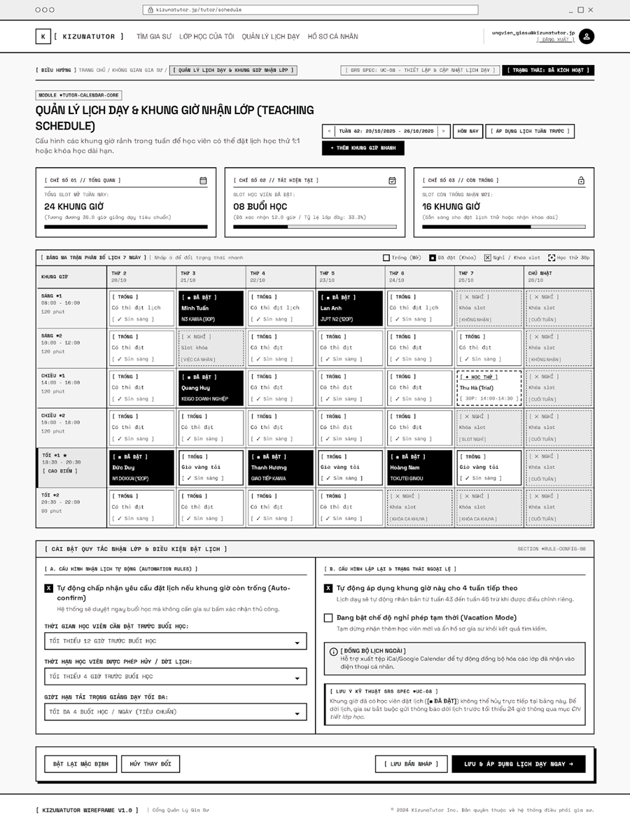This screen is used by the Tutor to open the weekly time slots in which learners can book trial or long-term lessons, and to set the rules that apply to those bookings (UC-027 Manage Availability, UC-041 Schedule Lesson Sessions, UC-042 Configure Reschedule Policy, UC-043 Reschedule Lesson). The screen allows the Tutor to:
● View Weekly Schedule: see all slots of the selected week in a 7-day matrix with their status.
● Change Slot Status: click a cell to switch it between Open and Off (blocked). Booked slots are locked.
● Navigate Weeks: move to the previous / next week or back to the current week; copy the previous week’s schedule.
● Add Slots Quickly: add one or several slots at once with “Add quick slot”.
● Configure Booking Rules: set auto-confirm, minimum advance booking time, cancel / reschedule deadline and maximum daily load.
● Configure Recurrence & Exceptions: repeat the schedule for the next 4 weeks, turn on Vacation Mode, and see the external calendar sync notice.
● Save Schedule: save as draft, or save and apply the schedule immediately.
Note: the Attendance part of this feature (UC-044 Check In Offline Session, UC-045 Check In Online Session) has no wireframe yet and is reserved as section 5.2.
Field Description
Field Name | Description
Header & Navigation
Menu | Links: Find Tutor, My Classes, Manage Teaching Schedule (current, highlighted), Profile.
User info & Logout | Signed-in email and a Logout link. Logout ends the session and navigates to the Login screen.
Breadcrumb & status | Text path “Home / Tutor Space / Manage Teaching Schedule & Accepting Slots” and a status tag “Activated”. Read-only.
Page header & week navigation
Title & description | Static text: “Teaching Schedule & Slot Management”, with a one-line explanation.
Week selector | Previous (<) and Next (>) buttons around the label “Week {n}: dd/MM/yyyy – dd/MM/yyyy”. Initial value: the current week. Changing the week reloads the summary cards and the matrix.
Today button | Button. Returns to the current week.
Apply previous week’s schedule button | Button. Copies the slot pattern of the previous week into the selected week. Slots that conflict with already booked lessons are skipped.
Add quick slot button | Button. Opens a dialog to add slots by day and time range.
Summary indicators
Total open slots this week | Number of open slots with the equivalent teaching hours (e.g. “24 slots ≈ 36.0 standard teaching hours”) and a progress bar. Read-only.
Learner-booked slots | Number of booked slots with confirmed hours and fill rate (e.g. “08 lessons, 12.0 hours, fill rate 33.3%”). Fill rate = booked / open × 100, 1 decimal.
Remaining available slots | Number of free slots still open for new trial or long-term bookings (e.g. “16 slots”).
Weekly availability matrix
Time slots (rows) | Fixed slots: Morning #1 08:00–10:00 (120 min), Morning #2 10:00–12:00, Afternoon #1 14:00–16:00, Afternoon #2 16:00–18:00, Evening #1 18:30–20:30 (peak hour, marked ★), Evening #2 20:30–22:00 (90 min).
Days (columns) | Monday to Sunday of the selected week, with date dd/MM.
Cell: Open | Available slot (“Open – Ready”). Click to switch to Off.
Cell: Booked | Slot reserved by a learner, shown in black with learner name and course (e.g. “Minh Tuan – N3 Kaiwa (90 min)”). Locked: cannot be edited or cancelled directly here.
Cell: Off / Blocked | Slot the tutor does not accept (dashed, with reason such as personal matter, weekend, not accepted). Click to reopen if not booked.
Cell: Trial 30 min | Slot holding a 30-minute trial lesson (e.g. “Thu Ha (Trial) 14:00–14:30”), dashed border.
Legend | Open, Booked (locked), Off / Blocked, Trial 30 min.
A. Automation rules
Auto-accept booking | Checkbox. Initial value: checked. When on, a booking request on an open slot is confirmed immediately without tutor confirmation.
Minimum advance booking time | Dropdown. Initial value: “At least 12 hours before lesson”. Learners cannot book a slot closer to the start time than this value.
Cancel / reschedule deadline | Dropdown. Initial value: “At least 4 hours before lesson”. Defines the latest time a learner may cancel or reschedule (UC-042).
Maximum teaching load | Dropdown. Initial value: “Max 4 lessons / day (standard)”. Slots beyond the limit cannot be booked.
B. Recurrence & exceptions
Repeat for next 4 weeks | Checkbox. Initial value: checked. Copies this week’s slot setting to the following 4 weeks, except weeks edited individually.
Vacation Mode | Checkbox. Initial value: unchecked. When on, the tutor stops receiving new learners and is hidden from search results.
External calendar sync | Information box. Supports exporting an iCal / Google Calendar file to sync accepted classes to the tutor’s personal phone calendar.
Technical note | Text. A slot that already has a booked learner cannot be cancelled here. To change it, the tutor must notify the learner at least 24 hours in advance through Class Details (UC-043).
Action bar
Reset to default button | Button. Restores the default rules and the previously saved schedule after confirmation.
Cancel changes button | Button. Discards unsaved changes.
Save draft button | Button. Saves changes without publishing; learners do not see draft changes.
Save & apply schedule now button | Button (primary). Validates and saves the schedule, makes open slots visible to learners immediately and shows a success toast MSG04.

6. Background Job Inventory

6.1 Auto-Cancel Unpaid Trial Bookings (JOB-01)
Trigger: Scheduled — every 15 minutes
Purpose: Automatically cancels trial lesson bookings if the deposit is not paid within the required time limit.
Processing steps:
- Find all trial lesson bookings with status = Pending Payment where the creation timestamp is older than the payment deadline (e.g., 30 minutes).
- For each unpaid booking found: update status to Cancelled, release the reserved tutor time slot, and send a notification to the learner.
- Log the total number of expired trial bookings cancelled in this run.
Failure behavior:
Scenario | System behavior
Database unreachable | Job retries up to 3 times with 30-second intervals. If still failing, logs a critical error. Unpaid bookings remain in pending state until the next successful run.
No locked accounts found | Job completes immediately with no action — this is normal and expected.

6.2 Auto-Check-Out Expired Sessions (JOB-02)
Trigger: Scheduled — daily at 11:59 PM
Purpose: Checks and automatically closes completed teaching sessions where tutors forgot to manually Check-Out.
Processing steps:
- Find all scheduled teaching sessions for the current day where the tutor checked in, the scheduled end time has passed, but status is still In Progress.
- For each unclosed session found: set session status to Completed (Auto Check-Out), record the system timestamp as check-out time, and flag for admin review if necessary.
- Log the total number of auto-checked-out sessions.
Failure behavior:
Scenario | System behavior
Database timeout during delete | Transaction rolls back for affected records. Job logs a warning and retries at the next scheduled time. No data corruption.
Retention period not configured | Job completes immediately with no action — this is normal and expected.

6.3 Clean Up Expired Verification OTPs (JOB-03)
Trigger: Scheduled — every 30 minutes
Purpose: Purges expired OTP codes and password reset tokens from the database to prevent table bloat and security risks.
Processing steps:
- Find all OTP verification codes and password reset tokens where the expiration timestamp is older than the current time.
- Delete the expired records in batches of up to 1,000 records per run to minimize database load.
- Log the total number of expired tokens purged.
Failure behavior:
Scenario | System behavior
Database timeout during delete | Current batch rolls back. Job logs a warning and tries again at the next scheduled run.
Retention period not configured | Job completes immediately with no action — this is normal and expected.

7. External API Inventory

7.1 Payment Gateway Request (API-EXT-01)
URL | [VNPAY Payment Gateway URL]
Purpose | Create deposit or tuition payment transactions and get redirect links to VNPAY.
Caller | Tutor Platform
Auth | Yes (Merchant ID & Checksum HMAC-SHA512)

7.2 VnPay Webhook / IPN (API-EXT-02)
URL | [Server Domain Webhook Endpoint]
Purpose | Receive instant payment results from VNPAY to update payment statuses.
Caller | VNPay payment gateway
Auth | HMAC-SHA512 signature validation

7.3 Email Service API (API-EXT-03)
URL | [Email API Endpoint]
Purpose | Send system emails such as OTP codes, booking alerts, and password resets.
Caller | Tutor Platform
Auth | Yes (Bearer API Key)

7.4 Google Maps API (API-EXT-04)
URL | [Google Maps Geocode API Endpoint]
Purpose | Convert user addresses into GPS coordinates to help find nearby tutors.
Caller | Tutor Platform
Auth | Yes (Google API Key)

7.5 Cloud Storage API (API-EXT-05)
URL | [Supabase / Firebase Storage Endpoint]
Purpose | Upload and store files such as study materials, homework, certificates, and complaint proof.
Caller | Tutor Platform
Auth | Yes (API Key / Service Role Token / Signed URL)

IV. Non-Functional Requirements

1. External Interfaces
This section specifies the interfaces required for KizunaTutor (KZT) to interact with human users, hardware devices, and external software services:
· User Interfaces: The system provides a responsive web user interface accessible via modern web browsers (Google Chrome, Microsoft Edge, Safari, Firefox). The interface dynamically adapts across desktop (1920 x 1080), tablet (768 px width) and smartphone (375 pxidth) viewports. The UI supports full Vietnamese localization and Japanese script rendering (Kanji, Furigana, Hiragana, Katakana).
· Hardware Interfaces: No proprietary external hardware is required. The system interfaces with standard user device hardware through standard Web APIs: client cameras and microphones for Google Meet sessions and local storage for offline flashcard caching.
· Software & External System Interfaces:
o Payment & Banking Gateway: Interfaces with SePay / VietQR / Napas 247 APIs for automated bank transfer reconciliation, payment QR code generation, and payout disbursals via secure webhooks.
o Identity Provider (OAuth 2.0): Interfaces with Google Identity Services for third-party Single Sign-On (SSO) and profile synchronization.
o Virtual Classroom & Calendar: Interfaces with Google Workspace / Google Meet API to automatically provision unique video classroom room links, and Google Calendar API (.ics generation) for lesson scheduling and reminders.
o Mailing Service: Interfaces with an authenticated SMTP Email Gateway for dispatching verification OTPs, milestone contract notices, dispute alerts, and financial receipts.
o Japanese Lexicon Dictionary API: Interfaces with standard Japanese-Vietnamese open dictionary databases to provide automated Furigana, Sino-Vietnamese (Han-Viet), and definition auto-completion during flashcard creation.
o Geolocation & Mapping Service: Interfaces with Google Maps Platform (Maps JavaScript API and Geocoding API) to provi Performance
o de location-based tutor search and relative map rendering.

2. Quality Attributes

2.1 Usability
- First-Time Task Completion: At least 80% of first-time users (Learners/Parents) must be able to complete a tutor search, view profiles, and submit a trial lesson booking within 5 minutes without prior training.
- Role Task Completion: At least 80% of participants per role (Learner, Parent, Tutor, Admin) must complete their core daily tasks unaided (e.g., Tutor grading homework within 3 minutes; Learner finishing a daily SRS flashcard session within 5 minutes).
- Error Guidance & Prevention: 100% of validated input fields must return immediate, user-friendly, field-specific error messages within 1 second. The system must display zero raw server stack traces, database exception codes, or unhandled HTTP errors to end users.
- Browser Compatibility: 100% of core workflows must function flawlessly on the latest 2 major versions of Google Chrome and Microsoft Edge on desktop at resolution.
- Responsive Layout: 100% of core screens must render cleanly without horizontal scrolling, overlapping text, or unreachable buttons on mobile ( ) and tablet ( ) screens.
- Language & Typography Presentation: At least 95% of UI labels must be verified for correct Vietnamese spelling and diacritics, with 0 UTF-8 character encoding errors across all Japanese Kanji and Furigana annotations.
·

2.2 Performance
Requirement | Target | Condition
Page load time | Any page loads within for 95% of page loads | Up to 100 users active simultaneously
Form submission response | System acknowledges within for 95% of submissions | Up to 100 users active simultaneously
Maximum simultaneous users | System remains fully functional for up to 100 users with a 0% request failure rate | Single-server deployment assumption
Chat / notification responsiveness | for 95% of chat messages; for 95% of notifications | Stable network and supported browser
Verification / payment action response | for 95% of actions, measured at the system boundary | Excludes third-party provider / bank latency
Administrative dashboard response | for 95% of dashboard loads | Full seeded data set, single administrator session
Smart matching recommendation | for 95% of recommendation queries | Candidate pool of up to 200 qualified tutors
Spaced Repetition (SM-2) review processing | for 95% of card review recalculations | SM-2 interval and easiness factor updates
Concurrent data consistency | 0 overlapping schedules and 0 duplicate tutor bookings | 100 concurrent attempts on the same time slot
Automated Batch Processing (Cron Jobs) | System completes weekly invoice generation and periodic payout calculations within 5 minutes. | Volume of up to 2,000 active contracts.

2.3 Security
Requirement | Description
Authentication required | Every page and API endpoint other than the sign-in page, registration page, public tutor discovery catalog requires the user to be signed in (HTTP 401 on unauthorized access).
Password protection | Passwords must never be stored in a form that a person or program can read or reverse. All credentials must be hashed using BCrypt with a minimum work factor of 12.
Account lockout & throttling | After 5 consecutive failed sign-in attempts within 10 minutes, the account is temporarily locked for 30 minutes to prevent brute-force credential attacks.
Credential & Verification file access | Tutor JLPT certificates, identity cards, and session Proof of Work (PoW) evidence files may only be accessed by authorized Tutors and Administrators. The system verifies access permissions on every file request and prevents enumeration by ID.
Role-Based Access Control (RBAC) | 100% of endpoint requests enforce strict RBAC permissions across all 7 user roles. Horizontal privilege escalation attempts across different learner profiles or contracts are strictly blocked.
Minor data protection | Learner profiles belonging to minors (< 18 years) are accessible only by the linked Parent account and Platform Administrators. Zero child personal contact fields are exposed in public views.
Payment & Escrow integrity | 100% of milestone escrow funding, milestone releases, dispute freezes, and payout withdrawals are restricted to authorized contracting parties and Administrators, with mandatory immutable financial ledger logging.
Session lifetime & invalidation | Authenticated user sessions become unusable after 30 minutes of continuous inactivity and are revoked immediately within 1 second upon explicit user logout.
Upload validation & sanitation | Uploaded files exceeding standard limit of 10MB (or up to 100MB for media/digital materials as defined per feature) are rejected. Only validated file types (PDF, PNG, JPG, MP3, MP4, WEBP) are accepted, with 100% of spoofed or executable files rejected.
Sensitive Financial Data Masking | Tutor payout bank account details must be securely masked on the UI (e.g., displaying only the last 4 digits: ******1234) to prevent shoulder surfing. Full account numbers are only accessible by the owning Tutor and authorized Administrators/Accountants.

2.4 Scalability, Availability, Maintainability & Compliance
- Scalability: System sustains 100 concurrent users with 0% error rate over 10 minutes. List and search queries return within under seeded data volumes of 1,000 tutors, 2,000 contracts, 10,000 lesson sessions, 50,000 flashcards, and 20,000 financial transactions. All list endpoints enforce mandatory pagination (default 20, max 50 items).
- Availability & Disaster Recovery: In case of third-party payment provider outages, at least 95% of non-financial features (browsing, diagnostic tests, SRS reviews) remain functional. Daily automated database backups execute at 02:00 ICT with maximum data loss . Working application state is restorable within 30 minutes.
- Maintainability & Monitoring: 0 credentials or service endpoints are hardcoded in source code (100% supplied via environment variables). 100% of unhandled application exceptions and governed financial actions are logged with timestamp, user ID, and endpoint details. A health visibility endpoint (/actuator/health) returns status within 1 second.
- Compliance & Ledger Consistency: 0 discrepancy is permitted between user wallet balances, active milestone escrow totals, and the platform transaction ledger across 100% of financial transactions.

V. Requirement Appendix

1. Business Rules
GBR-ID | Rule Statement | Applies To | Rationale | Enforced By
GB-01 | Status changes are one-way and sequential. No completed contract, approved milestone, or verified credential may be reverted to a previous state without a formal dispute or re-evaluation. | Contract status, Milestone status, Credential verification | Prevents data integrity loss and maintains a clear audit trail. | The system automatically on every state transition
GB-02 | Internal admin evaluation notes, interview scoring rubrics, and fraud risk scores are never visible to Tutors or Learners. | Verification reviews, Payout approvals, Dispute tickets | Protects administrative evaluation objectivity and prevents security gaming. | The system automatically on every page and API request
GB-03 | Tutor credential files (JLPT certificates, degrees) and session Proof of Work (PoW) photos may only be accessed by the owning Tutor, contracting Learner, and Administrators. | Credential files, PoW evidence documents | Protects personal data and identity confidentiality. | The system automatically on every file download request
GB-04 | When a sign-in fails, the error message must not reveal whether the email address exists or the password was incorrect. | User Sign-in | Prevents attackers from discovering and enumerating registered accounts. | The system automatically on every failed sign-in
GB-05 | A deactivated, suspended, or banned account cannot sign in or perform any platform action, regardless of password correctness. | User Sign-in, API Token Verification | Ensures penalized or departed users lose access immediately. | The system automatically on every authentication request
GB-06 | Unverified Tutors cannot receive trial bookings, sign contracts, or publish paid marketplace resources until full KYC and credential approval. | Tutor Onboarding, Booking, Publishing | Ensures high teaching quality and prevents unvetted individuals from charging fees. | The system automatically on all tutor action requests
GB-07 | Learners under 18 years of age must have an active Parent/Guardian link; contracts and escrow deposits for minors require Parent authorization. | Learner Profiles, Contract Signing, Escrow Deposits | Complies with legal requirements regarding minors and financial commitments. | The system automatically on contract and payment workflows
GB-08 | Direct sharing of private contact info (phone, banking, social links) in public bios or pre-contract chat is filtered and prohibited. | Public Tutor Bio, Pre-Contract Messaging | Prevents off-platform circumvention and protects user safety. | The system automated text filtering engine on message send
GB-9 | Online teaching sessions require the Tutor to explicitly perform Check-in and Check-out actions on the platform to record actual teaching timestamps and confirm session completion. | Online Lesson Sessions | Accurately tracks actual lesson duration and replaces manual OTP exchange. | The system automatically on lesson schedule interface
GB-10 | Contract tuition fees are billed via automated weekly invoices and must be paid upfront before the week's lessons begin. Tutor earnings are not directly withdrawn but disbursed through scheduled periodic payouts after platform commissions are deducted. | Weekly Invoicing, Scheduled Payouts | Protects learner funds while aligning with a structured, periodic payroll model for tutors. | The system automatically on invoice generation and payout execution
GB-11 | Completed lessons are marked as confirmed if the Learner explicitly approves, or automatically if 72 hours elapse after Check-out without a dispute. Only confirmed lessons are eligible for the next periodic payout batch. | Lesson Confirmation, Payout Calculation | Prevents learner inaction from delaying tutor compensation while allowing time for disputes. | The System Scheduler cron job executing daily
GB-13 | Spaced repetition flashcards enforce a minimum Easiness Factor ( ) and calculate review intervals dynamically via the SM-2 algorithm. | Flashcard Decks, Daily SRS Review | Optimizes long-term memory retention based on cognitive science principles. | The system Spaced Repetition Engine on card rating
GB-14 | Manual payout withdrawal requests are not permitted. Tutor earnings are automatically processed in batches by the system; funds included in a pending payout batch are locked in the ledger until the bank transfer is verified. | Payout Processing, Wallet Balances | Prevents double-spending and maintains ledger consistency during scheduled bank transfer latencies. | The system automatically upon payout batch generation
GB-15 | To protect user privacy, tutor locations displayed on public search maps must only show an approximate radius or district-level area. Exact residential coordinates or street addresses must never be exposed to public users. | Location-based Search (Map View) | Prevents physical tracking and ensures compliance with personal data protection regulations. | The system automatically by obfuscating coordinate precision on map API responses
GB-16 | Automated refunds for canceled regular lessons are calculated based strictly on the time margin before the scheduled start time, adhering to published platform policies (e.g., 100% refund if canceled > 24 hours prior). | Lesson Cancellation, Automated Refund Calculation | Ensures transparent, objective, and policy-driven financial resolution without manual bias. | The system automatically upon lesson cancellation triggers

2. System Messages
# | Message code | Message Type | Context | Content
1 | MSG01 | Inline | There is not any search result | No search results found. Please adjust your filter criteria.
2 | MSG02 | In red, under text box | Input-required fields are empty | The * field is required.
3 | MSG03 | Toast message | Account registered successfully | Registration successful! Please verify your email to activate your account.
4 | MSG04 | Toast message | Profile / Information updated successfully | Update profile successfully.
5 | MSG05 | Toast message | Email notification sent successfully | A confirmation email has been sent to {email_address}.
6 | MSG06 | In red, under text box | Input value length > max length | Exceed max length of {max_length} characters.
7 | MSG07 | In red, under text box | Input value length < min length | Minimum length required is {min_length} characters.
8 | MSG08 | In line | Invalid login credentials | Incorrect email or password. Please check again.
9 | MSG09 | Toast message | Account temporarily locked due to failed attempts | Account locked due to 5 consecutive failed attempts. Try again in 15 minutes.
10 | MSG10 | Modal alert | Guardian invitation code invalid or expired | Invalid Parent contact information. Please check the phone number or link and try again.
11 | MSG11 | In red, under text box | Password does not meet complexity requirements | Password must be at least 8 characters with 1 uppercase, 1 digit, and 1 special symbol.
12 | MSG12 | Toast message | Credential documents submitted for verification | Your credential documents have been submitted for verification.
13 | MSG13 | In line | File upload exceeds size limit | File size exceeds maximum limit of {max_size}. Allowed formats: PDF, PNG, JPG, MP3.
14 | MSG14 | Modal alert | Tutor availability time slot conflict | Selected time slot is no longer available. Please select another slot.
15 | MSG15 | Toast message | Trial session booking confirmed | Trial lesson booked successfully! Deposit held in escrow.
17 | MSG17 | In line | Online session OTP code mismatch or expired | Invalid Check-in OTP code. Please verify with your learner.
18 | MSG18 | Toast message | Milestone escrow deposited successfully | Escrow deposit successful! Milestone is now active.
19 | MSG19 | Toast message | Milestone funds released to tutor | Milestone approved! Escrow payment has been released to tutor wallet.
20 | MSG20 | Modal alert | Milestone auto-released after grace period | Milestone auto-released: 72 hours elapsed without dispute.
21 | MSG21 | Toast message | Dispute ticket submitted | Dispute filed successfully. Milestone escrow is frozen pending review.
22 | MSG22 | Toast message | Homework assignment submitted | Homework solution submitted successfully.
23 | MSG23 | In line | Homework submission past deadline | Submission deadline has passed. Late submissions are not permitted.
24 | MSG24 | Toast message | Daily SRS flashcard review completed | Excellent work! You completed all due flashcard reviews for today.
26 | MSG26 | Modal alert | Masterclass webinar event sold out | This Masterclass Webinar has reached maximum attendee capacity.
27 | MSG27 | In line | Insufficient wallet balance for transaction | Insufficient wallet balance. Please top up or pay directly via VietQR.
28 | MSG28 | In line | Withdrawal amount below minimum threshold | Minimum withdrawal amount is 200,000 VND and cannot exceed available balance.
30 | MSG30 | In line | Content safety filter blocked prohibited text | Content blocked: Prohibited words, contact info, or external links detected.

3. Other Requirements

3.1 Out of Scope (OOS)
ID | Excluded Item | Rationale
OOS-01 | Native iOS / Android Applications | Delivered exclusively as a responsive web application across desktop and mobile browsers within the academic thesis timeframe.
OOS-02 | Proprietary Video Streaming Server Infrastructure | Platform provisions Google Meet rooms via Google Workspace API; raw video recording and storage is managed on tutor's personal Google Drive with zero server storage overhead on KizunaTutor.
OOS-03 | In-Person Physical Background Checks | Tutor identity and credential verification is performed strictly digitally via uploaded official JLPT certificates, degrees, and video interviews.
OOS-04 | Third-Party Web Scraping & Social Scraping | Platform relies exclusively on organic profile data, lesson reviews, and assessments provided by authenticated users.
OOS-05 | Guaranteed JLPT Exam Passing Results | Platform provides diagnostic assessments, syllabus roadmaps, and formative analytics; it does not guarantee formal JLPT certification outcomes.
OOS-06 | International Currencies & Cross-Border Payment | Release targets the domestic Vietnamese market exclusively, utilizing VND currency and Vietnamese banking systems.
OOS-07 | Multilingual UI beyond Vietnamese and Japanese | System UI supports Vietnamese localization with full Japanese script (Kanji, Hiragana, Katakana, Furigana) rendering.
OOS-08 | Advanced Computer-Vision Proctoring | Diagnostic test anti-cheat focuses on tab-switch monitoring and randomized question banks without invasive webcam biometric proctoring.
OOS-09 | Live Commercial Bank Production Merchant Gateway | Financial flows operate against SePay Sandbox / VietQR Gateway for academic demonstration.
OOS-10 | Multi-Region Cloud Clustering & Auto-Scaling | System is deployed on a dedicated single-server architecture with capacity bounded by the 100 concurrent users baseline.
OOS-11 | 24/7 Dedicated Operations Staff | Maintained by the capstone engineering team; availability verified through scheduled drills rather than commercial SLA contracts.
OOS-12 | Formal Third-Party Security Certification (ISO 27001 / PCI-DSS) | Security is verified via static code analysis, OWASP Top 10 testing, and scenario verification by the project team.
OOS-13 | Hardware Accessibility Devices (Screen Readers / Braille) | Conforms to standard clean HTML5 semantic structure without specialized hardware accessibility certifications.
OOS-14 | Legacy Web Browsers | Only modern Evergreen browsers (Google Chrome, Microsoft Edge, Mozilla Firefox, Apple Safari) are supported.

3.2 Technical Assumptions (ASM)
ID | Technical Assumption Statement
ASM-01 | The system is delivered as a modern responsive web application accessible across desktop, tablet, and smartphone browsers.
ASM-02 | Front-end is built using ReactJS (TypeScript, Tailwind CSS); Back-end is developed using Java 21 with Spring Boot 3.x framework.
ASM-03 | Client-server communication utilizes RESTful APIs over HTTPS; real-time messaging, notifications, and classroom state use WebSocket.
ASM-04 | Relational data is stored in MySQL 8.0 / PostgreSQL; Redis is utilized for distributed caching, session tokens, and rate limiting.
ASM-05 | Payment simulation and automated bank transfer reconciliation use SePay / VietQR sandbox integration.
ASM-06 | Google Identity Services (OAuth 2.0) is the third-party single sign-on provider.
ASM-07 | Automated email dispatch (OTP, contract notices, invoices) is handled through an authenticated SMTP service.
ASM-08 | Production/Demonstration environment is deployed on an AWS EC2 instance (or equivalent Linux VPS) with Docker containerization.
ASM-09 | Digital materials, homework attachments, and evidence photos are stored in secured object storage with pre-signed URL access.
ASM-10 | Spaced Repetition Flashcard system executes the SuperMemo-2 (SM-2) algorithm on the backend engine.
ASM-11 | The application operates under a single locale: Vietnamese language interface, Japanese text support, VND currency, and Asia/Ho_Chi_Minh timezone (UTC+7).
ASM-12 | End users access the platform via broadband Wi-Fi or 4G/5G mobile internet on supported browsers.
ASM-13 | Database volume remains within the target capacity (up to 1,000 tutors, 2,000 contracts, 10,000 sessions, 50,000 flashcards) for the capstone scope.
ASM-14 | System administration, user moderation, and dispute arbitration are performed by authorized project team members.
ASM-15 | Deployment, database migrations, and testing are executed from documented scripts with reproducible configurations.
ASM-16 | The system utilizes Google Maps Platform (Maps JavaScript API & Geocoding API) to render map views and support location-based tutor discovery.
ASM-17 | Outbound scheduled payouts to tutor bank accounts are processed via system-generated payout batch files (e.g., CSV format) for manual execution by an Accountant on a corporate internet banking portal, rather than direct outbound API integration.
ASM-18 | Automated background processes (e.g., weekly invoice generation, periodic payout calculation, automated refund calculation) rely on the backend framework's scheduled tasks executing strictly within the configured UTC+7 timezone.

3.3 Abbreviations & Acronyms
Abbreviation | List of Abbreviations & Description
KZT | KizunaTutor Platform (Japanese Language Tutor Matching & Tiered Learning Support Platform)
BF | Business Flow
FT | Feature Group
UC | Use Case
SCR | Screen Identifier
JOB | Background Job / Scheduled Cron Task
GBR / GB | Global Business Rule
DBR | Data Business Rule
MSG | System Message Code
ID | Identifier
UI | User Interface
AI | Artificial Intelligence
RBAC | Role-Based Access Control
OTP | One-Time Password
KYC | Know Your Customer
OAuth | Open Authorization (Google Identity Services)
FAQ | Frequently Asked Questions
SLA | Service Level Agreement
KPI | Key Performance Indicator
TDS | Technical Design Specification
QR | Quick Response code (VietQR / Napas 247)
SMTP | Simple Mail Transfer Protocol
HTTP / HTTPS | HyperText Transfer Protocol (Secure)
URL | Uniform Resource Locator
MB | Megabyte (unit of upload size limits)
PDF | Portable Document Format
JPEG / JPG | Joint Photographic Experts Group
PNG | Portable Network Graphics
WEBP | Web Picture format
CSV | Comma-Separated Values
ICT | Indochina Time (UTC+7)
VND | Vietnamese Dong
JLPT | Japanese Language Proficiency Test (N5 to N1)
SRS | Spaced Repetition System (SuperMemo-2 Algorithm)
PoW | Proof of Work (Session Verification Evidence)
GMV | Gross Merchandise Value
REST | Representational State Transfer
JWT | JSON Web Token

